(MAR 2004/ISSUE 1.0)

LDK-24/100/300 WOTS

DECT Repeater Installation Manual

LGE.

REVISED HISTORY
DATE | ISSUE | CONTENTS OF CHANGES | REMARK
2004.07 | ISSUE 1.0 | -. Initial Release

* This installation manual is applicable for printed date and can be modified or updated due to production enhancement.
* Unauthorized copying or partial plagiarism is prohibited by law.
백지

CONTENTS
1. Purpose 6
2. Configuration 7
2.1 LG WOTS Configuration 7
2.2 Kirk Installation 7

1. Purpose

LG does not produce DECT repeater. The purpose of this manual is to give an installer how to configure other company DECT repeater for use on the LDK-24/100/300 WOTS. Up to now, available product to attach to our LG WOTS is listed below.

- Kirk DECT repeater

2. Configuration

2.1 LG WOTS Configuration
Before the installation of a DECT repeater, an installer should enter DECT programming mode and ensure that the PARK code is programmed in the attendant station. In this example, the PARK code 311 0017 063 7243 was used.

2.2 Kirk Installation
- Connect prog kit to PC and repeater as shown below.
The hardware package consists of two items (A serial cable and a modular connector adapter).
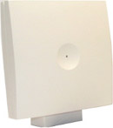
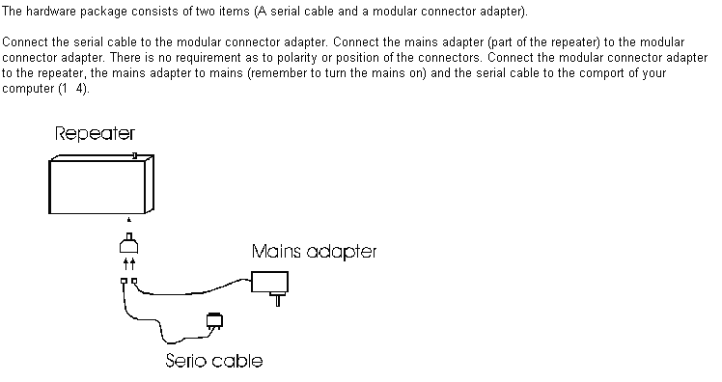
- Select Com port and press “Set Comport”– ensure message box “Repeater Connected”.
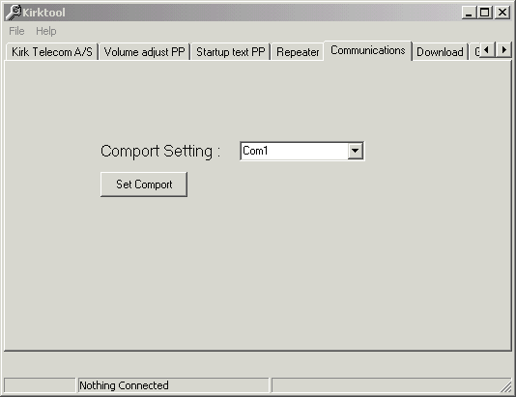
- Go to the Repeater tab in the program.
- For PARK code 311 0017 063 724 3 the CCFP 1500 code is: 1 0017 063 724
- Base station starts numbering from 0 – (For the first base station on the LG WOTS, set the “Base to synchronize on” as 0).
- Enter a new number which can be used for associating the repeater as base in the “Repeater number” box.
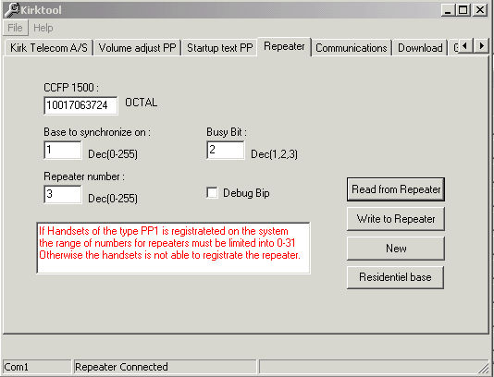
- Press “Write to repeater”.
- Power down the repeater and remove the serial cable.
- Power up the and check LED on repeater for indication that connection is made to the system. – LED keeps Flashing at a rate of about 1Hz = No sync.
- LED flashes at 1Hz, blinks quickly for a couple of seconds then stays on – connection to LG WOTS established.
- If connection is established the repeater is ready for use.

