LG-Nortel TSP
(ipLDK, iPECS)
User Guide

Issue 3.1Bb



REVISION HISTORY

Version | Date | Description of Change | S/W Version
Issue 1.0 | 12/MAR/2001 | Initial Release | 1.0Ae
Issue 2.0Aa | 05/FEB/2002 | Add Windows 2000 Server | 2.0Aa
Issue 3.0Aa | 31/MAY/2004 | Add ipLDK Features  Add Windows Server 2003 | 3.0Aa
Issue 3.0Ab | 18/AUG/2004 | Add Hot desk features | 3.0An
Issue 3.1Aa | 28/OCT/2004 | Add iPECS System
Issue 3.1Ad | 17/OCT/2005 | Add new features (Call ID etc.) | C.1Cc
Issue 3.1Ba | 14/DEC/2005 | Add LG-Nortel logo | C.1Ce
Issue 3.1Bb | 11/FEB/2006 | Add ARIA SOHO

CONTENTS

About This Manual 3
Audience 3
Associated Documentation 3
1. Introduction 4
1.1 What is the TAPI Application and LG-Nortel TSP 4
1.2 Enabling the TAPI Applications to use LG-Nortel system 4
2. Hardware/Software Requirements 6
2.1 Computer Requirements 6
2.2 Key Telephone systems Requirement 6
3. LG-Nortel TSP Installation & Configuration 7
3.1 Installation Procedure 7
4. 1st party connection 11
4.1 ipLDK-20/Nexer/ARIA SOHO 11
4.2 ipLDK-50/100/300/600 14
5. 3rd party connection 16
5.1 System Configurations 16
5.2 To configure a LG-Nortel TSP 17
6. Telephony Server Configurations 18
6.1 To enable or disable a telephony server 18
6.2 To assign a telephony user to a line or phone 20
6.3 To remove users from telephony lines or phones 21
7. Client Computer Configurations 22
7.1 To specify telephony servers on a client computer 22
7.2 Client disable from telephony servers 23

8. Support For TAPI Functions 24
8.1 Line Device Functions 24
8.2 Phone Device Functions 38
8.3 Device Specific Messages 44
9. Troubleshooting 54

About This Manual

This manual describes the use of LG-Nortel’s TSP, and the TSP (Telephony Service Provider) supporting Microsoft TAPI 2.1 for telephony applications. Those applications are referenced to as the TAPI application in the reminder of this manual.

Audience
This manual is for anyone using LG-Nortel TSP to develop TAPI applications.

Associated Documentation

ipLDK, iPECS Series Documentation
- Programming Manual for Digital Key Telephone System
- User's Guide for Digital Key Telephone

TAPI Documentation
- Microsoft Telephony Application Programming Interface (TAPI) Programmer’s Reference in the Microsoft Platform Software Development Kit, which documents Win32 TAPI applications.
- Microsoft Telephony Service Provider Interface (TSPI) Reference in the Microsoft Platform Service Provider Kit, which documents Win32 telephony service providers.

Introduction

What is the TAPI Application and LG-Nortel TSP
LG-Nortel TSP is the interface software or service provider that enables the application to access LG-Nortel Keyphone System.
Microsoft TAPI components included in Microsoft Windows use the routines in LG-Nortel TSP to access the system, and provide telephony functions to TAPI applications. Finally, the TAPI application can access LG-Nortel Keyphone System through the TAPI functions and LG-Nortel TSP routines.
The subsets of TAPI functions that LG-Nortel TSP supports include:
- Line Device Functions
- Phone Device Functions
- Device Specific Messages
For details of these functions, refer to Chapter 8 and associated documents described before.
Note: ipLDK SP is the filename of the LG-Nortel TSP.
Note: 1st party and 3rd party connection cannot be used at the same time.

Enabling the TAPI Applications to use LG-Nortel system
There are two modes enabling the TAPI applications to be serviced through LG-Nortel system. One is the 3rd party mode and the other is the 1st party mode.

In the 3rd party mode, referred to Figure 1.1, the TAPI application is on one of the client computers (may be Windows 98/2000/XP), which belongs to a Microsoft Windows domain serviced by the server computer (must be Windows 2000/2003 Server). LG-Nortel TSP must be installed in the server computer, and the server computer must be connected to LG-Nortel system through the LAN. But in case of ipLDK-50/100/300/600, you can use RS-232C. The TAPI application can access LG-Nortel system through the Telephony RSP (Remote Service Provider) on the client computer through the network. Another TAPI application can access LG-Nortel system on another client computer.
In the 3rd party mode, the TAPI application on the client can access the line(s), which is(are) assigned to the client by the server computer.

In the 1st party mode, referred to Figure 1.2, the TAPI application is on the desktop computer (Windows 98/2000/XP), which is connected to the external CTI module or CTIU with the RS-232C port. The CTI Module/CTIU is connected to the keyset. The model names of keyset, which can be used in the 1st party mode, are LDP or LKD Scout chip (ipLDK-100/300/600).
In ipLDK-Nexer/20/ARIA SOHO systems, DKT, SLT, and WKT can be used for 1st party mode using LAN connection.
In the 1st party mode, the TAPI application on the desktop computer can access only one line, which is connected to the keyset. And, a few features of the lineDevSpecific function would not be supported.

Note: iPECS system does not support 1st party connection.

Figure 1.1 CTI Architecture of 3rd party mode
Figure 1.2 CTI Architecture of 1st party mode

Hardware/Software Requirements

Computer Requirements
The computer requirements are as follows:
- Server/Client (for 3rd party connection)
Telephony Server: Windows 2000/2003 Server
- CPU: Pentium III 500 MHz or later
- RAM: 128 MB or later
- Available Hard disk: 500 MB or later

Client: Windows 98 or later
- CPU: Pentium II 200 MHz or later
- RAM: 32MB or later
- Available Hard disk: 200 MB or later

- Desk top (for 1st party connection)
- CPU: Pentium II 200 MHz or later
- RAM: 32MB or later
- Available Hard disk: 200 MB or later

Key Telephone systems Requirement
The System requirements are as follows:
- System: Key System (ipLDK-20/Nexer/ARIA SOHO/50/100/300/600, iPECS-300)
- To use ipLDK-50/100/300/600 1st party connection
- CTI Module (Model:V70, LKD keyset with Scout chip)
- CTIU enabled LDP keyset

- To use ipLDK-20/Nexer/ARIA SOHO 1st party connection
- Terminal Type
DKT, SLT, WKT (GDC-345H or later, Middleware: 1.0I or later)
- You need 1st party lock key or ez Phone lock key.

- To use 3rd party connection (ipLDK, iPECS)
- Terminal Type
DKT, SLT, WKT, LIP (GDC-345H or later, Middleware: 1.0I or later)
- You need 3rd party lock key
- For ipLDK-50/100, ASMU is needed.

LG-Nortel TSP Installation & Configuration

Installation Procedure
- Run Setup.exe in LG-Nortel TSP install version.
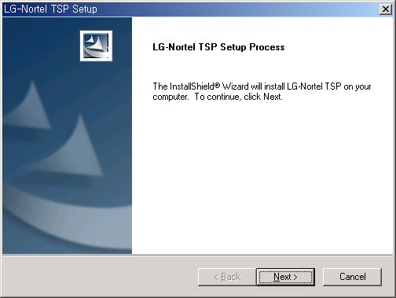

- Click [Next] button.
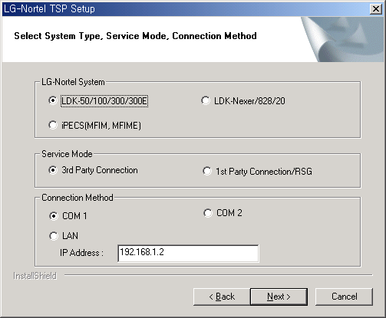

- Select each item. When you select LAN connection, you should insert IP address of LG-Nortel system as above.
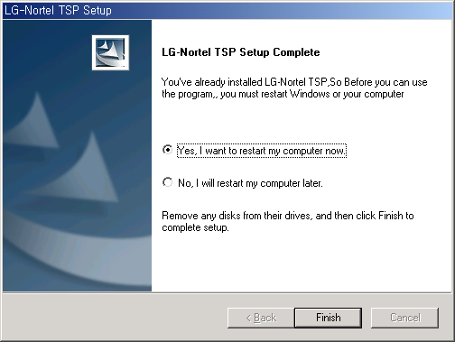

- Restart your computer to connect between LG-Nortel TSP and LG-Nortel system.
- You can change the LG-Nortel TSP configurations as following
- Open [Phone and Modem Options] in Control Panel.
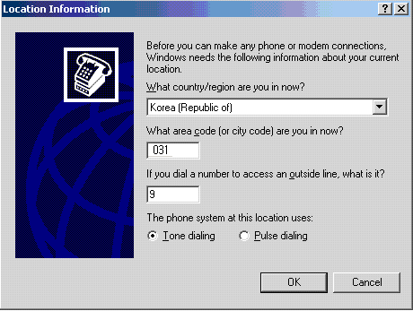
- Select country/region, insert area code and outside dial number.

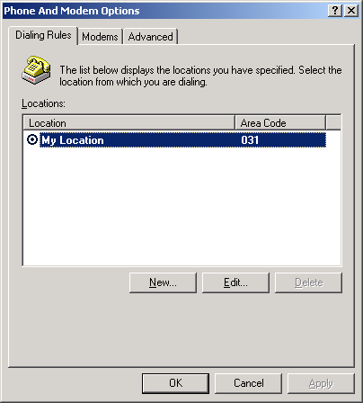

- On the [Advanced] tab under Providers, click [Telephony Service Provider for LG-Nortel System].
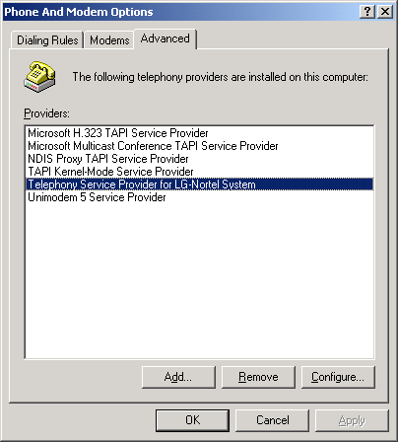
- Click [Configure…].
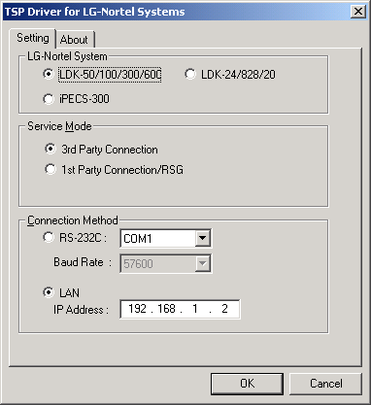

- You can change LG-Nortel TSP configurations in this dialog.
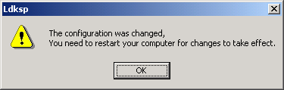

- If the configurations were changed, you should restart your computer to take effect.

1st party connection

A computer is communicating with ipLDK system directly. You should install LG-Nortel TSP on your local computer.

ipLDK-20/Nexer/ARIA SOHO

System configurations
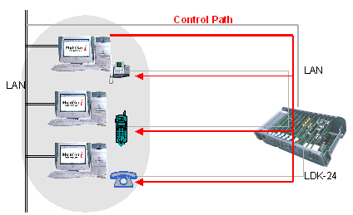

To assign a user to a line
- In PGM 125, type a client IP address in Edit box, click [Save] button.
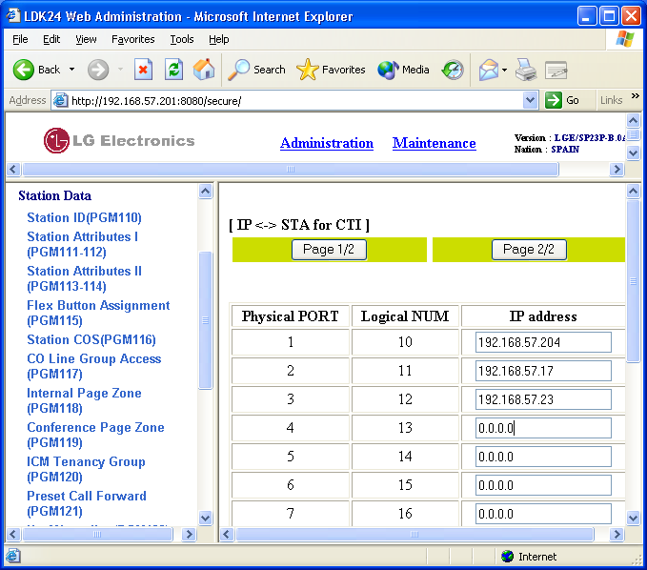

To configure a LG-Nortel TSP
- Verify LG-Nortel TSP configurations.
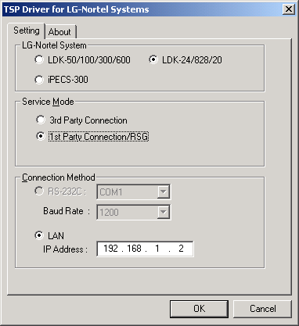
- Select ipLDK Nexer/20/ARIA SOHO in LG-Nortel System.
- Select 1st party Connection/RSG in Service Mode.
- Select LAN in Connection Method, and type IP address of ipLDK system.

ipLDK-50/100/300/600

System configurations
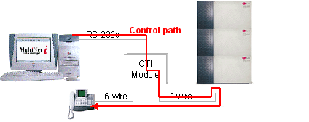
[Figure, How to use CTI Module]

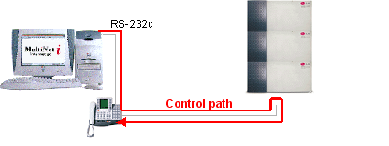
[Figure, How to use CTIU enabled keyset]

- In case of using CTI module, CTI module (Model: V70) is connected to LKD with Scout chip.
- CTIU enabled LDP keyset is available.

To configure a LG-Nortel TSP
- Verify LG-Nortel TSP configurations
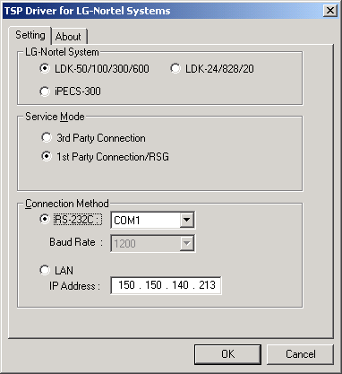
- Select ipLDK-50/100/300/600 in LG-Nortel System
- Select 1st party Connection/RSG in Service Mode
- Select COM1 or COM2, In case of RSG, LAN connection is available.

3rd party connection

For 3rd party connection, you need a Server computer (Windows 2000/2003 Server). You should install LG-Nortel TSP on Server computer. In client PC, TAPI Application is communicating with its server through RSP (Remote Service Provider).

System Configurations
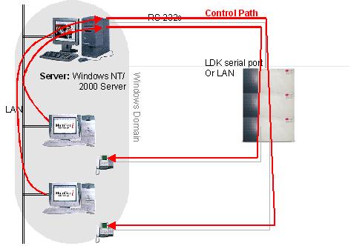

To configure a LG-Nortel TSP
- Verify LG-Nortel TSP configurations
- Select System.
- Select 3rd party connection
- In case of ipLDK-50/100/300/600, you can use anyone of connection Method. But in case of the others, only LAN connection is supported.

Telephony Server Configurations

To enable or disable a telephony server

Windows 2000/2003 Server
- Open Telephony
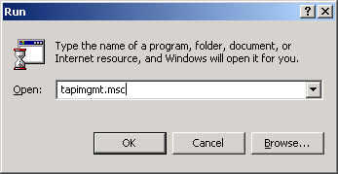
- To open Telephony on Windows 2000/2003 Server, click Start, click Run, and then type tapimgmt.msc.
- In the console tree, click the server you want to manage.
- In the Action menu, click Properties.
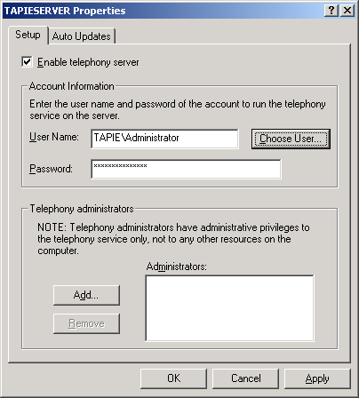
- On the Setup tab, select the Enable telephony server check box to enable the server or clear the check box to disable the server.
- When you enable the server, specify a logon account under Account Information. It must be a member of the Administrators group on the server, and also be in the same domain as the server or in a domain that has a two-way trust relationship with the domain containing the server.

This procedure changes whether clients can use the telephony devices on the server. Changes take effect the next time the system attempts to start the TAPI service.
If the Enable telephony server check box is unavailable, you need to start the Telephony service first. To manage the Telephony service, you must be a telephony administrator on the server or logged on as an administrator of the server.

To assign a telephony user to a line or phone

Windows 2000/2003 Server
- Open Telephony
- In the console tree, click Telephony Service Provider for LG-Nortel System.
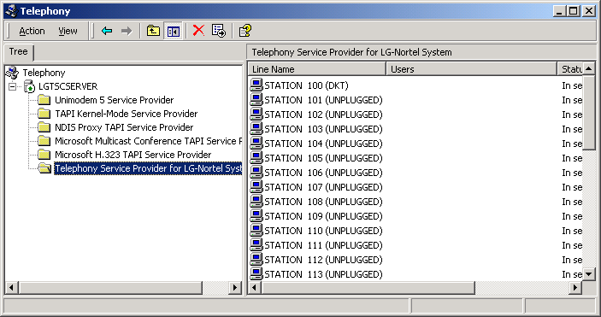

- In the details pane, under Line Name or Phone Name, click the line or phone.
- In the Action menu, click Edit Users, and then click Add.
- In Look in, click the domain containing the user.
- In the list, select the user, and then click Add.

This procedure permits TAPI client programs run by the user to use the line or phone on the server. A user added for a phone or line must be in the same domain as the TAPI server or in a domain that has a two-way trust relationship with the domain containing the server. Before a user can use the telephony line or phone, the TAPI server must be specified on the client computer.

To remove users from telephony lines or phones

Windows 2000/2003 Server
- Open Telephony.
- In the console tree, click Telephony Service Provider for LG-Nortel System.
- In the details pane, under Line Name or Phone Name, click the line or phone.
- In the Action menu, click Edit Users.
- In Assigned Users, click a user, and then click Remove.

After you perform this procedure, TAPI client programs run by the user will be unable to use the line or phone on the TAPI server.

Client Computer Configurations

To specify telephony servers on a client computer

Windows 2000/XP
- Open a Command Prompt window.
- Type Tcmsetup /c server1 server2….

To open a Command Prompt window, click Start, point to Programs, point to Accessories, and then click Command Prompt.
The TAPI client is installed with the Microsoft Windows 2000 operating system, but you need to perform this procedure to specify servers for the client. The client must be in the same domain as the server or in a fully trusted domain.
You must log on to the client as an administrator to perform this command. If you are logged on to a computer in the Users or Power Users group, you can use the runas command to run tcmsetup as an administrator, for example:
  - runas /user:mydomain\myname “tcmsetup /c servername”
You may have to restart the Telephony service for this change to take effect.

When you use Windows Server 2003, the following service pack should be installed on a client computer.
  - Windows 2000 Professional: Service Pack 5 or later.
  - Windows XP Home: Service Pack 2 or later.
  - Windows XP Professional: Service Pack 2 or later.

Windows 98
- On a Windows 95 or Windows 98 TAPI client computer, click Start, point to Settings, and then click Control Panel.
- Double-click Network.
- (Optional) If Client for Microsoft Networks is not in the list of installed network components, click Add, and follow the instructions to add it.
- Click File and Print Sharing, conform that both check boxes are selected, and then click OK.
- Click the Access Control tab, click User-level access control, and then click OK.
- Open a Command Prompt window, type tcmsetup /c servername.

After you complete this procedure, you need to specify a TAPI server on the client. To make the telephony resources on the server available to the client users, the server administrator needs to assign the users to telephones or lines on the server. Users must log onto a valid domain account.
A Windows 95 TAPI client must be upgraded to TAPI2.1 to use the TAPI services provided by a Windows 2000 TAPI server.

Client disable from telephony servers
  - Open a Command Prompt window.
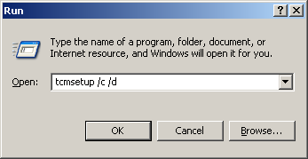
  - tcmsetup /c /d

Client user cannot see the lines or phones.

Support For TAPI Functions

Line Device Functions
The following Sections describe TAPI Line Device functions supported by LG-Nortel TSP.
For more information about TAPI functions, refer to the Microsoft Windows Telephony Application Programmer’s Guide.

TAPI Function | LG-Nortel TSP Support
lineAddProvider | Supported (TAPI itself).
lineAddToConference | Supported.
lineAnswer | Supported.
lineBlindTransfer | Supported.
lineClose | Supported.
lineCompleteCall | Supported.
lineCompleteTransfer | Supported.
lineConfigProvider | Supported (TAPI itself).
lineDeallocateCall | Supported (TAPI itself).
lineDevSpecific | Supported.
lineDial | Supported.
lineDrop | Supported.
lineForward | Supported.
lineGenerateDigits | Supported.
lineGetAddressCaps | Supported.
lineGetAddressID | Supported.
lineGetAddressStatus | Supported.
lineGetCallInfo | Supported.
lineGetCallStatus | Supported.
lineGetConfRelatedCalls | Supported.
lineGetCountry | Supported (TAPI itself).
lineGetDevCaps | Supported.
lineGetID | Supported.
lineGetLineDevStatus | Supported.
lineGetMessage | Supported (TAPI itself).
lineGetNewCalls | Supported.
lineGetProviderList | Supported (TAPI itself).
lineGetStatusMessages | Supported.
lineHold | Supported.
lineInitializeEx | Supported.
lineMakeCall | Supported.
lineNegotiateAPIVersion | Supported.
lineNegotiateExtVersion | Supported.
lineOpen | Supported.
TAPI Function | LG-Nortel TSP Support
linePark | Supported.
linePickup | Supported.
linePrepareAddToConference | Supported.
lineRedirect | Supported.
lineReleaseUserUserInfo | Supported.
lineRemoveFromConference | Supported.
lienRemoveProvider | Supported (TAPI itself).
lineSendUserUserInfo | Supported.
lineSetCallData | Supported.
lineSetCallPrivilege | Supported.
lineSetStatusMessages | Supported.
lineSetupConference | Supported.
lineSetupTransfer | Supported.
lineShutdown | Supported.
lineSwapHold | Supported.
lineTranslateAddress | Supported (TAPI itself).
lineTranslateDialog | Supported (TAPI itself).
lineUncompleteCall | Supported.
lineUnhold | Supported.
lineUnpark | Supported.

The followings are more detail descriptions of ipLDK-supporting TAPI functions. It was referred to MSDN Library.

lineAnswer
The lineAnswer function answers the specified offering call. The function is completed asynchronously.
  - LG-Nortel TSP supports the user-user information in the lpsUserUserInfo.
LONG lineAnswer(
HCALL hCall,
LPCSTR lpsUserUserInfo,
DWORD dwSize
);
  - SLT cannot use this function.

lineCompleteCall
The lineCompleteCall function specifies how a call that could not be connected normally should be completed instead. The network or switch may not be able to complete a call because network resources are busy or the remote station is busy or doesn't answer. The application can request that the call be completed in one of a number of ways. The function is completed asynchronously.
  - LINECALLCOMPLMODE_CALLBACK: A user can use this completion mode when the called user does not answer or the station status of the called user is DND(Do Not Disturb)
LONG lineCompleteCall(
HCALL hCall,
LPDWORD lpdwCompletionID,
DWORD dwCompletionMode,
DWORD dwMessageID
);
  - LINECALLCOMPLMODE_CAMPON: A user can use this completion mode when the station status of t he called user is busy.
  - LINECALLCOMPLMODE_INTRUDE: When the called user does not answer the call, the Attendant user can use this completion mode.
  - LINECALLCOMPLMODE_MESSAGE: When the called user does not answer the call, the caller user leaves a voice message.

lineDevSpecific
The lineDevSpecific function enables service providers to provide access to features not offered by other TAPI functions. The meanings of the extensions are device specific, and taking advantage of these extensions requires the application to be fully aware of them. The function is completed asynchronously.
  - dwAddressID must be zero.
LONG lineDevSpecific(
HLINE hLine,
DWORD dwAddressID,
HCALL hCall,
LPVOID lpParams,
DWORD dwSize
);

LG-Nortel TSP supports the following device-specific functions. Some features are supported only in the 3rd party mode:

- Paging
“PAGE/xx…x” in the lpParams field where xx…x is:
- INT_PAGE_Z01 ~ INT_PAGE_Z35: Announce your voice to the internal zone (01~35).
- INT_ALL_CALL: Announce your voice to all internal zones.
- EXT_PAGE_Z01 ~ EXT_PAGE_Z03: Announce your voice to the external zone (01~03).
- EXT_ALL_CALL: Announce your voice to all external zones.
- ALL_CALL: Announce your voice to all external and internal zones.
- MEET_ME: Answer and connect the announcing call.
This function can be used when the call (hCall) is in the following status.
- in an idle status
- in an dial status
- in the status of hearing a dial tone, an error tone, or a busy tone
If a wrong lpParams is transferred, or the line device does not have a page access right, or anyone is using a page function, or there is no member in the transferred page zone, the lResult actual parameter of the corresponding ASYNC_COMPLETION is LINEERR_OPERATIONFAILED. The function is completed successfully
Ex) If you want to announce your voice to all internal zones, include the following codes to your application source code. Most device-specific functions use the similar method to the following source code.
char lpParam[]=”PAGE/INT_ALL_CALL”;
lineDevSpecific( hLine, dwAddressID, hCall, (LPVOID)lpParam, sizeof(lpParam) );

- DVU (Digitized Voice Unit)
“DVU/xx…x” in the lpParams field where xx…x is:
- DATE; voice announcement of the date and the time.
- STANO; voice announcement of the number of the station
- OUTMSG_REC; record customer message
- OUTMSG_DEL; delete customer message
- OUTMSG_PLAY; play customer message
- STA_STATUS; voice announcement of the following information of the station
- Station Number
- ICM Signaling Mode
- Number of Message Waiting
- Wake-up Time
- DND state
- Forwarded to other station
- Forwarded to Speed Bin
- Station COS X

- PAGEMSG_REC; record page announcement
- PAGEMSG_DEL; delete page announcement
- PAGEMSG_PLAY; play page announcement
- MSGWAIT_PLAY; play the message queued
- MSGWAIT_DEL; delete the current message
- MSGWAIT_PLAY_NEXT; play next message queued
- MSGWIAT_REW: rewind the message due to admin setting.
- MSGWAIT_ADD: add voice message.
- MSGWAIT_CALLBACK: With CLI, make call to an external.
- FORWARD_UNCOND: set incoming call to forward to DVU unconditionally.
- FORWARD_BUSY: set incoming call to forward to DVU when It is busy.
- FORWARD_NOANSW: set incoming call to forward to DVU when it is no answer
- FORWARD_BUSYNA: set incoming call to forward to DVU when it is busy and no answer.

This function with lpParams not related to Message-waiting can be used in an idle status or in the status of hearing a dial tone. This function with lpParams of MSGWAIT_PLAY can be used in an idle status or the status of hearing a dial tone. If the application uses this when hearing a DVU message, the message will be replayed.
If a wrong lpParams is transferred, or the line device does not have a DVU access right, or DVU board is not installed, or there is not available channel, or memory is insufficient, the lResult actual parameter of the corresponding ASYNC_COMPLETION is LINEERR_OPERATIONFAILED.

- Get SMDR (Station Message Detail Recording) Data
“SMDR/x” in the lpParams field where x is:
- B (Begin)
- E (End)
This function enables or disables the application to receive the SMDR data. If the application uses this function with lpParams of “SMDR/B”, the LG-Nortel TSP will send the application the device-specific message of SMDR whenever the SMDR data occurs from ipLDK system, and then, you can get the SMDR data using lineGetAddressStatus function. If the application doesn’t want to receive any SMDR data from ipLDK, use this function with lpParams of “SMDR/E”.
Note: ipLDK 3rd party mode only

- Get Changed Station Status
“STA_STATUS/x” in the lpParams field where x is:
- B (Begin)
- E (End)
This function enables or disables the application to receive the changed station status data. If the application uses this function with lpParams of “STA_STATUS/B”, the LG-Nortel TSP will send the application the device-specific message whenever any stations’ status is changed. The message will have the physical number of the station and the changed status data in its parameters. Refer to LINE_DEVSPECIFIC message of the status. If the application doesn’t want to receive any station status data from LG-Nortel TSP, use this function with lpParams of “STA_STATUS/E”.
The application can monitor the status changing of any station connected to the ipLDK system, even if the line of a station doesn’t be open by the application.
Note: ipLDK-50/100/300/600 1st party does not support

- Get Changed CO Line Status
“COL_STATUS/x” in the lpParams field where x is:
- B (Begin)
- E (End)
This function enables or disables the application to receive the CO line status data. If the application uses this function with lpParams of “COL_STATUS/B”, the LG-Nortel TSP will send the application the device-specific message whenever the CO line status is changed. The message will have the physical number of the CO line and the changed status data in its parameters. Refer to LINE_DEVSPECIFIC message of the status. If the application doesn’t want to receive any CO line status data from LG-Nortel TSP, use this function with lpParams of “COL_STATUS/E”.
The application can monitor the status changing of any CO line connected to the ipLDK system.
Note: ipLDK-50/100/300/600 1st party does not support

- Get All Station Status
“ALL_STA_STATUS” in the lpParams field
This function can tell the application the status of all stations. The status is described in Device Specific Data Format. After the function is completed asynchronously, the LINE_DEVSPECIFIC message is sent to the application. Then, the application can get the status data using lineGetAddressStatus function. Refer to LINE_DEVSPECIFIC message and lineGetAddressStatus function.
The application can get the status of any station connected to the ipLDK system, even if the line of a station doesn’t be open by the application.
Note: ipLDK-50/100/300/600 1st party does not support

- Get All CO Line Status
“ALL_COL_STATUS” in the lpParams field
This function can tell the application the status of all CO lines. The status is described in Device Specific Data Format. After the function is completed asynchronously, the LINE_DEVSPECIFIC message is sent to the application. Then, the application can get the status data using lineGetAddressStatus function. Refer to LINE_DEVSPECIFIC message and lineGetAddressStatus function.
The application can get the status of any CO line connected to the ipLDK system.
Note: ipLDK-50/100/300/600 1st party does not support

- Get System Time
“GETTIME” in the lpParams field
This function can tell the application current LG-Nortel TSP server time. After the function is completed asynchronously, the LINE_DEVSPECIFIC message is sent to the callback function. Refer to LINE_DEVSPECIFIC.
Note: 3rd party mode only

- Set CO Line Hold Type
“CO_HOLD/xxx” in the lpParams field where xxx is:
- EXC(Exclusive Hold)
- SYS(System Hold)
This function sets the holding type of CO line. If an application holds a CO line using lineHold, the CO line will be held with the type that the application sets using this function. For example, after an application uses this function with “CO_HOLD/SYS” in the lpParams field, the CO line held with the function Error: Reference source not found will be on system holding. The default type of holding is Exclusive Hold.

- Get Station’s Logical Number
“STA_NUM/xxx” in the lpParams field where “xxx” is the physical number of the station (eg. 001, 010, 100)
This function asks LG-Nortel TSP to return the logical number (station number) of the station. After asynchronous successful response of this function, the application will receive the LINE_DEVSPECIFIC message, which contains the physical number and the logical number of the station in its parameters. Refer to LINE_DEVSPECIFIC.
Note: ipLDK-50/100/300/600 1st party does not support

- Get All Stations’ Logical Numbers
“ALL_STA_NUM” in the lpParams field
This function asks LG-Nortel TSP to return the logical numbers (station number) of all stations. After asynchronous successful response of this function, the application will receive the LINE_DEVSPECIFIC message. Then, the application can get the logical numbers of all stations by using lineGetAddressStatus function. Refer to LINE_DEVSPECIFIC message and lineGetAddressStatus function.
Note: ipLDK-50/100/300/600 1st party does not support

- Get Station Information
“STA_INFO/xxx” in the lpParams field where “xxx” is the physical number of the station (eg. 001, 010, 100)
This function asks LG-Nortel TSP to prepare to provide the information of the station, which has the physical number of “xxx.” After asynchronous successful response of this function, the application will receive the LINE_DEVSPECIFIC message. Then, the application can get the information of the station by using lineGetAddressStatus function. Refer to LINE_DEVSPECIFIC message and lineGetAddressStatus function.
Note: ipLDK-50/100/300/600 1st party does not support

- Get CO Line Information
“COL_INFO/xxx” in the lpParams field where “xxx” is the physical number of the CO line (eg. 001, 010, 100)
This function asks LG-Nortel TSP to prepare to provide the information of the CO line, which has the physical number of “xxx.” After asynchronous successful response of this function, the application will receive the LINE_DEVSPECIFIC message. Then, the application can get the information of the station by using lineGetAddressStatus function. Refer to LINE_DEVSPECIFIC message and lineGetAddressStatus function.
Note: ipLDK-50/100/300/600 1st party does not support

- Get All Park Number
“ALL_PARK_NUM” in the lpParams field.
This function asks LG-Nortel TSP to prepare to provide the information of all park number. After asynchronous successful response of this function, the application will receive the LINE_DEVSPECIFIC message. Then, the application can get the information of the station by using lineGetAddressStatus function. Refer to LINE_DEVSPECIFIC message and lineGetAddressStatus function.
Note: 3rd party mode only

- Dummy Station Log on
“LOGON/xxxx/yyyyy” in the lpParams field where xxxx, yyyyy are:.
xxxx: Station Number (3 or 4 digits)
yyyyy: Password (5 digits)

- Dummy Station Log off
“LOGOFF/xx…xx” in the lpParams field where xx…xx is:.
  - NOCHANGE
  - VMIB
  - VMGROUP/yyyy, yyyy is a VM group number
  - VMIB
  - MOBILE
  - STATION/xxxx, xxxx is a station number. Forward to Station.

- UCD DND Log on/off in UCD group
“UCD_DND_ON/xxxx” in the lpParams: Activate UCD DND.
“UCD_DND_OFF/xxxx” in the lpParams: Deactivate UCD DND.
  - xxxx is a UCD group number.

“S_UCD_DND_ON/xxxx/yyyy” in the lpParams: Activate UCD DND by Supervisor.
“S_UCD_DND_OFF/xxxx/yyyy” in the lpParams: Activate UCD DND by Supervisor.
  - xxxx is a UCD group number.
  - yyyy is a station number (3 or 4 digits)

- Make/delete Conference Room
“CONF_ROOM/E/xxx/yyyyy” in the lpParams: Activate Conference Room.
“CONF_ROOM/E/xxx/yyyyy” in the lpParams: Deactivate Conference Room.
  - xxxx is a Conference Room number.
  - yyyyy is a password.

- Get Call ID in a ACD group
“CO_CALLID /xxx” in the lpParams.
  - xxxx is a ACD Group number.

- Call Answer by Call ID
“CO_CALLID_ANS /xxx” in the lpParams.
  - xxxx is a Call ID number.

lineDial
The lineDial function dials the specified dialable number on the specified call. The function is completed asynchronously.
- Account Code
LONG lineDial(
HCALL hCall,
LPCSTR lpszDestAddress,
DWORD dwCountryCode
);
“AC/xx…x” in the lpszDestAddress field where xx…x are account code digits which are within 12 digits.
These digits will be included in the SMDR data record. These can be used to allocate cost or time for the call.
This function can be used when the call (hCall) is in the connected status.

lineForward
The lineForward function forwards calls destined for the specified address on the specified line, according to the specified forwarding instructions. When an originating address (dwAddressID) is forwarded, the specified incoming calls for that address are deflected to the other number by the switch. This function provides a combination of forward and do-not-disturb features. This function can also cancel forwarding currently in effect. The function is completed asynchronously.
  - dwAddressID must be zero.
LONG lineForward(
HLINE hLine,
DWORD bAllAddresses,
DWORD dwAddressID,
LPLINEFORWARDLIST const lpForwardList,
DWORD dwNumRingsNoAnswer,
LPHCALL lphConsultCall,
LPLINECALLPARAMS const lpCallParams
);
  - LG-Nortel TSP supports the following functions:
- DND (Do Not Disturb)
lpForwardList→ForwardList[0].dwDestAddressSize to NULL.
- Forward all calls unconditionally.
lpForwardList→ForwardLIst[0].dwForwardMode to LINEFORWARDMODE_UNCOND.
- Forward any calls on busy.
lpForwardList→ForwardLIst[0].dwForwardMode to LINEFORWARDMODE_BUSY.
- Forward any calls on no answer.
lpForwardList→ForwardLIst[0].dwForwardMode to LINEFORWARDMODE_NOANSW.
- Forward any calls on busy/no answer.
lpForwardList→ForwardLIst[0].dwForwardMode to LINEFORWARDMODE_BUSYNA.

lineGetAddressStatus
The lineGetAddressStatus function allows an application to query the specified address for its current status.
In the structure of lpAddressStatus, LG-Nortel TSP fills dwDevSpecificSize, dwDevSpecificOffset and the corresponding data field. Especially, LG-Nortel TSP can return SMDR, All Station Status, All CO Line Status, Station Information, CO Line Information, and All Station’s Numbers. If a TAPI application want to get those data, those data receiving process must be started with lineDevSpecific function related to those data. Whenever those data occurs, the LINE_DEVSPECIFIC message is sent to the callback function. Then, the application can get those data using this function. Refer to lineDevSpecific function (SMDR, All Station Status, All CO Line Status, Station Information, CO Line Information, and All Station’s Number),
LONG lineGetAddressStatus(
HLINE hLine,
DWORD dwAddressID,
LPLINEADDRESSSTATUS lpAddressStatus
);

lineGetCallInfo
The lineGetCallInfo function enables an application to obtain fixed information about the specified call.
LG-Nortel TSP fills dwCallerID, dwCallerIDName, dwCalledID, dwCalledIDName, dwConnectedID, dwConnectedIDName when proper ID and Name is received. The dwRedirectingID and dwRedirectingIDName are provided to the ringing station when the DID incoming call is forwarded from a station to another station. The dwRedirectionID and dwRedirectionIDName are unavailable.
LONG lineGetCallInfo(
HCALL hCall,
LPLINECALLINFO lpCallInfo
);

lineMakeCall
The lineMakeCall function places a call on the specified line to the specified destination address. Optionally, call parameters can be specified if anything but default call setup parameters are requested. The function is completed asynchronously.
LG-Nortel TSP supports the following functions:
LONG lineMakeCall(
HLINE hLine,
LPHCALL lphCall,
LPCSTR lpszDestAddress,
DWORD dwCountryCode,
LPLINECALLPARAMS const lpCallParams
);
- CO Call
“Cxx…x” or “@xx…x” in the lpszDestAddress field where xs are 0 through 9,*, and #. The front three xs represent CO line number and the following digits are real dialing numbers.
- CO Group Call
“Gxx…x” or “$xx…x” in the lpszDestAddress field where xs are 0 through 9, *, and #. The front three xs represent CO line group number and the following digits are real dialing numbers.
- Networking Call
“xxx” in the lpszDestAddress field where xxx is extension number or station group number.
- Outside/Long distance Call
“ss…sxx…x” in the lpszDestAddress field where ss…s is the Outside Access or Long distance Access string you have described at Telephony of Control Panel in your computer, and the following digits are real dialing number. The same response, that comes out when you Dial 9(0 in some countries) and the following digits in your keyset, will come out.
LG-Nortel TSP ignores the value in the dwCountryCode field. Also, the following four special functions are supported:

- Station Speed Dial
“SPD/xx…x” in the lpszDestAddress field where xx…x is:
- “Cyyyzzz” or “@yyyzzz” where yyy is CO number and zzz is speed dial number.
- “Gyyyzzz” or “$yyyzzz” where yyy is CO group number and zzz is speed dial number.
- “zzz” where zzz is speed dial number.(000 ~ 099)

- System Speed Dial
“SPD/xx” in the lpszDestAddress field where x is:
- “Cyyyzzzz” or “@yyyzzzz” where yyy is CO line number and zzzz is system speed dial number.
- “Gyyyzzzz” or “$yyyzzzz” where yyy is CO group number and zzzz is system speed dial number.
- “zzzz” where zzzz is system speed dial number.(2000 ~ 4999)

- Last Number Redial(LNR)
“LNR/xx…x” in the lpszDestAddress field where x is:
- “Cyyy” or “@yyy” where yyy is CO line number.
- “Gyyy” or “$yyy” where yyy is CO group number.
- (None)

- Save Number Redial(SNR)
“SNR/xx…x” in the lpszDestAddress field where x is:
- “Cyyy” or “@yyy” where yyy is CO line number.
- “Gyyy” or “$yyy” where yyy is CO group number.
- (None)

- Make a call to a Conference Room
“xxx/yyyyy” in the lpszDestAddress field where x is:
    - “xxx” is a Conference Room number.
    - “yyyyy” is a password.

lineNegotiateAPIVersion
The lineNegotiateAPIVersion function allows an application to negotiate an API version to use.
The negotiated API version number of LG-Nortel TSP with the pointer lpdwAPIVersion is
LONG lineNegotiateAPIVersion(
HLINEAPP hLineApp,
DWORD dwDeviceID,
DWORD dwAPILowVersion,
DWORD dwAPIHighVersion,
LPDWORD lpdwAPIVersion,
LPLINEEXTENSIONID lpExtensionID
);
Low Version: 0x00010004
High Version: 0x00020001
The extension identifiers of LG-Nortel TSP in the structure pointed by lpExtensionID are
lpExtensionID->dwExtensionID0: 0x0ccb18c0
lpExtensionID->dwExtensionID1: 0x10202109
lpExtensionID->dwExtensionID2: 0x80002f8d
lpExtensionID->dwExtensionID3: 0xf354241e

lineNegotiateExtVersion
The lineNegotiateExtVersion function allows an application to negotiate an extension version to use with the specified line device. This operation need not be called if the application does not support extensions.
The negotiated extension version of LG-Nortel TSP with the pointer lpdwExtVersion is
LONG lineNegotiateExtVersion(
HLINEAPP hLineApp,
DWORD dwDeviceID,
DWORD dwAPIVersion,
DWORD dwExtLowVersion,
DWORD dwExtHighVersion,
LPDWORD lpdwExtVersion
);
Low Version: 0x00020001
High Version: 0x00020001

linePark
The linePark function parks the specified call according to the specified park mode. The function is completed asynchronously.
LINEPARKMODE_NONDIRECTED in the field dwParkMode is applied only in 3rd party mode.
LONG linePark(
HCALL hCall,
DWORD dwParkMode,
LPCSTR lpszDirAddress,
LPVARSTRING lpNonDirAddress
);

lineRedirect
The lineRedirect function redirects the specified offering call to the specified destination address.
If the offering call is external call, LG-Nortel TSP can support only the redirection of DID call.
LONG lineRedirect(
HCALL hCall,
LPCSTR lpszDestAddress
DWORD dwCountryCode
);

lineSetStatusMessages
The lineSetStatusMessages function enables an application to specify which notification messages to receive for events related to status changes for the specified line or any of its addresses.
If this function is executed, you will receive the following messages:
LONG lineSetStatusMessages(
HLINE hLine,
DWORD dwLineStates,
DWORD dwAddressStates
);
  - The number of Message Wait.
  - The number of voice message
  - Forward information
  - The range of conference room (ipipLDK or later version)

Phone Device Functions
The TAPI phone-device class functions supported by LG-Nortel TSP are described in the following table:

Function | LG-Nortel TSP Support
phoneClose | Supported.
phoneDevSpecific | Supported.
phoneGetData | Supported.
phoneGetDevCaps | Supported.
phoneGetID | Supported.
phoneInitializeEx | Supported.
phoneNegotiateAPIVersion | Supported.
phoneNegotiateExtVersion | Supported.
phoneOpen | Supported.
phoneShutdown | Supported.

phoneDevSpecific
The phoneDevSpecific function is used as a general extension mechanism to enable a Telephony API implementation to provide features not described in the other TAPI functions. The meanings of these extensions are device specific.
LG-Nortel TSP supports the following device-specific functions:
LONG phoneDevSpecific(
HPHONE hPhone,
LPVOID lpParams,
DWORD dwSize
);
- Wake-Up
“WU/xx…x” in the lpParams field where xx…x is:
- HHMM (HH:hour, MM:minute)
- HHMM/S (S:once)
- HHMM/C (C:continuous)
- CURR (current): to get current wake up time. You will get the “none” string if current wake up time does not be set.
- DELE (delete): to delete current wake up time.
- Authorization Code/Password
“ACP/xx…x” in the lpParams field where xx…x is:
- yyyyy/zzzzz (yyyyy : old password, zzzzz : new password) where each y and z is 0 through 9,*, and #.
- NEWPW/yyyyy (yyyyy : new password) where y is 0 through 9,*, and #.
- CURPW: to get current password. If there is no current password, ipLDK system returns “NOPAS.”

- Temporal Station COS Change
“TSCC/xx…x” in the lpParams field where xx…x is:
- D (down)
- C (current)
- R/yyyyy where yyyyy is password
- Preselected Message Program
“PMP/xx…x” in the lpParams field where xx…x is:
- A message string that can contain alphabet, :, (, ), 0 through 9, or space character within 24 letters.
- /CUR (current message), PMP//CUR
- /DEL (delete message), PMP//DEL
- ICM Answer Mode
“IAM/x” in the lpParams field where x is:
- H (hands free mode)
- T (tone ring mode)
- P (privacy mode)
- C (current)
- BGM Assignment
“BGM/xx” in the lpParams field where x is:
- 00 (No use)
- 01 (BGM Channel 1)
- 02 (BGM Channel 2)
- 03 (BGM Channel 3)
- 04 (BGM Channel 4)
- 05 (BGM Channel 5)
- 06 (BGM Channel 6)
- 07 (BGM Channel 7)
- 08 (BGM Channel 8)
- 09 (BGM Channel 9)
- 10 (BGM Channel 10)
- 11 (BGM Channel 11)
- 12 (BGM Channel 12)
- Cu(Current BGM Channel)

- Preselected Message Selection
“PMS/mm/xx…x” in the lpParams field where mm is:
- 00: Display preselected message programmed in each station. “/xx…x” must not be set.
- 01: Display “LUNCH / RETURN AT hh:mm” where xx…x is hhmm.
- 02: Display “ON VACATION / RETURN AT dd mon” where xx…x is ddmm.
- 03: Display “OUT OF OFFICE / RETURN AT hh:mm” where xx…x is hhmm.
- 04: Display “OUT OF OFFICE / RETURN AT dd mon” where xx…x is mmdd.
- 05: Display “OUT OF OFFICE / RETURN UNKNOWN” where /xx…x must not be set.
- 06: Display “CALL : telephone number” where xx…x is telephone number (Max: 18 digits).
- 07: Display “IN OFFICE : STA ssss” where xx…x is ssss.
- 08: Display “IN A MEETING / RETURN TIME hh:mm” where xx…x is hhmm.
- 09: Display “AT HOME.” “/xx…x” must not be set.
- 10: Display “AT BRANCH OFFICE” where /xx…x must not be set.
- 11 – 20: Display preselected messages programmed in attendant..
- 21: Current preselected message where /xx…x must not be set.
- 99: Unset current preselected message.
- Differential Ring (Digital Keyset Only)
“DR/x” in the lpParams field where x is:
- 1 ~ 4 (Ring Type)
- 0 (Current Ring Type)
- LCD Language Mode
“LLM/x” in the lpParams field where x is:
- 0 (English)
- 1 (Corresponding Country)
- 2 (Current)
- Headset Mode Program
“HMP/x” in the lpParams field where x is:
- 0 (Headset mode off)
- 1 (Headset mode on)
- 2 (Current)

phoneGetData
The phoneGetData function uploads the information from the specified location in the open phone device to the specified buffer.
LONG phoneGetData(
HPHONE hPhone,
DWORD dwDataID,
LPVOID lpData,
DWORD dwSize
);
LG-Nortel TSP supports the following functions:
- Wake-Up
“0x01” in the dwDataID field
The lpData field and its meaning are:
- DELET: No setting
- HHMMF where HH:hour, MM:minute, F: C(continuous)/S(single)
- Authorization Code/Password
“0x02” in the dwDataID field
The lpData field and its meaning are:
- NOPAS: No password
- xxxxx: Current password
- Temporal Station COS Change
“0x03” in the dwDataID field
The lpData field and its meaning are:
- D: COS Down
- R: COS Restored
- Preselected Message Program
“0x04” in the dwDataID field
The lpData field and its meaning are:
- xx…x: null terminated string
- ICM Answer Mode
“0x05” in the dwDataID field
The lpData field and its meaning are:
- H: hands free
- T: Tone ring
- P: Privacy
- BGM Assignment
“0x06” in the dwDataID field
The lpData field and its meaning are:
- 0: not in use
- x: channel no(1 or 2)
- Preselected Message Selection
“0x07” in the dwDataID field
The lpData field and its meaning are:
- /mm/xx…x where mm is message number and xx…x is the related string. Refer to phoneDevSpecific function
- Differential Ring (Digital Keyphone Only)
“0x08” in the dwDataID field
The lpData field and its meaning are:
- x: ring type(1-4)

- LCD Language Mode
“0x09” in the dwDataID field
The lpData field and its meaning are:
- 0: English
- 1: Domestic

- Headset/Speakerphone Mode Program
“0x0B” in the dwDataID field
The lpData field and its meaning are:
- 0: Off
- 1: On

phoneNegotiateAPIVersion
The phoneNegotiateAPIVersion allows an application to negotiate an API version to use for the specified phone device.
The negotiated API version number of LG-Nortel TSP with the pointer lpdwAPIVersion is
LONG phoneNegotiateAPIVersion(
HPHONEAPP hPhoneApp,
DWORD dwDeviceID,
DWORD dwAPILowVersion,
DWORD dwAPIHighVersion,
LPDWORD lpdwAPIVersion,
LPPHONEEXTENSIONID lpExtensionID
);
Low Version: 0x00010004
High Version: 0x00020001
The extension identifiers of LG-Nortel TSP in the structure pointed by lpExtensionID are
lpExtensionID->dwExtensionID0: 0x7bdc3120
lpExtensionID->dwExtensionID1: 0x10204a78
lpExtensionID->dwExtensionID2: 0x8000318d
lpExtensionID->dwExtensionID3: 0xf354241e

PhoneNegotiateExtVersion

The phoneNegotiateExtVersion function allows an application to negotiate an extension version to use with the specified phone device. This operation need not be called if the application does not support extensions.

The negotiated extension version of LG-Nortel TSP with the pointer lpdwExtVersion is
LONG phoneNegotiateExtVersion(
HPHONEAPP hPhoneApp,
DWORD dwDeviceID,
DWORD dwAPIVersion,
DWORD dwExtLowVersion,
DWORD dwExtHighVersion,
LPDWORD lpdwExtVersion
);
Low Version: 0x00020001
High Version: 0x00020001

Device Specific Messages

LINE_DEVSPECIFIC
The LINE_DEVSPECIFIC message is sent to notify the application about device-specific events occurring on a line, address, or call. The meaning of the message and the interpretation of the parameters are described below.
LG-Nortel TSP sends this message to application to notify the following events:
LINE_DEVSPECIFIC
dwDevice = (DWORD) hLineOrCall;
dwCallbackInstance = (DWORD) hCallback;
dwParam1 = (DWORD) DeviceSpecific1;
dwParam2 = (DWORD) DeviceSpecific2;
dwParam3 = (DWORD) DeviceSpecific3;
- SMDR, All Station Status, All CO Line Status have received. (Refer to lineDevSpecific function)
hLine in the dwDevice field,
“0x01” in the dwParam1 field.
- SMDR data is received.
“0x01” in the dwParam2 field.
- All Station Status data is received.
“0x04” in the dwParam2 field.
- All CO Line Status data is received.
“0x05” in the dwParam2 field.
- All Station Numbers are received..
“0x08” in the dwParam2 field.
- Station Information is received.
“0x09” in the dwParam2 field.
- CO line Information is received.
“0x0A” in the dwParam2 field.
- All Park Numbers are received.
“0x0B” in the dwParam2 field.
- CO Call IDs are received.
“0x10” in the dwParam2 field.

After receiving this message, the application can get the data using lineGetAddressStatus function.
Note: 3rd party mode only

- The UserUserInfo data have been accumulated over 2.
hCall in the dwDevice field,
“0x02” in the dwParam1 field,
“xx” in the dwParam2 field where xx is the number of accumulated UserUserInfo data.

- The response of “Get System Time” in lineDevSpecific function has received.
hLine in the dwDevice field,
“0x03” in the dwParam1 field,
“yyyymmmm” in the dwParam2 field where yyyy is year, mmmm is month,
“ddhhmmss” in the dwParam2 field where dd is date, hh is hour, mm is mimute, ss is second.

- The MSGWait (ICM number) has received.
hLine in the dwDevice field,
“0x04” in the dwParam1 field,
“x” in the dwParam2 field where x is 0x01(ON) or 0x00(OFF),
“y” in the dwParam3 field where y is the station number which leave the waiting message (DWORD).

- DVU MSG has received.
hLine in the dwDevice field,
“0x05” in the dwParam1 field,
“0x01” in the dwParam2 field,
“x” in the dwParam3 field where x is received DVU message number.

- DND state has changed.
hLine in the dwDevice field,
“0x06” in the dwParam1 field,
“0x01” in the dwParam2 field,
“x” in the dwParam3 field where x is 0x01(ON) or 0x00(OFF).

- The station’s state has changed to DVU Forwarded.
hLine in the dwDevice field,
“0x06” in the dwParam1 field,
“0x02” in the dwParam2 field.

- Station number related to physical number is sent.
hLine in the dwDevice field,
“0x07” in the dwParam1 field,
“x” in the dwParam2 field where x is the physical number of the station in DWORD, which has described in lineDevSpecific function,
“y” in the dwParam3 field where y is the station number of the station, x, in 4-byte characters.
Note: 3rd party mode only

- Station Status has changed.
hLine in the dwDevice field,
“0x08” in the dwParam1 field,
“x” in the dwParam2 field where x is the physical number of the station in DWORD,
“y” in the dwParam3 field where y is the changed status of the station. (Status is described in Device Specific Data Format)
Note: 3rd party mode only

- CO Line Status has changed.
hLine in the dwDevice field,
“0x09” in the dwParam1 field,
“x” in the dwParam2 field where x is the physical number of the CO line in DWORD,
“y” in the dwParam3 field where y is the changed status of the CO line. (Status is described in Device Specific Data Format)
Note: 3rd party mode only

- My Station Status has changed.(Opened line’s status has changed)
hLine in the dwDevice field,
“0x0B” in the dwParam1 field,
“x” in the dwParam2 field where x is the changed status of my station in DWORD, (Status is described in Device Specific Data Format)
Note: 3rd party mode only

- Wake up ring
hLine in the dwDevice field,
“0x10” in the dwParam1 field,
“x” in the dwParam2 field where x is 0x01(Ring) or 0x00(Stop),

- Linked Pair
hLine in the dwDevice field,
“0x11” in the dwParam1 field,
“x” in the dwParam2 field where x is 0x01(Slave is in use) or 0x00(Stop),
Note: 1. The master receives CTI Message, but the slave doesn’t.
2. When the slave is in use, the master can’t use CTI Functions

- Park Number
hLine in the dwDevice field,
“0x12” in the dwParam1 field,
“x” in the dwParam2 field where x is the Park number.
“y” in the dwParam3 field where y is the CO line.

- Station number has changed
hLine in the dwDevice field,
“0x36” in the dwParam1 field,
“x” in the dwParam2 field where x is the Port Number
“y” in the dwParam3 field where y is the Changed Station number
- Range of Conference Room
hLine in the dwDevice field,
“0x37” in the dwParam1 field,
“x” in the dwParam2 field where x is the Start Number
“y” in the dwParam3 field where y is the Last number

- Dummy Station
hLine in the dwDevice field,
“0x38” in the dwParam1 field,
“x” in the dwParam2 field where x is 0x00(Normal Keyset) or 0x01(Dummy Keyset).
“y” in the dwParam3 field where y is 0x00(Logon State) or 0x01(Dummy State).

- UCD DND has changed
hLine in the dwDevice field,
“0x39” in the dwParam1 field,
“x” in the dwParam2 field where x is 0x00(OFF) or 0x01(ON).
“y” in the dwParam3 field where x is a UCD group number.

- Get CO Call ID & DID Number (When you call lineDevSpecific(“COL_INFO/xxx”))
hLine in the dwDevice field,
“0x40” in the dwParam1 field,
“x” in the dwParam2 field where x is a call ID.
“y” in the dwParam3 field where x is a DID number.

- The Keyset has restarted
hLine in the dwDevice field,
“0xFE” in the dwParam1 field,
“0x01” in the dwParam2 field.

- The Keyset line has been disconnected
hLine in the dwDevice field,
“0xFE” in the dwParam1 field,
“0x03” in the dwParam2 field.

Device Specific Data Format
If an application requests SMDR, All Station Status, All CO Line Status for the line device using lineDevSpecific function, LG-Nortel TSP gathers the data and sends the application message of each data. Then, the application can obtain the data using lineGetAddressStatus. In the LINEADDRESSSTATUS structure of the function, LG-Nortel TSP fills dwDevSpecificSize, dwDevSpecificOffset, and attaches the corresponding data, which is represented as following. (Refer to lineGetAddressStatus in this document and in Microsoft Platform SDK)

- SMDR Data Format
- SMDR_DATA : ascii string, “SMDR_DATA” (9 bytes)
0 | 1 | 2 | 3 | 4 | 5 | 6 | 7 | 8 |  | 9 | 10 | 11 | 12 | 13 | 14 | 15 | 16 | 17
S | M | D | R | _ | D | A | T | A |  | Nu | Nu | Nu | Nu | Nu | Total size
FrameNum0 |  |  |  | FrameSize0 |  |  |  | FrameData0
FrameData0(unfixed size)
FrameNum1 |  |  |  | FrameSize1 |  |  |  |  | FrameData1
FrameData1(unfixed size)
- Nu : NULL character
- TotalSize : the total size of SMDR DATA format (4 bytes)
- FrameNum : the number of FrameData (4 bytes)
- FrameSize : the size of FrameData (4 bytes)
- FrameData : SMDR data (unfixed size). Refer to the following table

Field Name | No. of bytes | Descriptions
Sequential number | 4 | Sequential number (range 0000 ~ 9999)
Space | 1
Station | 5 | Station number (2, 3, or 4 digits)  CO number (CO xxx)
Space | 1
CO | 3 | CO Line number
Time | 8 | Call time serviced, 01:10:05(HH:MM:SS)
Space | 1
Start time | 14 | Start time, 25/11/01 14:20
Space | 1
Record type | 1 | t : Incoming CO transfer  I : incoming CO (answered)  O : outgoing CO  T : outgoing CO transfer  H : hold lost  R : ring lost  G : Group call lost
Dialed digits | 18 | Dialed digits (string)
Space | 2
Account group | 2 | Account Group Number field.
Space | 1
Metering count | 5 | Call metering count (record type : O, T)
Space | 1
Call cost | 11 | Call Cost (record type : O, T)
Space | 1
Account code | 12 | Account code field.

- Station Status Data Format

- STA_STATUS : ascii string, “STA_STATUS” (10 bytes)
0 | 1 | 2 | 3 |  | 4 | 5 | 6 |  | 7 | 8 | 9 | 10 | 11 | 12 | 13 | 14 | 15
S | T | A | _ |  | S | T | A |  | T | U | S | Nu | Nu | Total size
Frame0 |  |  |  | Frame1 |  |  |  | Frame2 |  |  | …
…
- Nu : NULL character
- Total size : total size of Station Status Data Format in byte (4 bytes)
- Frame0, Frame1, … Frame_{Max} : All Station Status Data frame (3 bytes)
X : physical number of station (physical number is order of connection of the station to ipLDK system)
0 - 1 | 2
X | Y
Y : one of the following status values
 | Status | Hexa value
Station Status | ST_INVALID | 0x01
Station Status | ST_SLAVE | 0x02
Station Status | ST_HOLD | 0x11
Station Status | ST_RING | 0x12
Station Status | STEXT_IDLE | 0x40
Station Status | STEXT_IDLE_WITH_DND | 0x41
Station Status | STEXT_ICM | 0x43
Station Status | STEXT_COL | 0x44
Station Status | STEXT_PGM | 0x45
Station Status | ST_BUSY | 0x10

- CO Line Status Data Format
- COL_STATUS : ascii string, “COL_STATUS” (10 bytes)
0 | 1 | 2 | 3 |  | 4 | 5 | 6 |  | 7 | 8 | 9 | 10 | 11 | 12 | 13 | 14 | 15
C | O | L | _ |  | S | T | A |  | T | U | S | Nu | Nu | Total size
Frame0 |  |  |  | Frame1 |  |  |  | Frame2 |  |  | …
…
- Nu : NULL character
- Total size : total size of CO Line Status Data Format in byte (4 bytes)
- Frame0, Frame1, … Frame_{Max} : All CO Line Status Data frame (3 bytes)
X : physical number of CO line (physical number is order of connection of the CO line to ipLDK system)
0 - 1 | 2
X | Y
Y : one of the following status values
 | Status | Hexa value
CO Line Status | ST_INVALID | 0x01
CO Line Status | ST_HOLD | 0x11
CO Line Status | ST_RING | 0x12
CO Line Status | STTRK_IDLE | 0x80
CO Line Status | STTRK_HOLD_RECALL | 0x81
CO Line Status | STTRK_HOLD_ATDRECALL | 0x82
CO Line Status | STTRK_IDLE_WITH_DISABLE | Not Support
CO Line Status | ST_BUSY | 0x10

- All Station’s Logical Number Data Format
- STA_NUMBER : ascii string, “STA_NUMBER” (10 bytes)
0 | 1 | 2 | 3 | 4 | 5 | 6 | 7 | 8 | 9 | 10 | 11 | 12 | 13 | 14 | 15
S | T | A | _ | N | U | M | B | E | R | Nu | Nu | Total Size
Nu₀ |  | Nu₁ |  | Nu₂ |  | …
… |  |  |  |  |  |  |  |  |  | Nu_{n}
- Nu : NULL character
- Total size : total size of All Station’s Logical Number Data Format in bytes (4 bytes)
- Nu₀ : logical(assigned internal) number of the first station in integer(2 byte)
- Nu₁ : logical(assigned internal) number of the second station in integer(2 byte)
- Nu_{n} : logical(assigned internal) number of the n th station in integer(2 byte)

- Station Information Data Format
- STA_INFO : ascii string, “STA_INFO” (8 bytes)
0 | 1 | 2 |  | 3 | 4 | 5 | 6 |  | 7 |  | 8 |  | 9 | 10 | 11 | 12 | 13 | 14 | 15
S | T | A |  | _ | I | N | F |  | O |  | Nu |  | Nu | Nu | Nu | Total Size
Pn |  |  | Sta Number |  |  |  |  | Sl |  | St |  | At | Ap |  | Ns | Sta Name ~
- Nu : NULL character
- Total size : total size of Station Information Data Format in byte (4 bytes)
- Pn : physical number of the station (2 byte)
- Sta Number : the number of the station in DWORD (4-byte integer)
(ex> 0x00000064 : station 100)
- Sl : slot number of the station in ipLDK system (1 byte)
- St : status of the station. Refer to the Station Status value (1 byte)
- At : type of the associated device (1 byte)
0x01 : the station is connected to a station
0x02 : the station is connected to a CO line
0x00/0xFF : the station is not connected
- Ap : physical number of the associated device (2 byte)
(ex> At = 0x02, Ap = 0x0001 : the station is now using CO line 01)
- Ns : size of the station’s name (1 byte)
- Sta Name : name of the station (size of Ns)

- CO Line Information Data Format
- COL_INFO : ascii string, “COL_INFO” (8 bytes)
0 | 1 | 2 | 3 | 4 | 5 | 6 | 7 |  | 8 | 9 | 10 | 11 | 12 | 13 | 14 | 15
C | O | L | _ | I | N | F | O |  | Nu | Nu | Nu | Nu | Total Size
Pn |  | St | At | Ap |  | Ns | Cs | CO Name
CallerID
- Nu : NULL character
- Total size : total size of CO Line Information Data Format in byte (4 bytes)
- Pn : physical number of the CO line (2 byte)
- St : status of the CO line. Refer to the CO Line Status value (1 byte)
- At : type of the associated device (1 byte)
0x01 : the CO line is connected to a station
0x02 : the CO line is connected to a CO line
0x00/0xFF : the station is not connected
- Ap : physical number of the associated device (2 byte)
(ex> At = 0x01, Ap = 0x0001 : the CO line is used by first station)
- Ns : size of the CO line name (1 byte)
- Cs : size of the CallerID of the CO line (1 byte)
- CO Name : name of the CO line (size of Ns)
- CallerID : CallerID of the CO line (size of Cs)
- All Park Number Data Format
- ALL_PARK_NUM : ascii string, “ALL_PARK_NUM” (12 bytes)
0 | 1 | 2 | 3 | 4 | 5 | 6 | 7 | 8 |  | 9 | 10 | 11 | 12 | 13 | 14 | 15
A | L | L | _ | P | A | R | K | _ |  | N | U | M | Total Size
Nu₀ |  |  |  | Nu₁ |  |  |  | Nu₂ |  |  |  |  | …
… |  |  |  |  |  |  |  |  | Nu_{n}
- Total size : total size of ALL Park Number Data Format in byte (4 bytes)
- Nu₀ : The first park number(4 byte)
- Nu₁ : The second park number(4 byte)
- Nu₂ : The third park number(4 byte)

- Co Call ID Data Format
0 | 1 | 2 | 3 | 4 | 5 | 6 | 7 | 8 |  | 9 | 10 |  | 11 | 12 |  | 13 | 14 |  | 15
C | O | L | _ | C | A | L | L | _ |  | I | D |  | Nu | Total Size
ACD |  |  |  | Nc | Cn1 |  | Cn2 |  | Cn3 |  |  | Cn4 |  |  | …
- COL_CALL_ID : ascii string, “COL_CALL_ID” (11 bytes)
- Nu : NULL character
- Total size : total size of Co Call ID Data Format in byte (4 bytes)
- ACD : ACD group number (4 byte)
- Nc: The number of Call IDs (1 byte)
- Cn₁ : The first Call ID (2 byte)
- Cn₂ : The second Call ID (2 byte)

Troubleshooting

- Lines and phones can not be seen on the server with the tapimgmt.msc command
Cause: The connection between LG-Nortel system and LG-Nortel TSP does not work correctly.
Solution: Ensure the following:
  - 3rd party lock key is set up correctly.
  - After installing LG-Nortel TSP, you should restart your computer.
  - Ensure the LG-Nortel TSP configurations.

- One or more client computers cannot see the telephony server.
Cause: The server cannot be reached on the network because it is not set up correctly.
Solution: Ensure the following:
  - The client computers can successfully log on to a domain.
  - The client computers can successfully see the server with the ping command.
  - That the telephony server has been configured correctly.

- Client computers cannot see lines on the telephony server.
Cause: The telephony server has not been set up correctly, or users have not been authorized to access lines on the server.
Solution: When a TAPI-based program accesses lines on the telephony server, the user who is running the program process is first authenticated. For the user to see the lines, they must have been assigned to the user. Ensure that the server has been set up correctly and that the user is assigned lines on the server.

- A client user cannot see lines or phones on the telephony server ever though the server is set up correctly and the lines or phones have been assigned to the user.
Cause: The client computer has not been enabled to use the telephony server.
Solution: Use tcmsetup on the client computer to specify the telephony server.

- A client user cannot see a new line on the telephony server, even though the server administrator has assigned the user to the line.
Cause: When you assign a currently running client user to a line on the telephony server, the new settings will not be available until the user restarts the telephony service on the client computer.
Solution: Stop all client TAPI applications on the client so that the telephony service will shut down. When the client applications restart, they will be able to see the newly allocated lines. If you cannot get TAPI to shut down, restart the client computer.

- A client logon ID must be used in English and digits.

- Edit the lmhosts.sam – No response or Long delay time between the TAPI server and a client.
If a subnet of client computer IP address and a subnet of TAPI server IP address are different, it takes long time to get the TAPI information between the TAPI server and a client.
The lmhosts.sam file is a static file that assists with remote NetBIOS name resolution on computers that cannot respond to NetBIOS name-query broadcasts. It contains NetBIOS name-to-IP addresses mappings.
To edit the lmhosts.sam
    - Open lmhosts.sam
Tipically, the lmhosts file is stored in the systemroot\System32\Drivers\Etc folder.
    - Add NetBIOS name-to-IP Address
    - Save the file.

To configure TCP/IP to use WINS
  - Open Network and Dial-up Connections
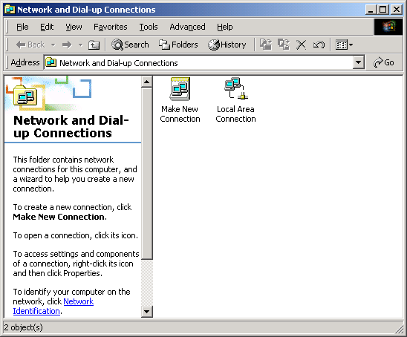

  - Right-click the network connection you want to configure, and then click Properties.
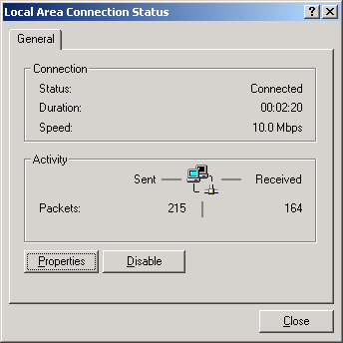

  - On the General tab (for a local area connection) or the Networking tab (all other connections), click Internet Protocol (TCP/IP), and then click Properties.
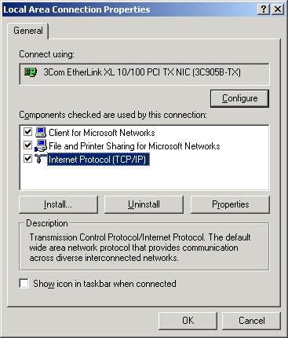

  - Click Advanced, click the WINS tab.

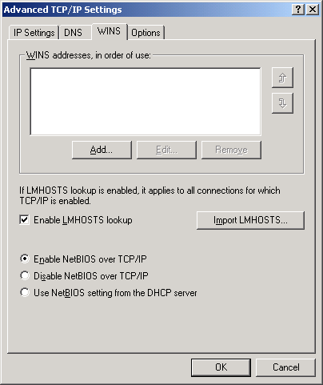
To enable the use of the lmhosts file to resolve remote NetBIOS names, select the Enable LMHOSTS lookup check box. This option is enabled by default.
To specify the location of the file that you want to import into the lmhosts file, click Import LMHOSTS, and select the file in the Open dialog box.

