ipLDK Speed Editor

Installation And User Guide

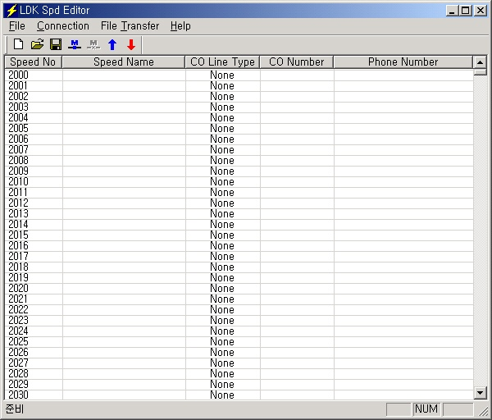

ISSUE 3.6.1


REVISION HISTORY

Issue | Date | Description of Changes | S/W Version | MPB Version
ISSUE 1 | Oct/2002 | Initial Release | 2.0Be | ~ 2.0Fx
ISSUE 2 | Oct/2003 | *Second Release  Protocol change from TCP to UDP | 2.2Ab | 2.2Dd ~
ISSUE 3 | Dec/2003 | Add ipLDK-50/100 Hotel  ipLDK-300E Office/Hotel | 2.2Ba ~ | 2.2Dd ~
ISSUE 3.1 | Jun/2004 | Add ipLDK20 Office | C.0Aa | ipLDK20 A.0Aa
ISSUE 3.2 | Jan/2005 | Add network number. | C.1Aa | C.2Aa
ISSUE 3.6 | Dec/2005 | LG Electronics, Inc. → LG-Nortel Co. Ltd. | C.1Ac
ISSUE 3.6.1 | Apr/2006 | ARIA SOHO added | C.1Ba | ARIA SOHO  1.0Aa

* Change history from previous version.
- Protocol Change: TCP (2.0Be) → UDP (2.2Ab or later)
- Connection Type: TCP/IP, Serial (2.0Be) → TCP/IP only (2.2Ab or later)
- Speed editor is the utility only for speed bin data in ipLDK system. So, it uses the connection channel of an ez-Attendant. We have changed the protocol that is used ez-Attendant connection from TCP to UDP since ipLDK version 2.2Xx.
- So, to use speed editor software, you should check the version of software (ipLDK and Speed editor)

** Available system
- 2.2Ab: ipLDK-50/100 office system, ipLDK-300 office/Hotel.
- 2.2Ba or later: ipLDK-50/100 Office/Hotel, ipLDK-300 Office/Hotel, ipLDK-300E Office/Hotel.
- 1.0Aa or later : ipLDK-20

*** This user guide is focused to Speed editor version 3.0Aa
Table of Contents

1. Introduction 2
1.1. Hardware/Software Requirements 2
1.2. Hardware Configuration 2
1.3. Installing Software 2
1.4. Uninstalling Software 2
1.5 Full Screen Layout 2
2. [File] Menu 2
2.1. [New] Sub-menu 2
2.2. [Open File] Sub-menu 2
2.3. [Save File] Sub-menu 2
3. [Connection] Menu 2
3.1. [Connect] Sub-menu 2
3. [File Transfer] Menu 2
4.1. Upload 2
4. Download 2
5. Editing Data 2
5.1. Editing in speed editor view 2
5.2. Editing Text or Doc File 2
5.3. Editing Excel File 2

1. Introduction
[ipLDK Spd Editor] is a MS-Windows application program that can download, edit, and upload speed data of ipLDK / ARIA SOHO system. This program can send and receive the speed information such as speed bin no, speed bin name, phone number, co line type(Net Number), and co number(Network index number).
→ Net number is not supported by ARIA SOHO system.

1.1. Hardware/Software Requirements
The system requirements for using this program are as follows.
- ipLDK / ARIA SOHO
- ipLDK System MPB Software Ver 2.2Da or later.
- In case of ipLDK20, it is possible to use this utility with the first release version.
- LAN Port should be installed on MPB for LAN connection.
- Unique IP Address should be assigned for LAN connection.
- In case of ARIA SOHO, MPB version 1.0Aa or later.

- PC
- Pentium Celeron 233MHz CPU or Higher CPU
- 256 color Super VGA (800 * 600) or higher
- NIC(Network Interface Card) for LAN Connection.
- 2 button Mouse
- At least 32MB RAM
- MS-Windows 98/me/2000/XP
- Enough hard drive space for installation

- Cable
- If NIC is used for LAN connection, UTP cable will be needed with RJ-45 Jack between PC and ipLDK system.

1.2. Hardware Configuration
In order to use LAN connection between PC and ipLDK / ARIA system, PC and ipLDK system should be connection local network.

1.3. Installing Software
Once the hardware is installed, you are ready to install the software.
Microsoft windows must be installed on your computer before you install [ipLDK Spd Editor] program. For information on installing Windows, refer to appropriate user’s manual.

Uninstalling Software
To uninstall [ipLDK Spd Editor] program, follow the procedure below :
- Click Uninstall – ipLDK Spd Editor Or, user can also select ipLDK Spd Editor in Add/Remove Program in Control Panel.

1.5 Full Screen Layout
Main Menu
Editing Area
[Fig 1-1] Full Screen Layout

2. [File] Menu
[File] menu includes [New], [Open File], [Save File].
- Recommends: When speed editor accesses to network drives, the opening and saving file can be failed due to the network condition. Therefore, it is recommended to copy files into local drives.

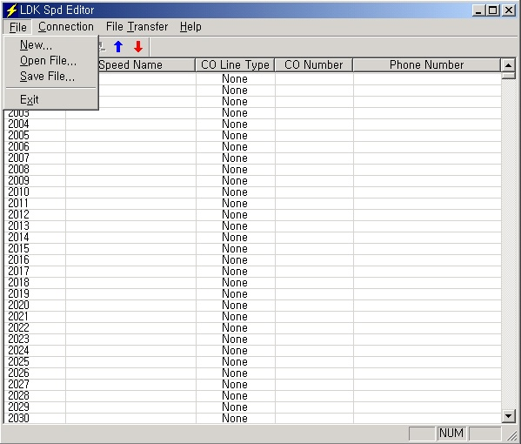
[Fig 2-1] [File] Menu

2.1. [New] Sub-menu

Procedures:
- Select [New] sub-menu in [File] menu. => [System Selection] dialog shows up.
- Select the system and version.
- Enter the range you want to edit.
- Click [OK] button.
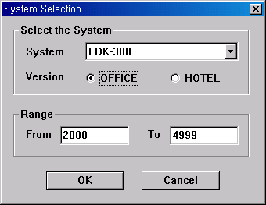
[Fig 2-2] [New] Sub-Menu

2.2. [Open File] Sub-menu

Procedures:
- Select [Open File] sub-menu in [File] menu. => [Open] Dialog shows up.
- Select the file type, text, doc or excel
3. Click [OK] button.

2.3. [Save File] Sub-menu

Procedures:
- Select [Save File] sub-menu in [File] menu. => [Save] Dialog shows up.
- Select the file type, text, doc or excel
- Click [OK] button.

3. [Connection] Menu

This program can be connected to ipLDK/ARIA SOHO system through LAN.
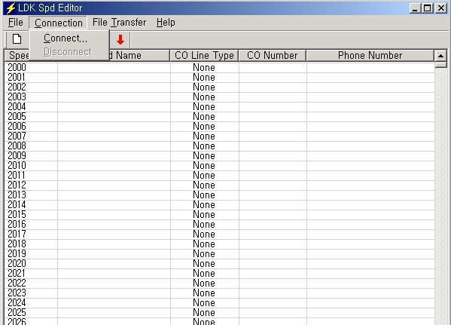
[Fig 3-1] [Connection] menu

** ipLDK SPD Editor uses the same port as ezATD.
** If ezATD is connected to the system, you can’t connect to the system using ipLDK SPD Editor until ezATD is disconnected.
** Unlike ezATD, ipLDK SPD Editor doesn’t need a lock key to use the system.

[Connect] Sub-menu

Procedures:
- Select [Connect] sub-menu in [Connection] menu. => [Login] Dialog shows up.
- If your PC is connected to the ipLDK/ARIA SOHO system by LAN, select [LAN Port Connect].

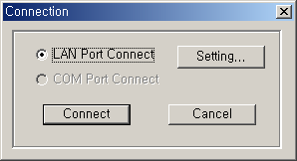
[Fig 3-2] Selection for Connect Type

For the LAN connection between PC and ipLDK/ARIA SOHO system, there must be a physical connection with 10BaseT Cable to local network. And ipLDK/ARIA SOHO system and PC should have valid IP address.

Conditions:
- ipLDK/ARIA SOHO system and PC should have valid IP address.
- If you want to connect directly, you have to use cross UTP cable. That means that the [Transmit] and [Receive] are cross. But you connect the ipLDK/ ARIA SOHO system and PC with HUB, you can use normal UTP cable that is used in your local network.
- If you want to connect from the different segment of LAN or from external site(via Internet), ipLDK / ARIA SOHO system should have correct gateway address(default router). If it doesn’t have gateway address, remote connection using TCP/IP will be not available.
- If you want to connect the ipLDK / ARIA SOHO system that is used in remote site, you may need some help from network administrator. Because many site uses the firewall/NAT/PAT in their router. So, to connect the system through the Internet, some help will be needed.
- In remote connection using Internet, connection speed / stability is depend on the environment of WAN traffic or routing

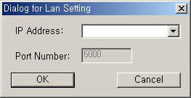
[Fig 3-3] IP Address Input Window

Procedure:
- Put an IP Address of the ipLDK / ARIA SOHO system like above, and press [OK].
- You can choose the site address using the combo box. The combo box have the IP address list that you have visited.
- If you want to connect the any site that has never visited, you have to enter the IP address into the combo box.
- In that case, you can’t edit the port number. Because port number is not changeable.

[File Transfer] Menu

  - When Speed Editor is logged on to ipLDK / ARIA SOHO System, don’t use a keyset for editing speed bin data
  - Recommends: When speed editor accesses to network drives, the opening and saving file can be failed due to the network condition. Therefore, it is recommended to copy files into local drives.

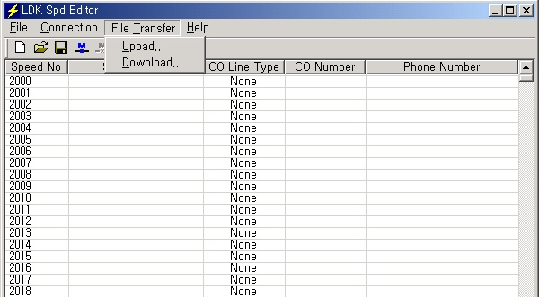
[Fig 4-1] File Transfer menu

4.1. Upload
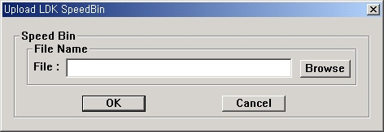
[Fig 4-2] Upload menu

Procedure:
- Check the file that you want to upload is being used by another process.
If the file is open, you can’t upload it.
- Select [Upload] sub-menu in [File Transfer] menu.
- Select [Browse], and select a file to upload.
- Click [OK] button.

Download
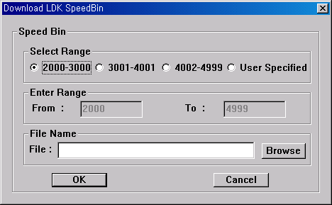
[Fig 4-3] Download menu

Procedure:
- Check the file that you want to download is being used by another process.
If the file is open, you can’t download it.
- Select [Download] sub-menu in [File Transfer] menu.
- Select Range. If you select User Specified, enter the range below.
- Select [Browse], and name a file you want the speed data to be saved.
- Click [OK] button to start download.

Editing Data

5.1. Editing in speed editor view
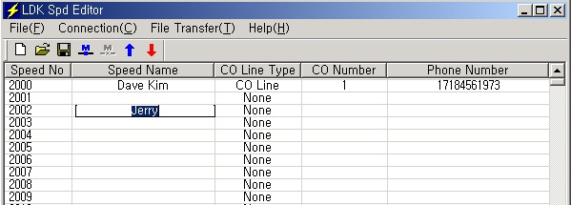
[Fig 5-1] Editing in speed editor view

Procedure:
- Click on an empty cell.
- Type the data and press [tab] to move on to next column or click on.
- Select [Save File] sub-menu in [File] menu. => [Save] Dialog shows up.
- Select the file type, text, doc or excel
- Click [OK] button.
** Enter the correct CO Line/CO Group Number/Network index number, otherwise the Speed Editor will ignore that CO Numbers during uploading. So CO Line Type and CO Number will not be updated.
*** Net number is not supported by ARIA SOHO system.
System | CO Line | CO Group | NET Number
ipLDK50/100 (Office/Hotel) | 1~40 | 1~24 | Index number in Networking PGM324(00~72)  From V3.2Aa(MP)  → Not used in ARIA SOHO
ipLDK300 (Office/Hotel) | 1~200 | 1~72
ipLDK300E (Office/Hotel) | 1~400 | 1~72
ipLDK20 (Office Only) | 1~12 | 1~8
ARIA SOHO (Office Only) | 1-12 | 1-8
When user wants to enter the network number, user should check the networking PGM.
User should enter the index number in networking PGM324(00~72). Otherwise LDK system may have incorrect operation. If user doesn’t know detail information, ask the system manager for that information.

5.2. Editing Text or Doc File
- Open the file you want to edit using Notepad or MS-Word.
- The file format looks as below.
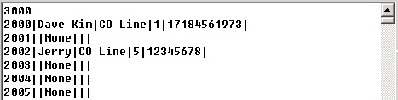
[Fig 5-2] Editing in Notepad or MS-Word

- The number 3000 on the first line represents the total number of speed data in this file.
- Each item is separated by a separator, | .
- Speed No | Speed Name | CO Line Type | CO Number | Phone Number
- When you write CO Line Type, write CO Line, CO Group and None, keeping an empty space between CO and Line, between CO and Group.
** Don’t exceed 16 characters when entering Speed Name.
** Don’t exceed 24 characters when entering Phone Number.
** Recommend editing in speed editor view.
** Pause and Flash should be entered only by upper-case letter. If you enter the lower-case letter, there may be error in the database.

5.3. Editing Excel File
- Open the file you want to edit using excel.
- The file format looks as below.
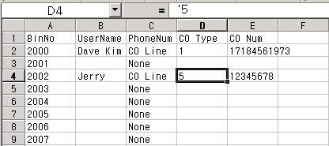
[Fig 5-3] Editing in Excel
- Click a cell to edit.
- Type data in. Be careful that you should type ‘ before every data, for example ‘5, not just 5.
- When you write CO Line Type, write CO Line, CO Group and None, keeping an empty space between CO and Line, between CO and Group.
** Don’t exceed 16 characters when entering Speed Name.
** Don’t exceed 24 characters when entering Phone Number.
** Recommend editing in speed editor view.
** Pause and Flash should be entered only by upper-case letter. If you enter the lower-case letter, there may be error in the database.

