LG Key System Software
Technical Information

STI-0046
Sep 21 2001

Title | LDK-300 and LDK-100 Monitor/Maintenance
System | LDK-300/LDK-100
Abstract

Revision History
Revision | By | History
1.0 | J. Kwon | 2001. 09. 21
1.1 | J. Kwon | 2001. 11. 06 – System access procedure added.
1.2 | H. Lim | 2002. 04. 23 – LDK-100 Added
1.3 | Cho.W.S | 2005. 06. 16 – Enhanced Trace Added
1.4 | SJ Ryu | 2005. 12. 14 – Enhanced Trace Guide Added

Table of Contents
1. System access procedure 1
1.1 Serial Connection 1
1.2 LAN Connection 1
1.3 Modem Connection 1
2. System monitoring commands 2
2.1 DIP Switch setting and meaning 2
2.2 Trace Commands 2
2.3 Other Commands 4
3. System Diagnostic/Maintenance commands 5
3.1 Maintenance Commands 5
3.2 Diagnostic Commands 7
4.Enhanced Trace Guide(Graphical Trace Mode) 1
4.1 Profile of Enhanced Trace 1
4.2 Usage of Enhanced Trace 1
4.3 Supported Messages of Enhanced Trace 1
4.3.1 Digital Line (PRI, VOI, BRI, STI-t, NPRI, NBRI) Type 1
4.3.2 Analog Line Type (DCO, LCO) Type 2
4.4 Enhanced Trace Examples 4
4.4.1 Incoming Call with PRIB. (ISDN Call) 4
4.4.2 Outgoing Call with VOIB. (NET Call) 1
4.4.3 Outgoing Call with LCOB. (Analog Call) 3

1. System access procedure

1.1 Serial Connection
- Be sure PC application port is not assigned to serial port that you want to connect.
- For trace, program print port to the proper serial port(PGM 175 - BTN 7).
- Connect using hyper terminal or other terminal program.

1.2 LAN Connection
- Be sure PC application port is not assigned to telnet.
- Program IP address and Gateway of the system(PGM 108 – BTN 2, BTN 4).
- Reset the system with DIP Switch 8 at OFF position.
- For trace, program print port to telnet(PGM 175 - BTN 7).
- Connect via telnet.

1.3 Modem Connection
- Be sure PC application port is not assigned to COM3-MODU.
- For trace, program print port to COM3-MODU(PGM 175 - BTN 7).
- Connect via modem.

2. System monitoring commands
Password : jennie
mon> [t|d|m|s|c|p|?|x] [option|parameters]

2.1 DIP Switch setting and meaning
DIP switch/LED | Setting and Meaning
DIP3 | Trace Control :  - ON-trace off  - OFF-trace on
DIP8 | Database initialize:  - ON - initialize memory  - OFF-save database

2.2 Trace Commands
Monitoring Type | Command | Meaning
Board Trace  (Max 6) | mon> t d ↵ | Delete all current trace commands and revert to idle condition.
Board Trace  (Max 6) | mon> t b xx n↵ | Set trace for board in slot xx  ,where 1≤ y ≤ 29 for LDK-300.  (28 is CPTU, and 29 is DTRU)  ,where 1≤ y ≤ 14 for LDK-100.  (13 is CPTU, and 14 is DTRU)  Option ‘n’ is graphical CO simple trace mode (Enhanced Trace). Option ‘n’ support the PRIB, VOIB, DCOB & LCO Type Boards.  If PRI or VOI board was set, you can see the net msgs and information elements: IP info, Calling num, Called num and etc…  Also in DCO or LCO board case, you can see the Calling num, Called num, and some of circuit commands related communications with outside system.
Board Trace  (Max 6) | mon> t b xx n↵ | e.g1) For setting trace for board in slot 7;  mon>t b 07  e.g2) enhanced trace for board in slot 8;  mon>t b 07 n
Device Trace  (Max 15) | mon> t ceht sxxx ↵ | At the sxxx, xxx should be physical station number. (i.e. port number of station)  Command options :  c : device command tracing. (MP → PP)  e : event tracing. (PP, Internal, Timer Event)  h : highway tracing.  t : CTI device command / event tracing.  (Multi-options can be used; ceh, c, eh, chi .etc.)  Example  If you want to trace the Station 102, you should enter the physical station number as following;  mon>t ceh s003  Even if the station number was changed from 102 to 702, the physical station number is not changed;  mon>t ceh s003
Device Trace  (Max 15) | mon> t cehtn cxxx ↵ | Tracing related to CO xxx.  Command options :  n: Enhanced Tracing(Graphical Mode)  (This side option ‘n’ is detailed enhanced trace mode. If you set the option ‘n’ at the particular CO in PRI or VOI boards, you may see all of network information elements.)  Example  For setting the command/event/hiway trace for CO line 07;  mon>t ceh c007  For the command/event graphical trace for CO line 08;  mon>t cen c008
Device Trace  (Max 15) | mon> t c sxxx a ↵ | Include LED / LCD data.
Device Trace  (Max 15) | mon> t nct | (Network Command Trace)  Only printed network text message.

* Enhanced Trace Option ‘n’ must need the DRAM. And It is executed over IP-LDK V3.5

2.3 Other Commands
Monitoring Type | Command | Meaning
Dump Memory | mon> d xxxxxx yyyyyy↵ | Dump memory between address xxxxxx and yyyyyy.  (xxxxxx and yyyyyy : memory address in hexadecimal.)
Modify Memory Content | mon> m xxxxxx bb↵ | Modify memory of address xxxxxx to bb.  (xxxxxx: memory address in hexadecimal,  bb: byte value in hexadecimal)
Show STA Status | mon> s xxx ↵ | Show STA xxx status  , where 1 ≤ y ≤ 300 for LDK-300.  , where 1 ≤ y ≤ 96 for LDK-100.
Show STA Status | mon> s xxx ↵ | e.g., For showing status of station 100  mon> s 001
Show CO Status | mon> c xxx ↵ | Show CO xxx status  , where 1 ≤ x ≤ 200 for LDK-300.  , where 1 ≤ x ≤ 40 for LDK-100.
Show CO Status | mon> c xxx ↵ | e.g., For showing status of CO number 7  mon> c 007
Print Channel Assign | mon> p [v|s]↵ | This command views and sets print channel.  Command options are:  v: View print channel  s: Set print channel
Help Menu | mon> ? ↵ | This command shows the available commands and their description.
Exit | mon> x ↵ | Exit monitor.

3. System Diagnostic/Maintenance commands
Password : brandy

3.1 Maintenance Commands
 | Commands | Meaning
Maintenance Commands | maint> bc | Shows board configuration table.
Maintenance Commands | maint> bl xxx yyy {r|t} | Listens B-channel of specified time-slot.  Example  To listen to rx channel of time-slot 2 at station 100(port 1):  maint> bl 1 2 r  Press any key to finish or after finished.
Maintenance Commands | maint> bs [xx]↵ | Shows board status. xx is slot number, 00 for MPB.
Maintenance Commands | maint> hd | Shows HDLC status.
Maintenance Commands | maint> reboot | This commands reboots the system. It needs admin password,and if it is not specified, ‘147*’ is used temporarily.
Maintenance Commands | maint> ta [options] | Shows traffic analysis data.  Command options:  all <timetype>: Print All Traffic Report  period <hhmm> <timetype>: Print Traffic Report Periodically  period_abort: Cancel Periodic Print  atd <timetype>: Print Attendant Traffic Report  callsum: Print Call Summary Report  callhour: Print Call Hourly Report  hw <timetype>: Print H/W Usage Summary Report  cosum <timetype>: Print CO Traffic Summary Report  cohour <cogrp#>: Print CO Traffic Hourly Report  <timetype> can be one of following:  tt : Today Total  yt : Yesterday Total  lh : Last Hour  yp : Yesterday Peak  tp : Today Peak
Maintenance Commands | maint> ws xx [options] | xx is slot number.  Shows WTIB statistics data.  Command options:  upload: Upload statistics data from WTIB  call: Total number of call & direction of the call  subs: Information per subscripted device  eoc: End of call  cell: Usage of frequency and slot  traf: Show holding time  acce: Access info.(basic/hand-over)  clea: Clear statistics data

3.2 Diagnostic Commands
 | Commands | Meaning
Diagnostic Commands | maint> db cc | Shows configuration constraints check result. It gives OK if the system configuration meets the maximum board configuration constraints.
Diagnostic Commands | maint> db pf | Shows preprogrammed faults. It checks if the admin programming configuration is same with the installed boards.
Diagnostic Commands | maint> db ts {sl|cf} | Shows time slot assignment and conflict status.
Diagnostic Commands | maint> db ht xx yy # | Tests PCM hiway using one DKT and one DTMF receiver.The first DKT of the assigned slot is used for the test.  Command options:  xx: slot number(DTIB)  yy: dtmf duration time(10ms base)  #: hiway number  (0-7 for LDK-300, 0-2 for LDK-100)  Example  To test hiway #1 using DTIB installed at 1st slot:  maint> db ht 01 01 1
Diagnostic Commands | maint> db dt | Tests DTMF receiver. This feature tests all DTMF receivers(up to 32) in the system.
Diagnostic Commands | maint> db ct | This command tests CPTU.
Diagnostic Commands | maint> db mt | This command tests DRAM module installed.
Diagnostic Commands | maint> db rt | Tests RTC. You can see current time and modify it. The time does not elapse while you are testing RTC.
Diagnostic Commands | maint> db pc | Shows power capacity of the PSU and current power usage status of the system.
Diagnostic Commands | maint> db rc | Shows RGU capacity. This feature shows RGU capacity, CO incoming ring cadence and ICM call ring cadence.
Diagnostic Commands | maint> de hs | Shows HDLC status.
Diagnostic Commands | maint> dr {is|ic} | Shows ISDN line status information.  Command options:  is: Shows ISDN line information.  ic: Clears ISDN line information.
Diagnostic Commands | maint> dr {ri|rc} | Shows reset information.  Command options:  ri: Shows reset information.  rc: Clears reset information.
Diagnostic Commands | maint> dr li {d|c|v|a} | Shows current resource assignment.  Command options:  d: DTMF receiver assignment  c: CPTU assignment  v: VMIB channel assignment  a: DTMF, CPTU, VMIB channel assignment

4.Enhanced Trace Guide(Graphical Trace Mode)

4.1 Profile of Enhanced Trace
Enhanced Trace is a graphical trace mode of IP-LDK V3.5. This new feature supports the networking message trace of PRI / VOI / BRI / STI (t-mode) / DCO / LCO / NBRI / NPRI Boards. Enhanced Trace is composed of translated messages of digital and analog lines. In case of digital line, networking messages are analyzed by the standard ETSI/ITU protocol and analyzed data is printed with large arrows. In case of analog line, communicated commands with other systems are analyzed and analyzed data is printed with small arrows. Below picture is example of Enhanced Trace.
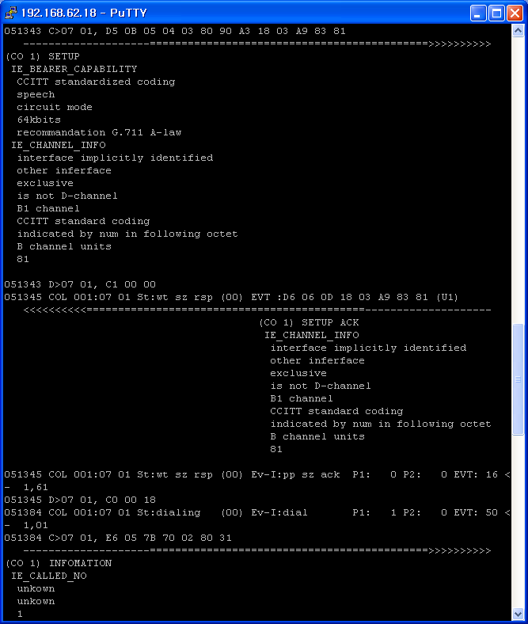
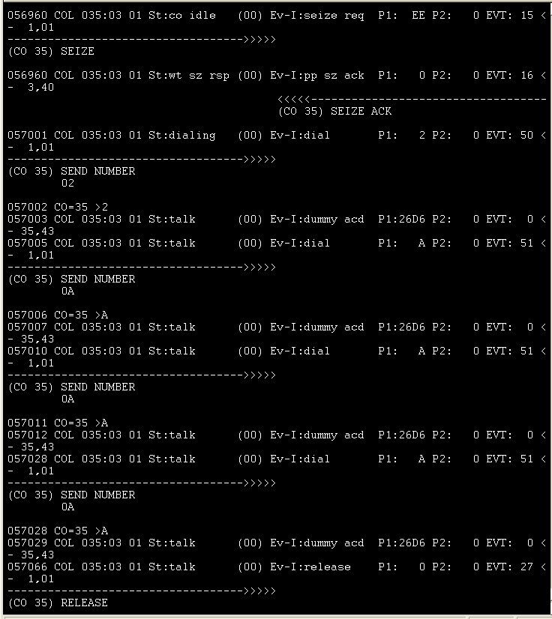

Digital CO line Trace (with large arrows) Analog CO line Trace (with small arrows)

Toward right arrows mean the outgoing message. Otherwise toward left arrows mean the incoming message

(Example) Digital CO case
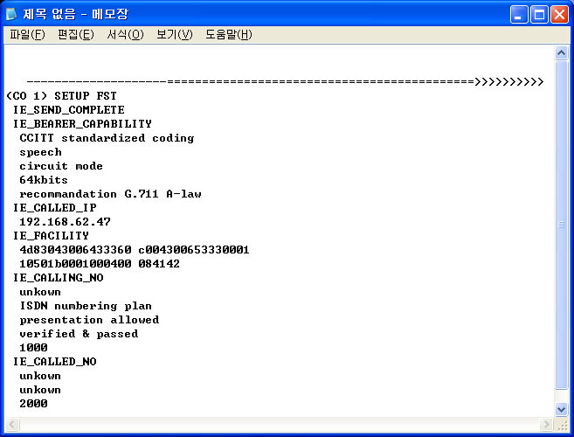
This is outgoing network message for SETUP with CO line 1 (Digital line)
&
This message compounds the information elements of bearer capability, called IP, facility, calling number, and called number.

* Enhanced Trace must need the DRAM. And It is executed over IP-LDK V3.5

4.2 Usage of Enhanced Trace
Enhanced Trace is one of system monitoring commands.
Board Trace: t b x n (‘x’ means board number)
All of Networking Trace: t nct (‘nct’ means the set all of networking CO graphical trace)
Specific CO Trace: t n c# (option ‘n’ could be used with other options (e, h, c, t) )

* Board Trace & All of Networking Trace: Simple Display Type
* Specific CO Trace: Complete Display Type
=> Simple Display Type shows the Networking Connection Message and Information Elements, but all of Information Elements (IE) could not be analyzed. Only including data of Called IP, Calling Number, Called Number and Cause elements could be analyzed, and then these data is printed.
=> Complete Display Type shows the Networking Connection Message, Information Elements and all of data contained on Information Elements (IE) data.

4.3 Supported Messages of Enhanced Trace

4.3.1 Digital Line (PRI, VOI, BRI, STI-t, NPRI, NBRI) Type
In case of digital line, networking messages are analyzed by the standard ETSI/ITU protocol.

Enhanced Trace Supported Messages for Networking Connection
Call Establishment Message | Call Information Phase Messages
ALERTING  CALL PROCEEDING  CONNECT  CONNECT ACK  PROGRESS  SETUP  SETUP ACK | USER INFORMATION
Call Clearing Messages | Miscellaneous Messages
DISCONNECT  RELEASE  RELEASE COMPLETE | FACILITY  INFORMATION  STATUS  STATUS REQ
* Additional Messages on ISDN also could be supported.
Enhanced Trace Supported Message for Information Elements
Networking  Information Element | Decoded & Print  / Only Print | Networking  Information Element | Decoded & Print  / Only Print
IE_BEARER_CAPABILITY | Decoded & Print | IE_CONNECTED_NO | Decoded & Print
IE_CAUSE | Decoded & Print | IE_CONNECTED_SUBADDR | Only Print Data
IE_CALL_IDENTITY | Only Print Data | IE_CALLING_NO | Decoded & Print
IE_CALL_STATUS | Decoded & Print | IE_CALLING_SUBADDR | Only Print Data
IE_CHANNEL_INFO | Decoded & Print | IE_CALLED_NO | Decoded & Print
IE_AOC | Only Print Data | IE_CALLED_SUBADDR | Only Print Data
IE_FACILITY | Only Print Data | IE_TRANS_NET_SELECT | Decoded & Print
IE_PROG_INDICATION | Decoded & Print | IE_LOW_LAYER_COMPATIBLE | Only Print Data
IE_NET_SPECIFIC_FACILITY | Only Print Data | IE_HIGH_LAYER_COMPATIBLE | Only Print Data
IE_NOTIFY_INDICATION | Decoded & Print | IE_USER_USER | Only Print Data
IE_DISPLAY | Only Print Data | IE_CONGEST | Decoded & Print
IE_DATE_TIME | Decoded & Print | IE_ISDN_FLASH_REQ | Only Print Data
IE_KEYPAD_FACILITY | Only Print Data | IE_ISDN_FLASH_ACK | Only Print Data
IE_CALLING_IP | Decoded & Print
IE_CALLED_IP | Decoded & Print
*Blue Mark: able to decode IE & print the analyzed results. And the others is printed raw (HEX Value) data.

4.3.2 Analog Line Type (DCO, LCO) Type
In this case Enhanced Trace could show the related CO commands to communicate with other systems. Analog messages dose not include any information elements, so Enhanced Trace show only the sent or received digit.

DCO case
Supported Messages
Receive Message Part |  | Send Message Part
Message Type | When the Msg is appeared | Message Type | When the Msg is appeared
RING DETECT | Receive The Call | SEIZE | Try to Seize the CO Line
RING STOP |  | RLS | CO Release
METERING | Detect Call Metering Signal | ANSWER | Answer the Call
LOOP IDLE |  | DGT SENT | Digit Sent
DGT SENT ACK |  | SND REGISTER RCL
SEIZE ACK | Receive CO Seize ACK | SND READY
SEIZE NAK |  | SND END OF DIAL
RLS ACK | Receive CO Release ACK | SND END OF DIAL BUSY
RCV DGT | Receive Digit | MAKE IDLE
RCV ANS | Receive Answer Signal | SND BLOCKING
RCV BLOCK |  | ANI DGT OP | Send Another Digit
RCV END OF DIAL
CALLER ID | Receive Caller ID
R2 END OF SIGNAL
ANI SVC START | Detect Another Service Start
ANI DGT SENT
*Blue Mark: Able to see the related digit.

LCO case
Supported Messages
Receive Message Part |  | Send Message Part
Message Type | When the Msg is appeared | Message Type | When the Msg is appeared
RING START | Receive The Call | SEIZE | Try to Seize the CO Line
RING STOP |  | RELEASE | CO Release
CALL METERING | Detect Call Metering Signal | ANSWER | Answer the Call
LOOP SUP DETECT |  | SEND_DIGIT | Digit Sent
DIAL TX ACK
SEIZE ACK | Receive CO Seize ACK
SEIZE NAK
RELEASE ACK | Receive CO Release ACK
FLASH ACK
DISA DGT
TONE DETECTED | Detect the Tone
RELEASED
CID DETECT | Receive Caller ID
*Blue Mark: Able to see the related digit.

4.4 Enhanced Trace Examples

4.4.1 Incoming Call with PRIB. (ISDN Call)
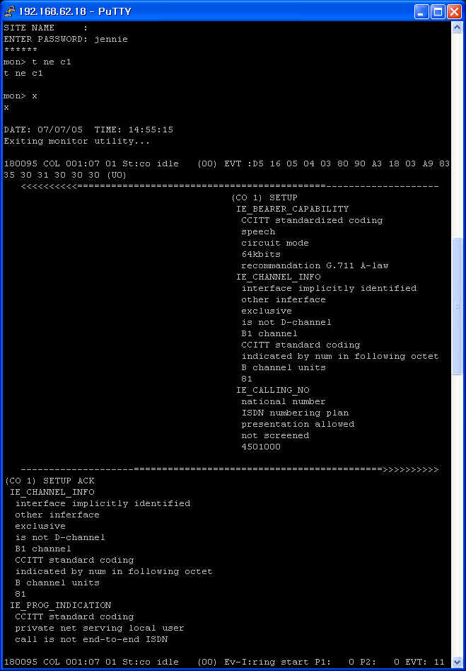
CO 1 Enhanced Device Trace
Complete Display Type
Receive the SETUP networking message
with bearer cap, channel, calling number
of Information Elements
Printed IE Data
Send the SETUP_ACK networking message
with channel, prog_indicator of Information Elements
Calling Number
‘4501000’
Printed IE Data
Printed IE Data
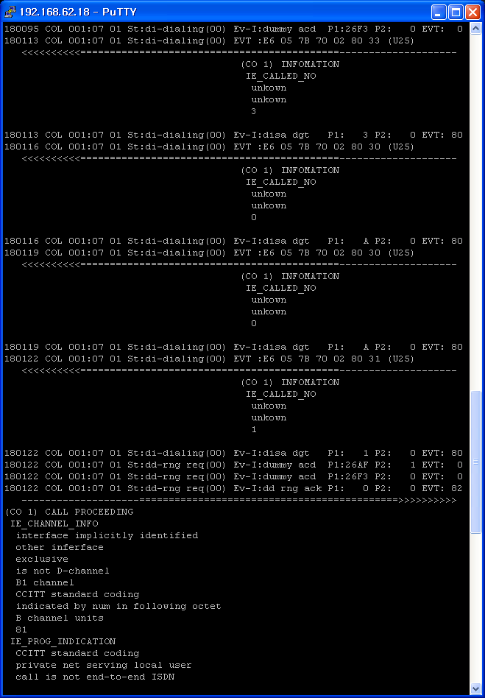
Receive the INFORMATION networking message
with called number ‘3’
Receive the INFORMATION networking message
with called number ‘0’
Receive the INFORMATION networking message
with called number ‘0’
Receive the INFORMATION networking message
with called number ‘1’
Send the PROCEEDING networking message
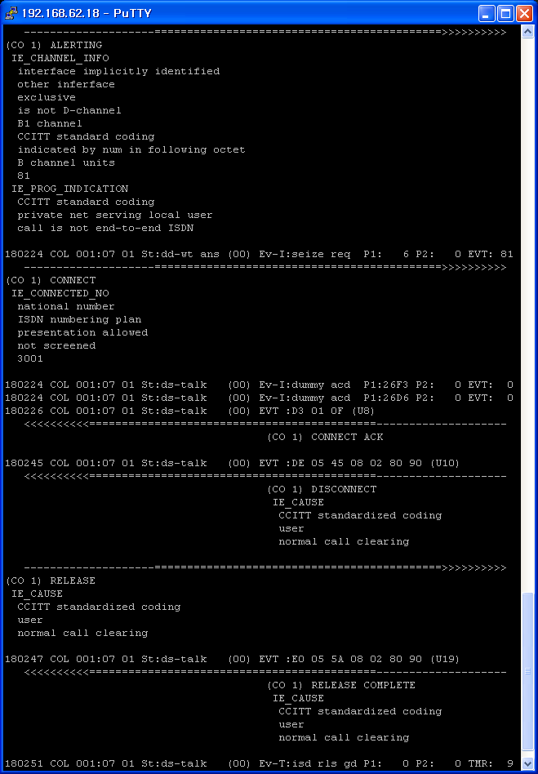
Send the ALRTING networking message
Send the CONNECT networking message
with ‘3001’ connected number
Receive the CONNECT ACK networking message
Receive the DISCONNECT networking message
with ‘normal call clearing’ message
Send the RELEASE networking message
Receive the RELEASE Complete networking message

4.4.2 Outgoing Call with VOIB. (NET Call)
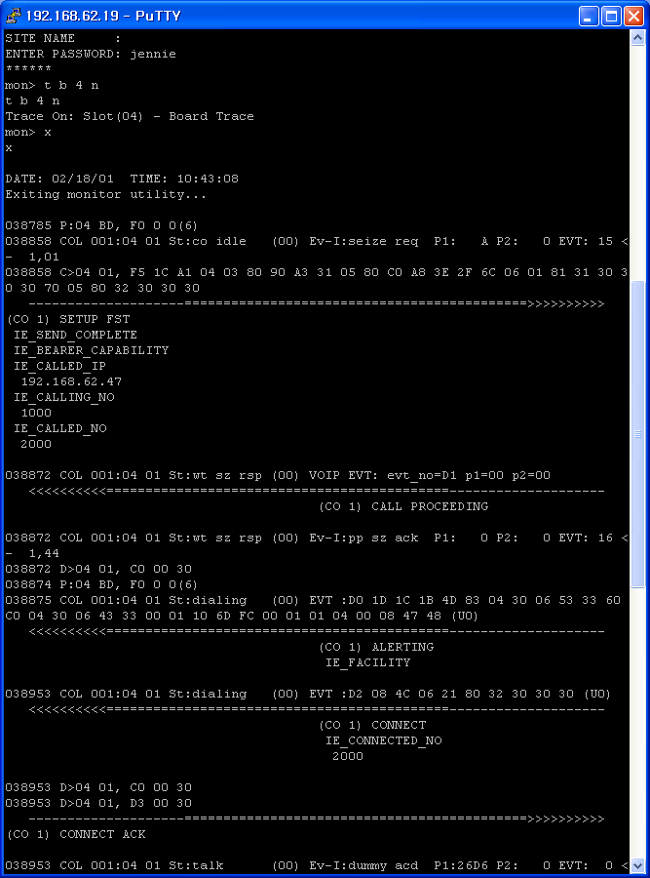
Enhanced Board Trace
Simple Display Type
Data of Information Elements have not been printed, except Called IP, Calling No, and Called No.
Send the SETUP networking message
by sending complete with bearer cap, channel, called IP, calling number, called number
Receive the CALL PROCEEDING
Receive the ALERTING with facility
Receive the CONNECT with called number ‘2000’
Send the CONNECTACK
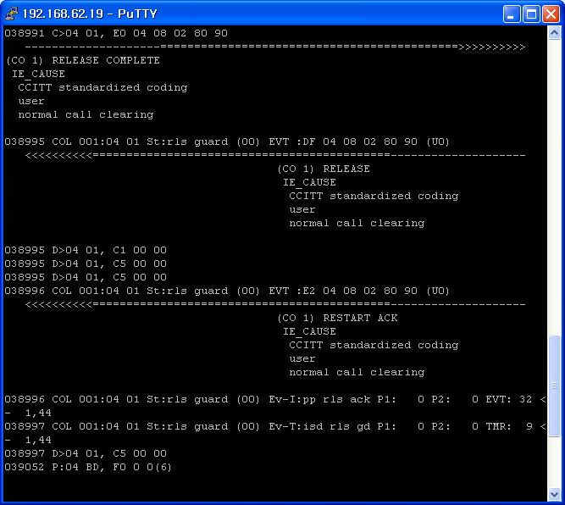
Send the RELEASE COMPLETE
This message means the DISCONNECT in this case.
Receive the RELEASE
Receive the RELEASE COMPLETE

4.4.3 Outgoing Call with LCOB. (Analog Call)
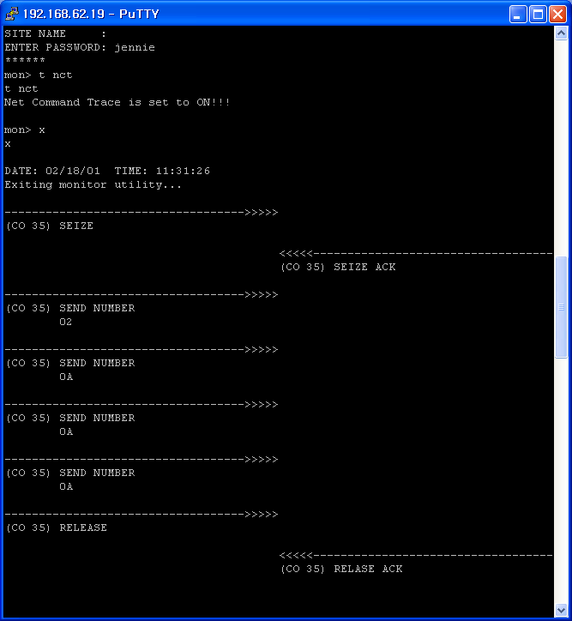
Enhanced all of Networking CO Trace
Simple Display Type
CO 35 Seize Request Message.
CO 35 Seize ACK Message.
Sending Digit
‘2000’
TALKING
CO 35 Release Request
CO 35 Release ACK
Dial Digit ‘2’
Dial Digit ‘0’
Dial Digit ‘0’
Dial Digit ‘0’

