LG Key System Software
Technical Information

STI-0049

July 12, 2004

Title | Lock Key Installation Guide for LDK Systems
System | LDK-300/100/50/24
Abstract | Lock Key Installation Guide for Enabling Advanced Features  Available Interfaces  Steps to Install Lock Keys  FAQ

Revision History
Revision | By | History
1.0A | Ho Lim | 2002. 7. 26.
1.0B | W.G.Kim | 2003.5.22 (LDK-24 part and Demo Lock Key feature are added.)
 | W.G.Kim | 2003.7.5 (LDK-24 Version is changed: B.0Af->A.0Bf (May 16, 2003),  B.0Ag->A.0Bg (May 27, 2003))
1.0C | W.G.Kim | 2003.11.5 Lock Key Installation – LDK-24 ‘Installation Command for Lock Keys (Version A.0Bg (May 27, 2003) or after)’ ‘Demo (Trial) for TAPI and PC Phone’ part changed; In ‘Meaning’, ‘PC Attendant’ is removed.
1.0D | W.G.Kim | 2003.11.12 LDK-24 ‘TAPI 1st Party’ is added in the part of Lock Key Installation – LDK-24 -> ‘Table) Installation Command for Lock Keys (Version A.0Da (Nov 12, 2003) or after)’
1.0E | W.G.Kim | 2004.1.8 LDK-24 ‘Demo (Trial) for Networking’ is added.
1.0F | K.H.LEE | 2004.7.9 LDK-50/100/300 Demo (Trial) Key is used for 60 days from B.2Gf version.  2004.7.12 LDK-24 Demo (Trial) Key is used for 60 days from X.0Hg version.
1.0G | Terry Heo | 2004.9.7 LDK-50/100/300 ‘Lock key for IPSoftPhone’ is added

Table of Contents

Lock Key Basics 3
Lock Key Installation – LDK-300/100/50 5
Lock Key Installation – LDK-24 9
Serial Interface Example – LDK-300/100/50 14
Serial Interface Example – LDK-24 16
Modem Interface Installation – LDK-300/100/50 18
ISDN Interface Installation – LDK-300/100/50 19
LAN Interface Installation – LDK-300/100/50 20
FAQ 21

Lock Key Basics

In LDK systems, there are some advanced features for which a special installation procedure is needed.
We call this procedure as “Lock Key Installation”.
Through this installation, users can use the advanced features of LDK system.

The first step for enabling an advanced feature will be obtaining the serial number of LDK system.
There are two kinds of serial numbers in LDK.

One is printed on the label of MPB and it contains 10 characters.
Refer to the following example.
In this example, the serial number is “109KC00031”.

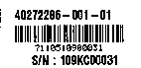
•Work Order Number for LG factory
•Serial Number
•Digit 1~5 : Model code
•Digit 6~9 : Serial Number
•Bar code for Digit 1~9
1 09 KC 00031
Year
Month
Factory code
KC: Korea ChoungJu
Serial N0

Example 1) Serial Number printed on the label of MPB

The other can be shown on the LCD of a digital terminal by pressing [TRANS] + 78.
16 hexadecimal characters will be displayed as in example 2) below.
The serial number is “000CCBF500000505” in this example.

KEY:000CCBF500000505
PCK:0..........

Example 2) Serial Number shown on the LCD of digital terminal

Two serial numbers are maintained internally in LGE and identified as a same thing.
Therefore, users need to know either of these two serial numbers.

The serial numbers are assigned by LGE Production Line and used to uniquely identify a system in field.

After the serial number of LDK is obtained, the next step is to get “Lock Key” for a specific advanced feature.
This means that each advanced feature will have its own key for the installation.
Since the serial number is unique, the keys for advanced features are unique.

Customers can download the Lock Key in the CS Homepage of LGE.
Please, contact someone in Marketing Dept. for more information on this.

With the correct key, it is possible to install the appropriate feature in LDK system.

Lock Key Installation – LDK-300/100/50

After getting a correct key for the feature, you can start installing the key in the system.

Four interfaces are available for Lock Key Installation.
They are Serial (RS-232C), Modem, ISDN, and LAN interfaces.
(With LDK-24, Lock Key can be installed via RS-232C interface and ‘telnet’)

Through any interface, you can access to the system by pressing [ENTER] key after connection is made.
Some prompt will be shown in the window that you are using.
The following is an example.

LDK-100 System
Version LGE/DX90P-B.0Ba JUL/02
DATE: 07/28/02
TIME: 13:40:06
SITE NAME :
ENTER PASSWORD:

Example 3) Prompt for password after [ENTER] key is pressed (LDK-100)

At this moment, the necessary password is “jannie” that is for Lock Key Installation. (Please, ignore quotation mark in real situation)
If you enter the password correctly, you will see the following.
LDK-100 System
Version LGE/DX90P-B.0Ba JUL/02
DATE: 07/28/02
TIME: 13:49:44
SITE NAME :
ENTER PASSWORD: ******
maint>

The commands required for each feature installation are summarized as follows.

Feature | Meaning | Command
Networking | QSIG over PRIB  VOIP over VOIB | q w 0 (lock_key)
PC Attendant | PC Attendant console | q w 1 (lock_key)
TAPI 2.1 | CTI Application supporting TAPI 2.1 | q w 2 (lock_key)
Table 1) Installation Command for Lock Keys (Version 2.0Aq or before)
Note: (lock_key) is the key string obtained in CS homepage that has 16 hexadecimal digits.

Feature | Meaning | Command
QSIG | QSIG over PRIB | q w 0 (lock_key)
PC Attendant | PC Attendant console | q w 1 (lock_key)
TAPI 2.1 | CTI Application supporting TAPI 2.1 | q w 2 (lock_key)
Networking | VOIP over VOIB | q w 5 (lock_key)
Table 2) Installation Command for Lock Keys (From Version 2.0Ar to B.2Ag)

Feature | Meaning | Command
QSIG | QSIG over PRIB | q w 0 (lock_key)
PC Attendant  (ezAttendent) | PC Attendant console | q w 1 (lock_key)
TAPI | CTI Application supporting TAPI | q w 2 (lock_key)
Networking | VOIP over VOIB | q w 5 (lock_key)
PC Phone (ezPhone) | PC Phone (ezPhone) | q w 6 (lock_key)
Demo (Trial) for PC  Attendant, TAPI and  PC Phone | It enables user to use PC Attendant, TAPI and PC Phone during 30 days without any Lock Keys for demo.  System reset needs. | q k start_demo_mode
Table) Installation Command for Lock Keys (From Version B.2Ag to B.2Ge)

Feature | Meaning | Command
QSIG | QSIG over PRIB | q w 0 (lock_key)
PC Attendant  (ezAttendent) | PC Attendant console | q w 1 (lock_key)
TAPI | CTI Application supporting TAPI | q w 2 (lock_key)
Networking | VOIP over VOIB | q w 5 (lock_key)
PC Phone (ezPhone) | PC Phone (ezPhone) | q w 6 (lock_key)
Demo (Trial) for PC  Attendant, TAPI,  PC Phone, QSIG and Networking | It enables user to use PC Attendant, TAPI, PC Phone, QSIG and Networking during 60 days without any Lock Keys for demo.  System reset needs. | q k start_demo_mode
Table) Installation Command for Lock Keys (Version B.2Gf or after)

Feature | Meaning | Command
QSIG | QSIG over PRIB | q w 0 (lock_key)
PC Attendant  (ezAttendent) | PC Attendant console | q w 1 (lock_key)
TAPI | CTI Application supporting TAPI | q w 2 (lock_key)
Networking | VOIP over VOIB | q w 5 (lock_key)
PC Phone (ezPhone) | PC Phone (ezPhone) | q w 6 (lock_key)
Demo (Trial) for PC  Attendant, TAPI,  PC Phone, QSIG and Networking | It enables user to use PC Attendant, TAPI, PC Phone, QSIG and Networking during 60 days without any Lock Keys for demo.  System reset needs. | q k start_demo_mode
IPSoft Phone | IP Soft Phone | q w 9 (lock_key)
Table) Installation Command for Lock Keys (Version C.0Am or after)

After you install some advanced features, you can see if the keys are stored correctly by entering “q d” command.
The following is an example.
LDK-100 System
Version LGE/DX90P-B.0Ba JUL/02
DATE: 07/28/02
TIME: 14:16:11
SITE NAME :
ENTER PASSWORD: ******
maint> q d
Serial Number: 000CCEF800000001
Date: 07-15-2002
System: LDK-100 (8 M)
Enabled Feature:
Part00 (QSIG)
Part01 (PC ATTD)
Part02 (CTI)
Part03 (RACK 2)
Part05 (NETWORK)
Mac Address : 00 40 5A 38 29 1D

maint>

Example 5) After command “q d” is entered (LDK-100)

You can get out of the maintenance by entering ‘x’ command.

Warning Notice) In order to apply the change made by the Lock Key installation, system must be reset at least once.

Lock Key Installation – LDK-24

After getting a correct key for the feature, you can start installing the key in the system.

Two interfaces are available for Lock Key Installation. They are Serial (RS-232C) and LAN interface (telnet).

Through any interface, you can access to the system by pressing [ENTER] key after RS-232C connection is made or by typing ‘telnet [LDK-24 IP]’.
Some prompt will be shown in the window that you are using.
The following is an example.

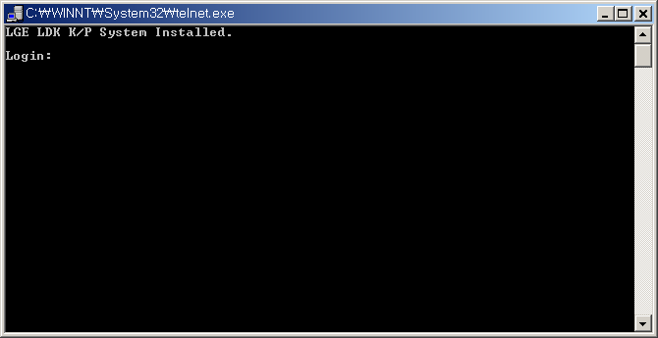

Example) Display for ‘tenet [LDK-24 IP]’ (LDK-24)

At this moment, the necessary id and password is “admin” and “admin” that is for Lock Key Installation. (Please, ignore quotation mark in real situation)
If you enter id and password correctly, you will see the following.

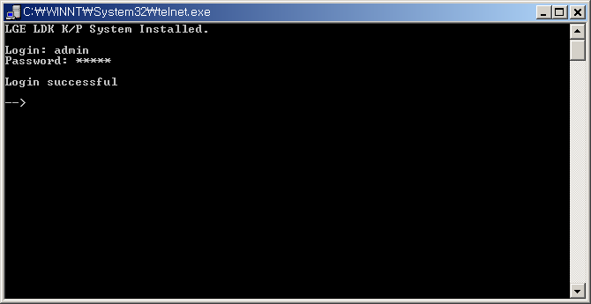
Example) After entering id and password “admin” (LDK-24)

To install Lock Key, you are in ‘call’ prompt. To get to ‘call’ prompt, enter “console enable” and then “call”.
Please refer to the following. You may enter “c e” instead of “console enable”.
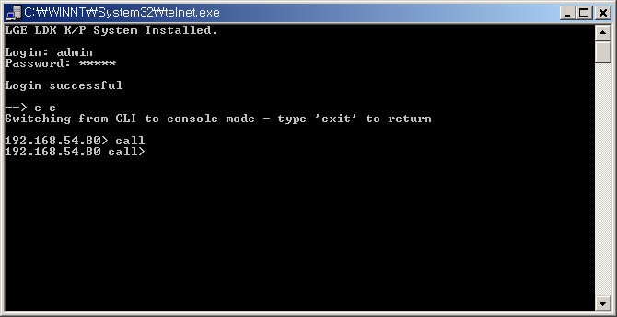
Example) After entering “c e” can “call” (LDK-24)

The commands required for each feature installation are summarized as follows.

Feature | Meaning | Command
TAPI | CTI Application supporting TAPI | mnt q w 2 (lock_key)
Networking | VOIP over VOIU | mnt q w 5 (lock_key)
PC Phone (ezPhone) | PC Phone (ezPhone) | mnt q w 6 (lock_key)
Table) Installation Command for Lock Keys (Version A.0Bf (May 16, 2003) or before)
Note: (lock_key) is the key string obtained in CS homepage that has 16 hexadecimal digits.

Feature | Meaning | Command
TAPI | CTI Application supporting TAPI | mnt q w 2 (lock_key)
Networking | VOIP over VOIU | mnt q w 5 (lock_key)
PC Phone (ezPhone) | PC Phone (ezPhone) | mnt q w 6 (lock_key)
Demo (Trial) for  TAPI and  PC Phone | It enables user to use TAPI and PC Phone during 30 days without any Lock Keys for demo.  System reset needs. | mnt q k  start_demo_mode
Table) Installation Command for Lock Keys
(From Version A.0Bg (May 27, 2003) to 1.0Ch (Oct 20, 2003))

Feature | Meaning | Command
TAPI | CTI Application supporting TAPI | mnt q w 2 (lock_key)
Networking | VOIP over VOIU | mnt q w 5 (lock_key)
PC Phone (ezPhone) | PC Phone (ezPhone) | mnt q w 6 (lock_key)
TAPI 1st Party | 1st Party TAPI Lock Key for other applications except LG ezPhone | mnt q w 8 (lock key)
Demo (Trial) for  TAPI and  PC Phone | It enables user to use TAPI and PC Phone during 30 days without any Lock Keys for demo.  System reset needs. | mnt q k  start_demo_mode
Table) Installation Command for Lock Keys
(From Version A.0Da (Nov 12, 2003) to 1.0Eh(Dec 24, 2003))

Feature | Meaning | Command
TAPI | CTI Application supporting TAPI | mnt q w 2 (lock_key)
Networking | VOIP over VOIU | mnt q w 5 (lock_key)
PC Phone (ezPhone) | PC Phone (ezPhone) | mnt q w 6 (lock_key)
TAPI 1st Party | 1st Party TAPI Lock Key for other applications except LG ezPhone | mnt q w 8 (lock key)
Demo (Trial) for  Networking, TAPI and  PC Phone | It enables user to use Networking, TAPI and PC Phone during 30 days without any Lock Keys for demo.  System reset needs. | mnt q k  start_demo_mode
Table) Installation Command for Lock Keys
(From Version 1.0Eh (Dec 24, 2003) to X.0Hf (Jul 2, 2004))

Feature | Meaning | Command
TAPI | CTI Application supporting TAPI | mnt q w 2 (lock_key)
Networking | VOIP over VOIU | mnt q w 5 (lock_key)
PC Phone (ezPhone) | PC Phone (ezPhone) | mnt q w 6 (lock_key)
TAPI 1st Party | 1st Party TAPI Lock Key for other applications except LG ezPhone | mnt q w 8 (lock key)
Demo (Trial) for  Networking, TAPI and  PC Phone | It enables user to use Networking, TAPI and PC Phone during 60 days without any Lock Keys for demo.  System reset needs. | mnt q k  start_demo_mode
Table) Installation Command for Lock Keys
(After version X.0Hg (Jul 12, 2004))

After you install some advanced features, you can see if the keys are stored correctly by entering “mnt q d” command.
The following is an example.
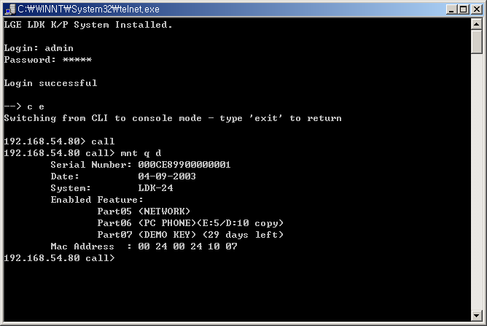
Example) After command “mnt q d” is entered (LDK-24)
You can get out of the “call” prompt by entering ‘home’ and then ‘exit’ command.

Warning Notice) In order to apply the change made by the Lock Key installation, system must be reset at least once.

You can also see if the keys are stored correctly by pressing [TRANS/PGM]+78 at any DKTU with LCD.
And you can see more detail information for PC Phone (ezPhone) Lock Key by pressing [TRANS/PGM]+79 at any DKTU with LCD.
The following is an example.
KEY: 000CC74500000002
PCK: ..2..56....
Example) [TRNAS/PGM]+78

PC-PHONE LICENSE
E:005/D:010
Example) [TRNAS/PGM]+79

Serial Interface Example – LDK-300/100/50

Please, see the following steps and the screen shot for LDK-300/100/50 Lock Key Installation.

- Properly match the serial port settings of LDK and PC.
- Use some terminal application like Hyper Terminal, Procomm Plus, or etc.
(We are using Procomm Plus for this example.)
- Connect RS-232 cable between LDK and PC.
- Open the COM port from the terminal application.
- Press [Enter].
- Enter jannie for password.
- Using Lock Keys obtained in CS Homepage, enter appropriate commands to LDK.
- Check if the keys are correctly entered by the command “q d”.
- Make a reset to the system to apply the change.

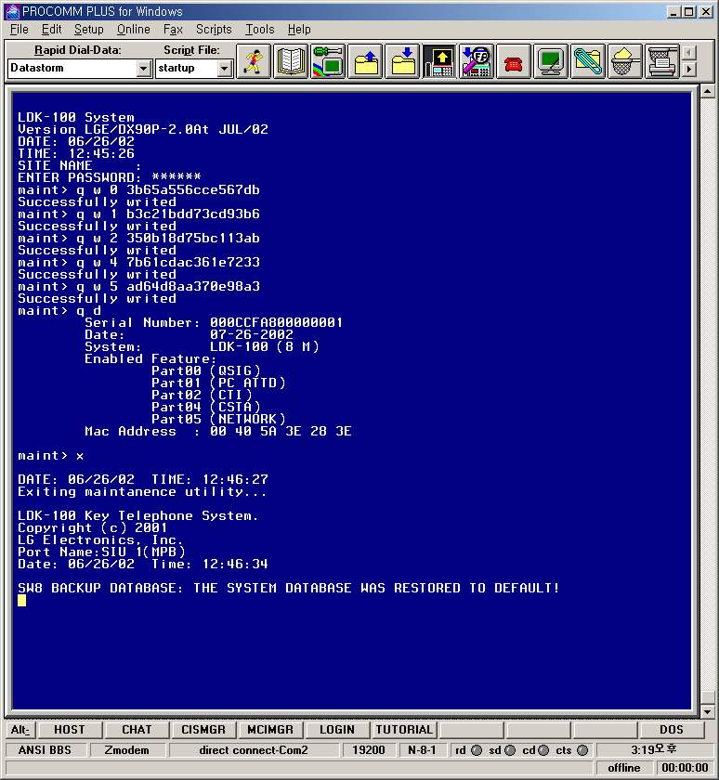

Serial Interface Example – LDK-24

Please, see the following steps and the screen shot for LDK-24 Lock Key Installation.

- Properly match the serial port settings of LDK-24 and PC.
- Use some terminal application like Hyper Terminal, Procomm Plus, or etc. (We are using Procomm Plus for this example.)
- Connect RS-232 cable between LDK-24 and PC.
- Open the COM port from the terminal application.
- Press [Enter].
- Enter “admin” and “admin” for id and password.
- Enter “c e”.
- Enter “call”.
- Using Lock Keys obtained in CS Homepage, enter appropriate commands to LDK-24.
- Check if the keys are correctly entered by the command “mnt q d”.
- Enter “home” and then “exit”
- Make a reset to the system to apply the change.

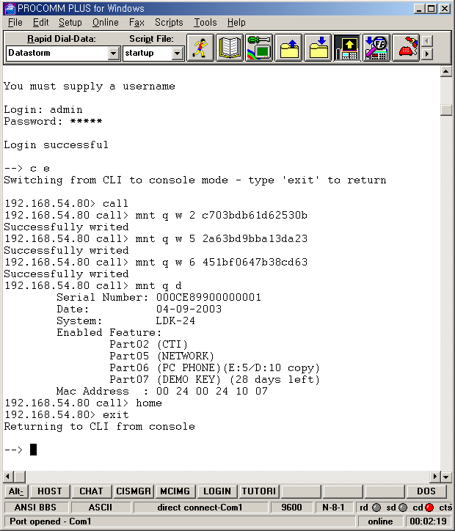

Modem Interface Installation – LDK-300/100/50

ISDN Interface Installation – LDK-300/100/50

LAN Interface Installation – LDK-300/100/50

FAQ

