2222288822

ipLDK Remote
Diagnostic Tool

Installation And User Guide

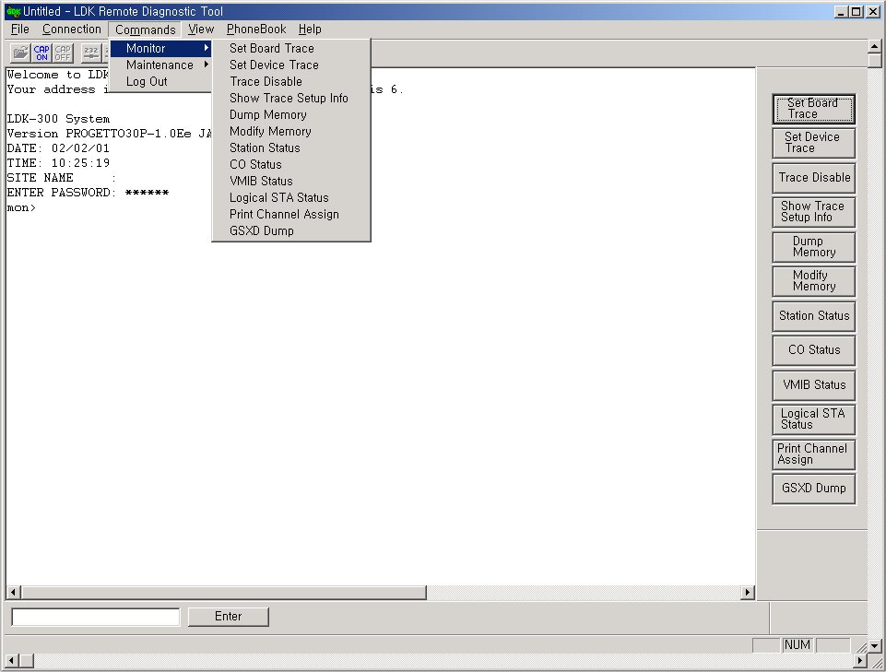

ISSUE 3.1


REVISION HISTORY

Issue | Date | Description of Changes | S/W Version
ISSUE 1 | June/2001 | Initial Release | A.0Aa
ISSUE 2 | Jan/2002 | Second Release | 1.0Ab
ISSUE 3 | Jan/2002 | Third Release | 1.0Ac
ISSUE 3.1 | Dec/2005 | LG Electronics, Inc. → LG-Nortel Co.Ltd. | 3.1Ac
ISSUE 3.2 | Mat/2006 | ARIA SOHO system was added | 3.1Ba

Table of Contents

1. Introduction 1
1.1. Hardware/Software Requirements 1
1.2. Hardware Configuration 2
1.3. Installing Software 2
1.4. Uninstalling Software 2
1.5. Important Notes for Users 3
1.6 Full Screen Layout 4
2. [File] Menu 5
2.1. [Open] Sub-menu 5
2.2. [Capture On] Sub-menu 6
2.3. [Capture Off] Sub-menu 6
3. [Connection] Menu 7
3.1. Serial Port Connection with ipLDK System 8
3.2. Modem Connection with ipLDK System 11
3.3 LAN Connection with ipLDK/ARIA SOHO System 19
3.4 ISDN Connection with ipLDK System – Not available with ARIA SOHO 22
4. [Commands] Menu 25
4.1. Executing Commands 25
4.2. Functions of Commands 28
5. [View] Menu 42
5.1. [ToolBar] Sub-menu 42
5.2. [Command Bar] Sub-menu 43
5.3. [Input Box Bar] Sub-menu 43
5.4. [Clear New] Sub-Menu 43
6. [Help] Menu 44
6.1. [About ipLDK Remote Diagnostic Tool] Sub-menu 45
7. [Data Display Area] 46
7.1. Data Display Functions 46
7.2 Automatic Data Storing Functions 47
7.3 Important Notes for Users 47

1. Introduction
[ipLDK Remote Diagnostic Tool] is a MS-Windows application program that may be used with PC Admin program. This program is for diagnosing problems of ipLDK/ARIA SOHO system and also maintaining the system from remote site. This program can send and receive the results of diagnostic commands of ipLDK/ARIA SOHO system such as GSXD test, Board configuration, S/W reset count, Station status, CO status, Station recovery, CO recovery, Version display, Help message, and Log out.

1.1. Hardware/Software Requirements
The system requirements for using this program are as follows;
- ipLDK/ARIA SOHO
- Serial Port that is installed on MPB as a basic option.
- LAN Port should be installed on MPB for LAN connection.
- Unique IP Address should be assigned for LAN connection.
- MODU that is installed on MPB.
- PC
- Pentium Celeron 233MHz CPU or Higher CPU
- 256 color Super VGA (800 * 600) or higher
- One or more Serial Port
- NIC(Network Interface Card) for LAN Connection.
- ISDN S-Card for ISDN Connection.(Option, Not available with ARIA SOHO)
- 2 button Mouse
- At least 32MB RAM
- MS-Windows 95/98/2000/me/XP/NT
- Enough hard drive space for installation

- Cable
- RS-232C Type Cable for connecting PC and ipLDK/ARIA SOHO system: Two connectors are needed for this connection. One connector should be a 9-pin female connector that is to be connected to ipLDK/ARIA SOHO, and the other one should fit the serial port of the PC. There are three required lines that should be connected for the communication between PC and ipLDK/ARIA SOHO system: Ground-Ground, Transmit-Transmit, and Receive-Receive.
- If external modem is used for PC, serial cable is need for the connection between PC and modem. About the connection between PC and modem, user must refer to the user’s manual of the modem and follow the description.
- If NIC is used for LAN connection, UTP cable will be needed with RJ-45 Jack between PC and ipLDK/ARIA SOHO system.

1.2. Hardware Configuration
In order to use serial connection between PC and ipLDK/ARIA SOHO system, PC should be connected to the basic serial port of ipLDK/ARIA SOHO system.
In order to use modem connection between PC and ipLDK/ARIA SOHO system, MODU should be installed in ipLDK/ARIA SOHO system and a modem should be installed in PC.
In order to use LAN connection between PC and ipLDK/ARIA SOHO system, PC and ipLDK/ARIA SOHO system should be connection local network.
In order to use ISDN connection between PC and ipLDK/ARIA SOHO system, PC should be connection to ISDN line.

1.3. Installing Software
Once the hardware is installed, you are ready to install the software.
Microsoft windows must be installed on your computer before you install [ipLDK Remote Diagnostic Tool] program. For information on installing Windows, refer to appropriate user’s manual.
This remote diagnostic software is a part of PC Admin software package like remote upgrade. So, you should install the PC admin software package to use remote diagnostic software.

Uninstalling Software
To uninstall [ipLDK Remote Diagnostic Tool] program, follow the procedure below :
- Click Uninstall – PC Admin menu that is under PC Admin for ipLDK in Program menu of MS-Windows. Or, user can also select PC Admin in Add/Remove Program in Control Panel.
- <Confirm File Deletion> message box that asks if the user wants to remove PC Admin files shows up. Click Yes button to proceed.

1.5. Important Notes for Users
- [ipLDK Remote Diagnostic Tool] is installed with PC Admin program.
- When you uninstall [ipLDK Remote Diagnostic Tool] program, PC Admin program is also uninstalled.
- In order to use modem connection with this program, TAPI and TAPI32 Dynamic-Link Library and TAPISRV.EXE should be installed in MS-Windows. These files are installed in most of the PCs MS-Windows is installed.
- When you uninstall [ipLDK Remote Diagnostic Tool], some files may not be deleted if the files were create after the installation of this program. Those files can be [PhoneNo.txt] file that is created after [Save] button is clicked on [Phone Number Dialog], or other saved files or backup files, and so on.
- If [GSXD Test] command is executed on the system that does not use GSXD chipset, the result of [GSXD Test] shows a message that indicates this condition.
In order to log-on to ipLDK system again after log-out from ipLDK/ARIA SOHO system, click [Enter] button in [Input Box Bar].
- When this program is executed, some components of this program (i.e. buttons in [Command Bar]) may be hidden. In this case, enlarge or maximize the window, then you will see all the components of this program.
- The title of a button in [Command Bar] may be aligned into two lines if the length of the title is long.

1.6 Full Screen Layout
Main Menu
LDK Command Line
Display Area
Command Menu
Command Bar

[Fig 1.1] Full Screen Layout

2. [File] Menu
[File] menu includes [Open], [Save], [Save As], [Print], [Print Preview], [Print Setup], and [Recent Files] that are file related operations.
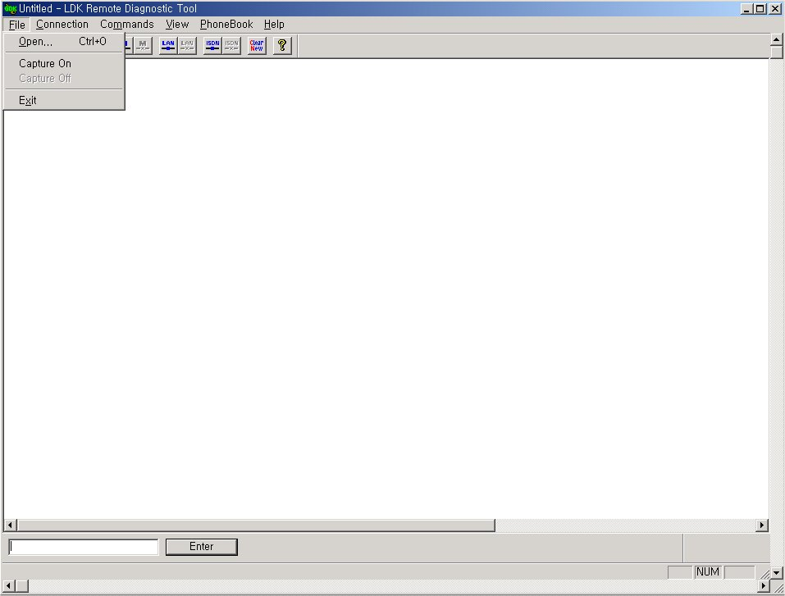
[Fig 2-1] [File] Menu

2.1. [Open] Sub-menu

Procedures:
- Select [Open] sub-menu in [File] menu. => [Open Dialog] shows up.
- Or, user can use tool button in [ToolBar] to execute the same command.
- Select one of the saved files. (File extension is *.dat)
- Click [OK] button.
- The dialog is closed, and the contents of the file is displayed in [Data Display Area].

2.2. [Capture On] Sub-menu

Procedures:
- Select [Capture On] sub-menu in [File] menu. . => [Save As Dialog] shows up.
- Enter different file name.
3. Click [OK] button.

2.3. [Capture Off] Sub-menu

Procedures:
- Select [Capture Off] sub-menu in [File] menu.

3. [Connection] Menu
ipLDK/ARIA SOHO system and this program can be connected in four ways, Serial, Modem, Lan, ISDN(Not available with ARIA SOHO).
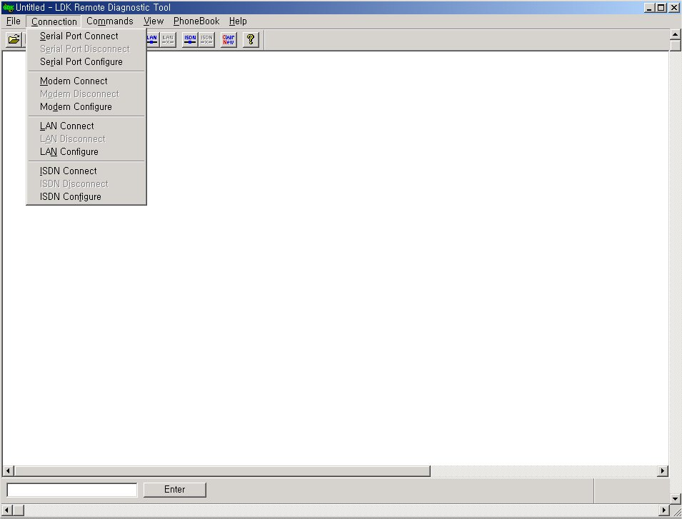
[Fig 2-2] [Connection] menu

3.1. Serial Port Connection with ipLDK System
For the serial port connection between PC and ipLDK system, there must be a physical connection with RS-232C standard serial cable.
** Serial Port may not be established through Window2000.
(Recommend to use Window98 to use serial port)

Conditions:
- The pins used in connection cable should be connected as follows;
- [Transmit] : [Transmit] of ipLDK/ARIA SOHO and [Transmit] of PC should be connected.
- [Receive] : [Receive] of ipLDK/ARIA SOHO and [Receive] of PC should be connected.
- [Ground] : [Ground] of ipLDK/ARIA SOHO and [Ground] of PC should be connected.
- The length of connection cable depends on the communication environment of the system. In normal condition, the cable length is limited to 15 meters. In better condition, 30-meter cable can be used.
- In ipLDK//ARIA SOHO system, it is connected to the serial port in MPB. Select one of the transmission rates among 2400bps, 4800bps, 9600bps.

3.1.1. [Serial Port Configure] Sub-menu
[Serial Port Configure] is for configuring serial port of PC that is to be connected to ipLDK/ARIA SOHO system.

Conditions:
- When the serial port connection is established, user cannot select this menu. The menu item is disabled in that case.
- Setting values are stored for the next session at which they are automatically restored and used.
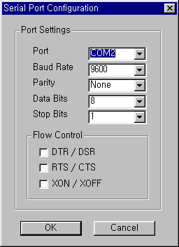
[Fig 2-3] Serial Port Configuration

Procedures:
- Select [Serial Port Configure] sub-menu in [Connection] menu.
- [Serial Port Configuration Dialog] shows up.
- Enter setting values.
- [Port] : Select connection port to be connected to ipLDK.
- [Baud Rate] : Select one of 2400bps, 4800bps, 9600bps. Selected [Baud Rate] must be same as that of ipLDK.
- [Parity] : Select [None].
- [Data Bits] : Select [8].
- [Stop Bits] : Select [1].
- [Flow] : All of [DTR/DSR], [RTS/CTS], [XON/XOFF] are not to be checked.
- Click [OK] button.

3.1.2. [Serial Port Connect] Sub-menu
[Serial Port Connect] connects the serial port of PC and ipLDK system with the setting values from [Serial Port Configure].

Conditions:
- If the connection is failed, an error message shows up. It means that other program is using the serial port or the port does not exist.

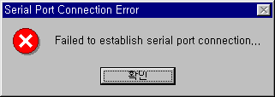
[Fig 2-4] Serial Port Connection Fail

- If the connection is established successfully, a message box shows up notifying this. The success of connection means that the connection between this program and the serial port of the PC is succeeded. This does not mean the connection between this program and ipLDK/ARIA SOHO system is succeeded.

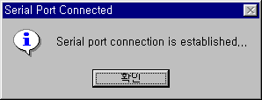
[Fig 2-5] Serial Port Connection Success Dialog

- If the serial port is already connected, the sub-menu and the tool button for serial port connection cannot be selected.

Procedures:
- Select [Connection] menu.
- Select [Serial Port Connect] in [Connection] menu.
- Or, user can use tool button in [ToolBar] to execute the same command.

3.1.3. [Serial Port Disconnect] Sub-menu
[Serial Port Disconnect] disconnects the serial port connection between PC and ipLDK/ARIA SOHO.

Conditions:
- If the two serial ports are already disconnected, the menu and the toolbar for serial port disconnection cannot be selected.

Procedures:
- Select [Connection] menu.
- Select [Serial Port Disconnect] sub-menu in [Connection] menu.
- Or, user can use tool button in [ToolBar] to execute the same command.

3.2. Modem Connection with ipLDK System
For the modem connection between PC and ipLDK/ARIA SOHO system, internal or external modem is needed for PC. Before executing this program, a modem should be installed in PC. Modem installation does not merely mean the physical connection between PC and modem but it includes all the procedures needed such as installing device driver file for MS-Windows.

3.2.1. [Modem Configure] Sub-menu
[Modem Configure] is for configuring modem of PC that is to be connected to ipLDK/ARIA SOHO system.

Conditions:
- When the modem connection is established, user cannot select this menu. The menu item is disabled in that case.
- MODU should be installed on the MPB of ipLDK/ARIA SOHO system.
- By clicking [Configure] button in [Modem Configuration Dialog], user can select or change various settings for modem configuration. The setting values are effective only during the execution time of this program and are not stored for next execution. Those values do not affect the modem settings of MS-Windows itself. In order to change modem configuration, it has to be done in [Control Panel] of MS-Windows. The changed settings from [Control Panel] are applied to all the application programs using modem.
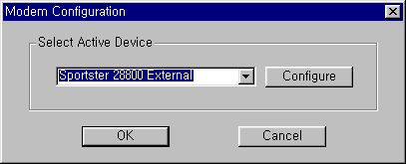
[Fig 2-6] Modem Configuration

Procedures:
- If needed, select or change modem settings by using [Control Panel].
- Select [Modem Configure] sub-menu in [Connection] menu.
- [Modem Configuration Dialog] shows up.
- The dialog shows current settings.
- [Select Active Device] : Select a modem that is to be used for modem connection with ipLDK system. The setting value is stored, and is restored and used when this program is executed next time.
- [Configure] button : This is for setting detailed modem configurations. The setting values are effective only during the execution time of this program and are not stored for next execution. Those values do not affect the modem settings of MS-Windows itself.
- Click [OK] button.

3.2.3. [Modem Connect] Sub-menu
[Modem Connect] establishes modem connection with the setting values from [Modem Configuration].

Conditions:
- If connection failure occurs, an error message is shown. The reason for the failure may be improper installation of modem, turning-off state of modem, busy state of destination, or various telecommunication problems that may occur during the session.
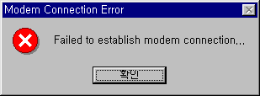
[Fig 2-7] Modem Connect Fail

- If unavailable phone number is entered or full phone number is not entered or destination does not answer, the connection is disconnected after a period of time that was set from [Modem Configure] as a time-out value.
- When making a modem connection, [Call Status Dialog] that shows the status of modem call shows up. This program shows call status messages sent from modem or modem device driver. Therefore, the messages in [Call Status Dialog] may differ from modem to modem. [Call Status Dialog] can be hidden from the screen by clicking [Hide] button on the right of [Call Status Dialog].

[Fig 2-9] Modem Connect State

- When the modem connection is established, user cannot select this menu. The menu item is disabled in that case.

Procedures:
- Select [Modem Connect] sub-menu in [Connection] menu. => [Phone Number Dialog] shows up.
- Or, user can use tool button in [ToolBar] to execute the same command.
- Enter phone number and make a modem call to destination by using [Phone Number Dialog]. (Refer to the description below for detailed explanation about how to use [Phone Number Dialog].)
- If connection failure occurs, an error message is shown, and if the connection is established, a message box shows up to notify this.
.

3.2.3.1 [Phone Book]
[Phone Book] is used for entering / storing phone numbers and making a modem call to destination.

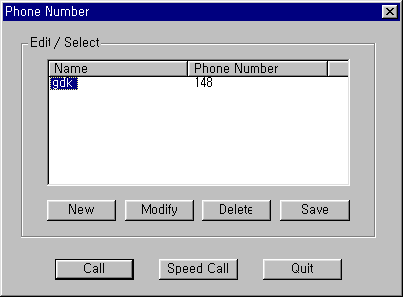
[Fig 2-9] Modem Phone Book

Procedures:
- In order to open [Phone Book], click [Modem Connect] sub-menu.
- In order to close [Phone Book], click [Quit] button.
- When entering new phone number ;

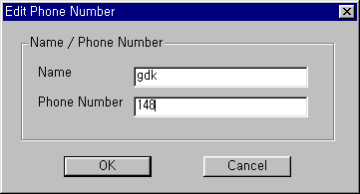
[Fig 2-10] Modem Phone Number Dialog

- Click [New] button to enter new phone number => [Edit Phone Number Dialog] shows up.
- Enter [Name] and [Phone Number]. [Name] and [Phone Number] can be input up to 40 characters, respectively. Five characters of ‘{‘, ‘}’, ‘[‘, ‘]’, ‘;’ cannot be entered for [Name]. For [Phone Number], only [Dialable Characters] can be input. (Refer to the description below for detailed explanation about [Dialable Characters].)
- Newly entered phone number is shown in [Phone Number Dialog] if [OK] button is clicked. Click [Cancel] button to cancel the input.
- If user wants to save the new phone numbers into [PhoneNo.txt] file for future use, click [Save] button in [Phone Number Dialog]. If user closes [Phone Number Dialog] without clicking [Save] button, the newly entered phone number will be lost.
- When modifying existing phone number ;
- In [Phone Number List Box], select a phone number item to be modified by clicking the [Name] of the item.
- After a selection is made, click [Modify] button. => [Edit Phone Number Dialog] shows up.
- Modify [Name] and/or [Phone Number]. [Name] and [Phone Number] can be input up to 40 characters, respectively. Five characters of ‘{‘, ‘}’, ‘[‘, ‘]’, ‘;’ cannot be entered for [Name]. For [Phone Number], only [Dialable Characters] can be input. (Refer to the description below for detailed explanation about [Dialable Characters].)
- Modified phone number is shown in [Phone Number Dialog] if [OK] button is clicked. Click [Cancel] button to cancel the input.
- If user wants to save the modified phone number into [PhoneNo.txt] file for future use, click [Save] button in [Phone Number Dialog]. If user closes [Phone Number Dialog] without clicking [Save] button, the modification will be lost.
- When deleting existing phone number ;
- In [Phone Number List Box], select a phone number item to be deleted by clicking the [Name] of the item.
- After a selection is made, click [Delete] button. => [Delete Confirmation Message Box] shows up.
- Deleted phone number is disappeared from [Phone Number Dialog] if [OK] button is clicked. Click [Cancel] button to cancel the deletion.
- If user wants to remove the deleted phone number from [PhoneNo.txt] file, click [Save] button in [Phone Number Dialog]. If user closes [Phone Number Dialog] without clicking [Save] button, the deletion will not be made in the file.
- When storing the contents of [Phone Number List Box] into file ;
- Click [Save] button in [Phone Number Dialog].
- A message box indicating success or failure of [Save] operation shows up.
- The contents of [Phone Number List Box] are saved in [PhoneNo.txt] file that is located in the directory this program is installed. User must not edit this file, and if user deletes this file by mistake, all the data in the file will be lost.
- For the stable use of [Phone Number Dialog], it is recommended to keep less than 1000 phone numbers. However, this program does not check and limit the number of phone numbers.

- When making a modem call by using [Phone Number List] ;
- In [Phone Number List Box], select a phone number item to be called by clicking the [Name] of the item.
- Click [Call] button in [Phone Number Dialog] => [Call Information Message Box] shows up.
- If [OK] button is clicked, modem call is started. Click [Cancel] button to cancel the modem call.
Or,
- Double-click on an item in [Phone Number List Box] => [Call Information Message Box] shows up.
- If [OK] button is clicked, modem call is started. Click [Cancel] button to cancel the modem call.
- When making a modem call with [Speed Call] button ;

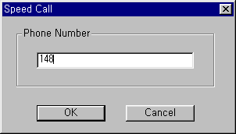
[Fig 2-11] Speed Call

- Click [Speed Call] button in [Phone Number Dialog] => [Speed Call Dialog] shows up.
- Enter phone number in [Phone Number] field. In [Phone Number] field, only [Dialable Characters] can be input. (Refer to the description below for detailed explanation about [Dialable Characters].)
- Click [OK] button, then [Call Information Message Box] shows up. If [OK] button is clicked on [Call Information Message Box], modem call is started. Click [Cancel] button to cancel the modem call. If [Cancel] button is clicked in [Speed Call Dialog], the modem call is canceled.

3.2.3.2 [Dialable Characters]
[Dialable Characters] are used to form a phone number that can be dialed. This program supports generally used [Dialable Characters]. Part of the [Dialable Characters] may not be working properly for some telephone network or modem.
- 0 – 9 A – D * #
DTMF and/or pulse digits.
- !
Hookflash (One-half second onhook, followed by one-half second offhook before continuing).
- P p
Pulse dialing is to be used for the digits following this.
- T t
Tone (DTMF) dialing is to be used for the digits following this.
- ,
This indicates that dialing is to be paused. The duration of a pause is device specific. Multiple commas can be used to provide longer pauses.
- W w
This indicates that dialing should proceed only after a dial tone has been detected.
- $
This indicates that dialing the billing information is to wait for a "billing signal" (such as a credit card prompt tone).

3.2.4. [Modem Disconnect] Sub-menu
[Modem Disconnect] disconnects modem connection.

Conditions:
- When the modem connection is disconnected, user cannot select this menu. The menu item is disabled in that case.

Procedures:
- Select [Connection] menu.
- Select [Modem Disconnect] sub-menu in [Connection] menu.
- Or, user can use tool button in [ToolBar] to execute the same command.
- If disconnection failure occurs, an error message is shown, and if the connection is disconnected, a message box shows up to notify this.

3.2.5. Important Note for Users
- The success of serial port connection means that the connection between this program and the serial port of the PC is succeeded. This does not mean the connection between this program and ipLDK/ARIA SOHO system is succeeded.
- Even though serial port or modem connection is disconnected by accident or some other reason, this program does not detect this. Instead, this program shows a message box if there is no answer after sending a command to ipLDK/ARIA SOHO system.
- If modem connection is not established after a period of time that was set from [Modem Configure] as a time-out value, this program give up making a modem connection and shows a message box to notify this.

3.3 LAN Connection with ipLDK/ARIA SOHO System
For the LAN connection between PC and ipLDK/ARIA SOHO system, there must be a physical connection with 10BaseT Cable to local network. And ipLDK system and PC should have valid IP address.

Conditions:
- ipLDK/ARIA SOHO system and PC should have valid IP address.
- If you want to connect directly, you have to use cross UTP cable. That means that the [Transmit] and [Receive] are cross. But you connect the ipLDK/ARIA SOHO system and PC with HUB, you can use normal UTP cable that is used in your local network.
- If you want to connect from the different segment of LAN or from external site(via Internet), ipLDK/ARIA SOHO system should have correct gateway address(default router). If it doesn’t have gateway address, remote connection using TCP/IP will be not available.
- If you want to connect the ipLDK/ARIA SOHO system that is used in remote site, you may need some help from network administrator. Because many site uses the firewall/NAT/PAT in their router. So, to connect the system through the Internet, some help will be needed.
- In remote connection using Internet, connection speed / stability is depend on the environment of WAN traffic or routing

3.3.1. [LAN Configure] Sub-menu
[LAN Configure] is for configuring the destination IP address that is to be connected to ipLDK system.

Conditions:
- When the LAN connection is established, user cannot select this menu. The menu item is disabled in that case.
- Setting values are stored for the next session at which they are automatically restored and used. But only one IP address will be saved.

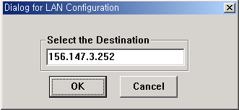
[Fig 3-1] LAN Configuration

Procedures:
- Select [LAN Configure] sub-menu in [Connection] menu.
- [LAN Configuration Dialog] shows up.
- Enter the destination IP address.
- Click [OK] button.

3.3.2. [LAN Connect] Sub-menu
[LAN Connect] connects the PC and ipLDK/ARIA SOHO system with the setting IP address from [LAN Configure].

Conditions:
- If the connection is failed, an error message shows up. It means that the IP address is not valid or the ipLDK/ARIA SOHO system doesn’t have IP address or there are some errors.

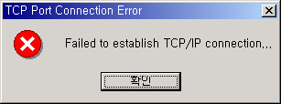
[Fig 3-2] LAN Connect Fail

- If the connection is established successfully, a message will be displayed in [Display Area]. The success of connection means that the connection between this program and the NIC of the PC is succeeded. This does not mean the connection between this program and ipLDK/ARIA SOHO system is succeeded.

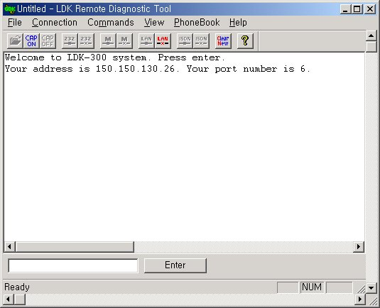[Fig 3-3] LAN Connect Succeed

- If the LAN port is already connected, the sub-menu and the tool button for LAN connection cannot be selected.

Procedures:
- Select [Connection] menu.
- Select [LAN Connect] in [Connection] menu.
- Or, user can use tool button in [ToolBar] to execute the same command.

3.3.3. [LAN Disconnect] Sub-menu
[LAN Disconnect] disconnects the LAN connection between PC and ipLDK.

Conditions:
- If the LAN connection are already disconnected, the menu and the toolbar for LAN disconnection cannot be selected.

Procedures:
- Select [Connection] menu.
- Select [LAN Disconnect] sub-menu in [Connection] menu.
- Or, user can use tool button in [ToolBar] to execute the same command.

3.4 ISDN Connection with ipLDK System – Not available with ARIA SOHO
For the ISDN connection between PC and ipLDK system, PC must have a ISDN S-Card.

Conditions:
- The PC should have ISDN S card(ISDN Modem) to connect the ipLDK system via ISDN Line. And ISDN modem drive should be installed on your PC.
- ipLDK system should have ISDN BRIB or PRIB or STIB T Mode.

3.4.1. [ISDN Configure] Sub-menu
[ISDN Configure] is for configuring the telephone number that is to be connected to ipLDK system.

Conditions:
- When the ISDN modem connection is established, user cannot select this menu. The menu item is disabled in that case.
- Setting values are stored for the next session at which they are automatically restored and used. But only one telephone number will be saved.

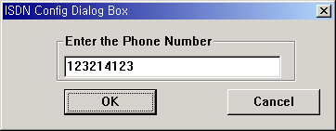
[Fig 3-4] ISDN Phone Number

Procedures:
- Select [ISDN Configure] sub-menu in [Connection] menu.
- [ISDN Configuration Dialog] shows up.
- Enter the telephone number.
- Click [OK] button.

3.4.2. [ISDN Connect] Sub-menu
[ISDN Connect] connects the PC and ipLDK system with the setting telephone number from [ISDN Configure].

Conditions:
- If the connection is failed, an error message shows up. It means that the destination site telephone number is not valid. In this case check the telephone number that you have entered.

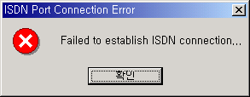
[Fig 3-5] ISDN Connect Fail
- If the connection is established successfully, a message box will be. The success of connection means that the connection between this program and the ISDN modem of the PC is succeeded. This does not mean the connection between this program and ipLDK system is succeeded.

- If the ISDN port is already connected, the sub-menu and the tool button for ISDN connection cannot be selected.

Procedures:
- Select [Connection] menu.
- Select [ISDN Connect] in [Connection] menu.
- Or, user can use tool button in [ToolBar] to execute the same command.

3.4.3. [ISDN Disconnect] Sub-menu
[ISDN Disconnect] disconnects the ISDN connection between PC and ipLDK.

Conditions:
- If the LAN connection is already disconnected, the menu and the toolbar for LAN disconnection cannot be selected.

Procedures:
- Select [Connection] menu.
- Select [LAN Disconnect] sub-menu in [Connection] menu.
    - Or, user can use tool button in [ToolBar] to execute the same command.

4. [Commands] Menu
This program can send commands to ipLDK/ARIA SOHO system to get diagnostic results while a connection is established. This program reads command configuration from [CmdConf.txt] file that is installed with executable file, and use the data for [Menu], [Command Bar], and [Input Box Bar]. [CmdConf.txt] file is command configuration file, and the contents of the file follow special rules for command configuration.

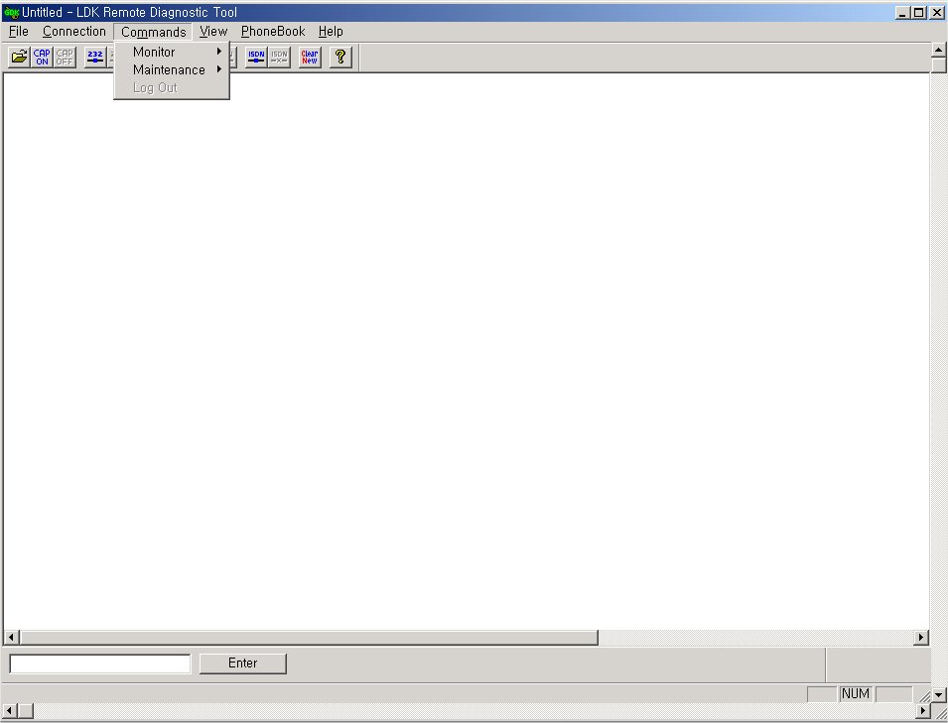
[Fig 4-1] Commands menu

4.1. Executing Commands
The following is the description about how to execute commands.
* This program does not check the validity of command argument that is needed for some commands, and error handling is done in ipLDK/ARIA SOHO system.

4.1.1 Using [Commands] Menu
[Commands] menu includes all the commands from [CmdConf.txt] file.

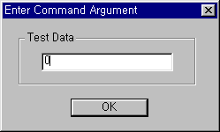
[Fig 4-2] Command Arguments Dialog
- Procedures
- Select [Commands] menu => Sub-menu of [Commands] menu is shown.
- Click on the sub-menu of the command to be executed.
- If the command needs an argument, [Enter Command Argument Dialog] shows up. Enter a proper argument in it. The length of the argument is limited to 6 characters.
- The command is executed.

4.1.2 Using [Command Bar]
- Procedures for Executing [Commands]
- Click the button of the command to be executed in [Command Bar].
- If the command needs an argument, [Enter Command Argument Dialog] shows up, and user can enter proper argument in it. The length of a argument is limited to 6 characters.
- The command is executed.

4.1.3 Using [Input Box Bar]
[Input Box Bar] can be used to execute almost all the monitoring and diagnostic commands supported by ipLDK/ARIA SOHO system. Command usages and limitations follow ipLDK system specification. The length of input in [ipLDK Command Edit Box] is limited to 40 characters
[Input Box Bar] can be docked on the top or bottom side of the window.
- Procedures for Using [ipLDK Command Edit Box] and [Enter] Button

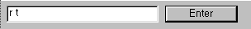
[Fig 4-4] Edit Dialog

- Click on [ipLDK Command Edit Box] so that input cursor comes to be blinking inside the box. If input cursor already exists in [ipLDK Command Edit Box], this procedure is not needed.
- Input ipLDK command in [ipLDK Command Edit Box]. The length of the input is limited to 40 characters.
- Click [Enter] button to send the command input in [ipLDK Command Edit Box] to ipLDK system. Or, user can press [Enter Key] on keyboard to send the command.
- If [Enter] button is clicked when [ipLDK Command Edit Box] is empty, a character that corresponds to [Enter Key] is sent to ipLDK system. The same operation can be done by pressing [Enter Key] when input cursor exists in [ipLDK Command Edit Box].
- If user wants to log-in again to ipLDK/ARIA SOHO system after log-out from maintenance or monitor mode, he/she can click [Enter] button to get a chance to input password and log-in again.
- When user tries to execute a remote command (r-type command) that needs an argument by typing the command in [ipLDK Command Edit Box], he/she should also type the argument with the command. For [ipLDK Command Edit Box], [Enter Command Argument Dialog] is not provided.

4.2. Functions of Commands
Commands provided by ipLDK/ARIA SOHO system are as follows ;
- [Monitor Commands] that is available when user logged on with ‘jennie’ as password.

? - Help menu
t b xx - Set Board Trace
t [c|e|h|t] ([s|c|d|t|v|#]xxx) [a|r] - Set Device Trace
t d - Delete Trace Info
t p - Show Trace Setup Info
d [addr1] [addr2] - Mump Memory
m addr xx - Modify Memory
s ### - STA Status
c ### - COL Status
v ### - VMIB Status
l ### - Logical STA Status
p [v][s] - Print Port Assign
gsxd dump [all] - GSXD dump
x - Exit monitor

- [Remote Commands] that is available when user logged on with ‘brandy’ as password.

? - Help Menu
bc - Display Board Configuration Table
bl - B-channel Listening
bs ## - View Board Status
db [de][dr] - Display Diagnostic Result
hd - Display HDLC Status
log [view|clear] - Log view or clear
reboot - Remote System Reset
setsw [oos|nor] ## - Set Service Switch
ta [all][period][atd][callsum]…… - Traffic Analysis
ts - Display Time-slot Assigment
up - S/W Upgrade
vc [s][u][a]… - VMIB Annc/Usr Greeting Clear
ws ? - WTIB Statistics
x - Exit Command

And [db] command’s detail information is displayed in below.
db cc - Configuration Constraint
db pf - Pre-Programmed Fault
db ts - Time-Slot Conflict
db ht - Hiway TestPre-Programmed Fault
db dt - DTRU Test
db ct - CPTU Test
db mt - Memory Test
db rt - RTC Test
db pc - Power Capacity
db rc - RGU Capacity
de hs - HDLC Status
dr [is/ic] - ISDN Line Status
dr [ri/rc] - Reset Information
dr li [d/c/v/a] - Resource Assignment

4.2.1 Monitor – Set Board Trace
Sets trace for board in slot xx.
For setting trace for board in slot 7:
mon>t b 07

4.2.2 Monitor – Delete Trace Info
Deletes all current trace commands and revert to idle condition.

4.2.3 Monitor – Set Device Trace
Sets trace for device.
Command options are as following:
c : device COMMAND tracing. (MP → PP)
e : EVENT tracing. (PP, Internal, Timer Event)
h : HIGHWAY tracing.
t : CTI device command / event tracing.
Device options are as following:
S : Tracing related to station
C : Tracing related to CO
D : Tracing related to DTMF
T : Tracing related to CPTU
V : Tracing related to VMIB channel
If you want to trace the Station 102 about Cmd, Evt and Hiway information, you should enter the command option with physical station number as following;
mon>t ceh s002
At the Sxxx, xxx should be physical station number, i.e., port number of station. So, even if the station number was changed from 102 to 702, the physical station number is not changed;
mon>t ceh s002

4.2.4 Monitor – Dump Memory
Dumps memory between the two addresses, which are in hexa decimal. If you omit one of the two address range memories are dumped beginning at address specified until pressing Ctrl-C.

4.2.5 Monitor – Modify Memory
Modify memory beginning at the address until pressing Ctrl−C.

4.2.6 Monitor – COL Status
This command is for showing the status of a CO line connected to ipLDK/ARIA SOHO system.

Conditions:
- This command can be executed when this program is connected to ipLDK/ARIA SOHO system.
- If [OK] button is clicked without entering value in [Enter Command Argument Dialog], a message box that indicates this shows up. (Empty field is not allowed)
- User can cancel the command by clicking [X] button on the top right side of [Enter Command Argument Dialog].
- The length of the argument is limited to 6 characters.
- The argument is a physical port number that starts from 1.
- If non-numeric value is entered, ipLDK/ARIA SOHO system assumes it as starting port number.
- If invalid value (or big value) is entered, ipLDK/ARIA SOHO system handles the error.

Procedures:
- Select [CO Status] sub-menu in [Commands] menu, or click [CO Status] [Command Bar] button.
- Or, user can input “c #” (# : Port Number) in [ipLDK Command Edit Box] and then click [Enter] button, or select [CO Status] in [Remote Command Combo Box] and then click [Execute] button.

For showing status of CO number 07
mon> c 07
Here is an example of CO line status:

Slot0, Chan0, State0, AscD255T255

Slot = 00, Dev No = 00, Hiway = 00, Timeslot = 2341cc
RX_Sum Loc = ffff, TX_Sum Loc ffff
Ucd0, Store0, Sent0

22739c 00 00 00 ff 00 00 00 ff ff ff 05 ff ff ff 01 00
2273ac 00 ff ff ff ff 00 ff 00 00 00 00 00 00 00 00 00
2273bc 00 00 00 00 00 00 00 00 00 00 00 00 00 00 00 00
2273cc 00 00 00 00 00 00 00 00 00 00 00 00 00 00 00 00
2273dc 00 00 00 00 00 00 00 00 00 00 00 00 00 00 00 00
2273ec 80 00 00 10 ff ff 00 00 00 00 00 00 00 00 00 00
2273fc 00 00 00 00 00 00 00 00 00 00 00 00 00 00 00 00
22740c 00 00 00 00 00 00 00 00 00 00 00 00 00 00 00 00
22741c 00 00 00 00 07 00 00 00 00 00 00 00 00 00 00 00
22742c 00 00 ff 00 00 ff 00 ff 00 ff 64 ff 00 00 00 ff
22743c ff 00 00 00 00 ff ff 00 00 00 00 00 00 00 00 00
22744c 00 00 00 00 00 00 ff ff ff 00 ff 00 ff ff 00 ff
22745c 00 00 00 ff ff 00 ff ff ff ff ff 00 00 00

4.2.7 Monitor – STA Status
This command is for showing the status of a station connected to ipLDK/ARIA SOHO system.

Conditions:
- This command can be executed when this program is connected to ipLDK/ARIA SOHO system.
- If [OK] button is clicked without entering value in [Enter Command Argument Dialog], a message box that indicates this shows up. (Empty field is not allowed)
- User can cancel the command by clicking [X] button on the top right side of [Enter Command Argument Dialog].
- The length of the argument is limited to 6 characters.
- The argument is a physical port number that starts from 0.
- If non-numeric value is entered, ipLDK/ARIA SOHO system assumes it as starting port number.
- If invalid value (or big value) is entered, ipLDK/ARIA SOHO system handles the error.

Procedures:
- Select [Station Status] sub-menu in [Commands] menu, or click [Station Status] [Command Bar] button.
- Or, user can input “s #” (# : Port Number) in [ipLDK Command Edit Box] and then click [Enter] button, or select [Station Status] in [Remote Command Combo Box] and then click [Execute] button.

For showing status of station 107
mon> s 008
Here is an example of STA status:
Slot1, Chan97, State1, AscD255T255
Ucd0, Store0, Sent0
Xfer0, Hold0, Held255

22175c 00 01 01 04 00 61 01 ff ff ff ff ff ff 00 ff ff
22176c ff ff ff 40 00 00 80 00 60 18 00 00 00 ff ff 00
22177c 00 00 00 00 00 ff ff ff ff 00 0a 08 00 ff 00 00
22178c ff ff 00 00 ff 00 00 00 00 00 00 00 ff ff ff ff
22179c ff ff ff 00 ff 00 00 00 00 00 00 00 00 00 00 00
2217ac 00 00 00 00 00 00 00 00 00 00 00 00 00 00 00 00
2217bc 00 00 00 00 00 00 00 00 00 00 00 00 00 00 00 00
2217cc 00 00 00 00 00 00 00 ff ff ff ff ff ff ff ff ff
2217dc ff ff ff ff ff ff ff ff ff ff ff ff ff ff ff ff
2217ec ff ff ff ff ff ff ff ff ff ff ff ff ff ff ff ff
2217fc ff ff ff ff ff ff ff ff ff ff ff ff ff ff ff ff
22180c ff ff ff ff ff ff ff ff ff ff ff ff ff ff ff ff
22181c ff ff ff ff ff ff ff ff ff ff ff ff ff ff ff ff
22182c ff ff ff ff ff ff ff ff ff ff ff 00 00 13 39 2e
22183c 00 2a 05 00 ff 00 00 00 00 00 00 14 00 01 00 00
22184c 00 00 00 00 00 00 00 00 00 01 00 00 00 00 00 00
22185c 00 00 00 ff 00 18 00 00 00 00 ff ff ff ff 01 b8
22186c 00 00 ff ff 00 00 00 00 00 22 18 74 00 22 18 74
22187c 00 22 18 7c 00 22 18 7c 00 00 00 00 ff 00 ff ff
22188c 00 00 00 ff 84 ff ff ff ff 02 84 ff ff ff ff 02
22189c ff ff 00 00 00 ff ff 00

4.2.8 Monitor – Print Channel Assign
Sets print port. You can select one of several print ports. By default, serial interface unit 1 is used.

4.2.9 Monitor – x
This command is for log-out from ipLDK system.
Conditions:
- This command can be executed when this program is connected to ipLDK/ARIA SOHO system.

Procedures:
- Select [Log Out] sub-menu in [Commands] menu, or click [Log Out] [Command Bar] button.
- Or, user can input “x” in [ipLDK Command Edit Box] and then click [Enter] button, or select [Log Out] in [Remote Command Combo Box] and then click [Execute] button.

4.2.10 Monitor - ?
This command is for showing the help messages of [Remote Commands].
Conditions:
- This command can be executed when this program is connected to ipLDK/ARIA SOHO system.

Procedures:
- Select [Help Message] sub-menu in [Commands] menu, or click [Help Message] [Command Bar] button.
- Or, user can input “?” in [ipLDK Command Edit Box] and then click [Enter] button, or select [Help Message] in [Remote Command Combo Box] and then click [Execute] button.

4.2.11 Maintenance - Display Board Configuration Table(bc)
This command is for showing the board configuration of ipLDK/ARIA SOHO system.

Conditions:
- This command can be executed when this program is connected to ipLDK/ARIA SOHO system.
- User can confirm the configuration of the boards installed in ipLDK/ARIA SOHO system.

Procedures:
- Select [Board Configuration] sub-menu in [Commands] menu, or click [Board Configuration] [Command Bar] button.
- Or, user can input “bc” in [ipLDK Command Edit Box] and then click [Enter] button, or select [Board Configuration] in [Remote Command Combo Box] and then click [Execute] button.

4.2.12 Maintenance - B-channel Listening(bl)
Listens B-channel of specified time slot.

4.2.13 Maintenance - View Board Status(bs ##)
This command shows board status. ## is slot number.

4.2.14 Maintenance - Display HDLC Status(hd)
This command shows HDLCstatus.

4.2.15 Maintenance - Log View or Clear(log [view|clear])
Log information can be viewed and cleared by this command.

4.2.16 Maintenance - Remote System Reset(reboot)
This command resets the system. You should enter admin password twice to reset the system. If the admin password does not exist, 147* is used temporarily for admin password.

4.2.17 Maintenance - Traffic Analysis(ta [all][period][period_abort][atd][callsum] [callhour] [hw] [cosum] [cohour])

Shows traffic analysis data.
Command options are as following:
ta all <timetype> - Print All Traffic Report
ta period <hhmm> <timetype> - Print Traffic Report Periodically
ta period_abort - Cancel Periodic Print
ta atd <timetype> - Print Attendant Traffic Report
ta callsum - Print Call Summary Report
ta callhour - Print Call Hourly Report
ta hw <timetype> - Print H/W Usage Summary Report
ta cosum <timetype> - Print CO Traffic Summary Report
ta cohour <cogrp#> - Print CO Traffic Hourly Report

timetype - [tt|yt|lh|yp|tp]
- tt : Today Total
- yt : Yesterday Total
- lh : Last Hour
- yp : Yesterday Peak
- tp : Today Peak
Refer to 2.30 Traffic Analysis for detailed information and print form.

4.2.18 Maintenance - Display Time-slot Assignment(ts)
Displays time-slot assignment.

4.2.19 Maintenance - S/W Upgrade(up)
Upgrades software.

4.2.20 Maintenance - WTIB Statistics(ws ## [command])
Shows WTIB statistic data.
Command options are as following:
[?] : Help
[upload] : Upload Data statistics data
[call] : Total number of call & direction of the call
[subs] : Information per subscripted device
[eoc] : End of call
[cell] : Usage of frequency and slot
[traf] : Show holding time
[acce] : Access info.(basic/hand-over)
[clea] : Clear statistics data
Refer to WTIB Statistics for more detailed information and print form.

4.2.21 Maintenance - Exit(x)
This command is for log-out from ipLDK system.
Conditions:
- This command can be executed when this program is connected to ipLDK/ARIA SOHO system.

Procedures:
- Select [Log Out] sub-menu in [Commands] menu, or click [Log Out] [Command Bar] button.
- Or, user can input “x” in [ipLDK Command Edit Box] and then click [Enter] button, or select [Log Out] in [Remote Command Combo Box] and then click [Execute] button.

4.2.22 Maintenance - Help(?)
This command is for showing the help messages of [Remote Commands].
Conditions:
- This command can be executed when this program is connected to ipLDK/ARIA SOHO system.

Procedures:
- Select [Help Message] sub-menu in [Commands] menu, or click [Help Message] [Command Bar] button.
- Or, user can input “?” in [ipLDK Command Edit Box] and then click [Enter] button, or select [Help Message] in [Remote Command Combo Box] and then click [Execute] button.

4.2.23 Diagnostic – Configuration Constraint(db cc)
Shows if the current configuration meets the configuration constraints.

4.2.24 Diagnostic – Pre-programmed Fault(db pf)
Shows pre-programmed faults. Checks if the admin programmed data are different from the boards that are installed in the system. Prints warning message if there is any difference.

4.2.25 Diagnostic - Time-slot Conflict(db ts [sl][cf])
Shows time-slot assignment table and time-slot assignment conflict status. In case of PRIB, channel 31, 32 should be assigned the same time slot with that of channel 1. Command options are as following:
[sl] – time-slot assignment table
[cf] – time-slot conflict

4.2.26 Diagnostic – Hiway Test(db ht ## ## #)
Tests PCM hiways using one DKT and one DTMF receiver. If you assign slot number, dtmf receiver duration time, and hiway number, this program tests 48 time-slots in the specified hiway. Note that the first DKT of the assigned slot is used for the test. The DKT is connected to time-slot successively and DTMF tone is connected to that time-slot too. If the DKT receives the specified DTMF tone, we regard the time-slot operates correctly.

Usage: db ht xx yy # ( xx: slot number(DTIB), yy: dtmf duration time, #: hiway number(0-7))

4.2.27 Diagnostic – DTRU Test(db dt)
Tests DTMF receiver. This feature tests all DTMF receivers in the system. Currenlty max 32 dtmf receivers can be tested

4.2.28 Diagnostic – CPTU Test(db ct)
Tests CPTU.

4.2.29 Diagnostic – Memory Test(db mt)
Tests DRAM modules. Writes specified value(e.g. 0x5a) to the DRAM and reads again, to check if the valid data are read.

4.2.30 Diagnostic – RTC Test(db rt)
Tests RTC. You can see current time and modify it. The time does not elapse when you test RTC, so you have to correct the time before you finish it.

4.2.31 Diagnostic – Power Capacity(db pc)
Shows power capacity of the PSU and current power usage status of the system. If the total power usage per rack exceeds the limit, you should change the confiugration.

4.2.32 Diagnostic – RGU Capacity(db rc)
Shows RGU capacity. This feature shows RGU capacity, CO incoming ring cadence and ICM call ring cadence. You don’t have to uninstall the station even if the number of stations exceeds the RGU capacity.

4.2.33 Diagnostic – HDLC Status(de hs)
Shows HDLC status.

4.2.34 Diagnostic – ISDN Line Status(dr is)
Shows ISDN line status information.

4.2.35 Diagnostic – Reset Information(dr ri)
Shows reset information.

4.2.36 Diagnostic – Resource Assignment(dr li [d|c|v|a])
Shows current resource assignment
d – DTMF receiver assignment
c – CPTU assignment
v – VMIB channel assignment
a – DTMF, CPTU, VMIB channel assignment

5. [View] Menu
[View] menu is used for showing / hiding [ToolBar], [Status Bar], [Command Bar], [Input Box Bar], and for clearing [Data Display Area] and starting a new document.

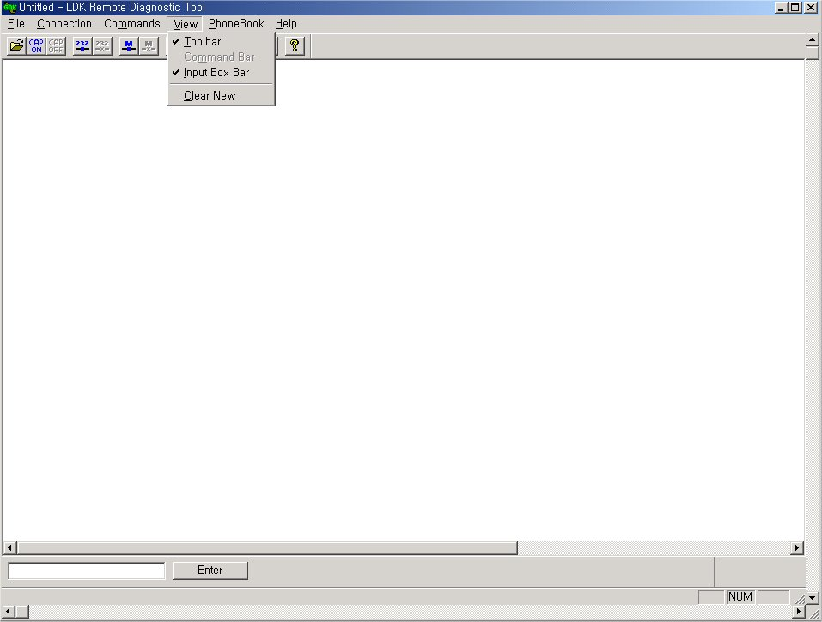
[Fig 5-1] View menu

5.1. [ToolBar] Sub-menu
[ToolBar] sub-menu is working in toggling way, and a check mark is shown when [ToolBar] is shown on the screen.

Procedures:
- Select [ToolBar] sub-menu in [View] Menu.
- If [ToolBar] is shown on the screen, it becomes to be hidden, and if it is hidden already, it becomes to be shown.

5.2. [Command Bar] Sub-menu
[Command Bar] sub-menu is working in toggling way, and a check mark is shown when [Command Bar] is shown on the screen.

Procedures:
- Select [Command Bar] sub-menu in [View] Menu.
- If [Command Bar] is shown on the screen, it becomes to be hidden, and if it is hidden already, it becomes to be shown.
** Command Bar is enabled only after you have entered Monitor or Maintenance Mode.

5.3. [Input Box Bar] Sub-menu
[Input Box Bar] sub-menu is working in toggling way, and a check mark is shown when [Input Box Bar] is shown on the screen.

Procedures:
- Select [Input Box Bar] sub-menu in [View] Menu.
- If [Input Box Bar] is shown on the screen, it becomes to be hidden, and if it is hidden already, it becomes to be shown.

5.4. [Clear New] Sub-Menu
[Clear New] sub-menu is used for clearing [Data Display Area] and starting a new document. Because new document has no name (or title) yet, ‘Untitled’ is shown on the [Title Bar] of the window as a document name.

Procedures:
- Select [Clear New] sub-menu in [View] Menu.
- Or, user can use tool button in [ToolBar] to execute the same command.
- All the data displayed in [Data Display Area] are erased, and new document is started.

6. [Help] Menu
In [Help] menu, only [About ipLDK Remote Diagnostic Tool] sub-menu exists.

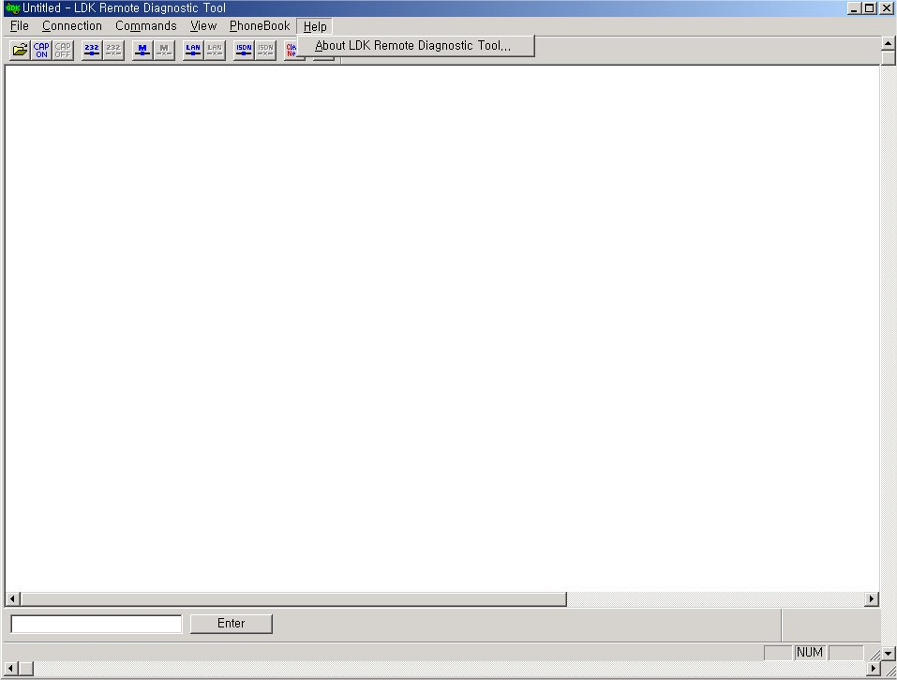
[Fig 6-1] Help menu

6.1. [About ipLDK Remote Diagnostic Tool] Sub-menu
When [About ipLDK Remote Diagnostic Tool] sub-menu is clicked, [About ipLDK Remote Diagnostic Tool Dialog] shows up, and the name of this program and copyright information is displayed on the dialog.

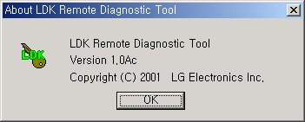
[Fig 6-2] About Dialog

Procedures:
- Select [About ipLDK Remote Diagnostic Tool] sub-menu in [Help] menu.
- Or, user can use tool button in [ToolBar] to execute the same command.
- [About ipLDK Remote Diagnostic Tool Dialog] shows up.
- When [OK] button is clicked, [About ipLDK Remote Diagnostic Tool Dialog] disappears.

7. [Data Display Area]
[Data Display Area] displays the data from serial port, modem or data file. When displaying data, this area follows some rules and executes functions according to them.

7.1. Data Display Functions
If the data to be displayed exceeds the size of [Data Display Area], a vertical scroll bar appears to enable scrolling [Data Display Area]. Horizontal scroll bar is always displayed even though the width of displayed data does not exceed the size of [Data Display Area].
- While data are coming from serial port or modem, [Data Display Area] is automatically scrolled to the last line if the data to be displayed exceeds the size of [Data Display Area].
- If the data are from data file, [Data Display Area] is not scrolled to the last line but displays the data from the first line.
- If a data file is opened while data are coming from serial port or modem and being displayed in [Data Display Area], previously displayed data are erased and new data from data file are displayed in [Data Display Area]. If more data are still coming from serial port or modem, the data are appended after the last line of the file data and the file name remains the same. This is for preventing loss of real time data from serial port or modem.
- If user executes a ipLDK/ARIA SOHO command after opening a data file, the file is closed and new file (or document) is started with the name “Untitled”.
- Once a file name is assigned for the data in [Data Display Area] by using [Save] sub-menu or [Save As] sub-menu, the file name remains the same even though more data are coming from serial port or modem and being displayed. Therefore, the appended data can be stored in the same file.
- If [Clear New] sub-menu is selected or [Clear New] tool button is clicked, [Data Display Area] is cleared and a new document (or file) named “Untitled” is started.

7.2 Automatic Data Storing Functions
[Data Display Area] does not scroll indefinitely. If the number of lines of displayed data exceeds 2,000 lines (in general), this program stores the displayed data into a data file and clears [Data Display Area]. Then, this program keeps displaying incoming data in [Data Display Area]. The maximum number of lines of data is system dependant. If the PC is using smaller fonts, more lines will be displayed.
- In general, if more than 2,000 lines of data are displayed in [Data Display Area], the data are stored in a data file automatically. The name of the file has the format of “Thhmmss.dat” (hh : current hour , mm : current minute , ss : current second), and this file is saved in the directory this program is installed. User can open this file by using [Open] sub-menu or [Open] tool button to see the contents of the file.
- While automatic data storing function is being executed, several bytes of data may be lost. This happens especially when the data transfer rate is high and performance of PC is low or the PC is busy working other jobs. And, the first line of data displayed after automatic data storing function is executed may have broken format.

7.3 Important Notes for Users
If the performance of the PC is not good enough, some scrolled data may not have complete forms. If this happens, scroll [Data Display Area] by using scroll bar to refresh the area.

