MGI64 Upgrade Procedure (Simple Look)

1. Connect SIO Cable
SET : 36800-8-none-1-none

2. Login MGI64 Board.
* Bootrom Mode: id - mgi, pwd - mgi
* Program Mode: id - mgi, pwd - mgi1234
* Telnet Mode: id - mgi, pwd - mgi12345

3. Run Config Command.
* Input "allset" command and follow the command.

4. Reboot
--------------------------------------------------------------
MGI64 Card use the tftp upgrade method.
so, prepare one computer for tftp server, and SIO Cable.

When you configure the tftp server IP address, and MGI64 Card IP address,
Restart the MGI64 Card. It make automatically upgrade MGI64 new S/W.

- Make “MGI64” New Directory.
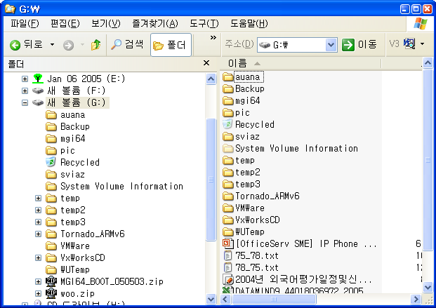
MGI64 Folder

- Copy MGI64 S/W
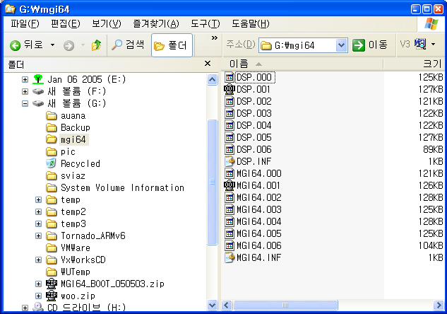

- First Install tftp Server program.
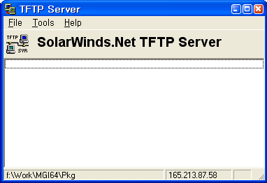

- Configure tftp Server like below.
File -> Configure
* This is Tftp Root Directory
* MGI64 directory will be show.
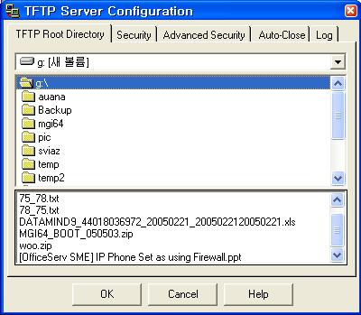

- Check Security Option
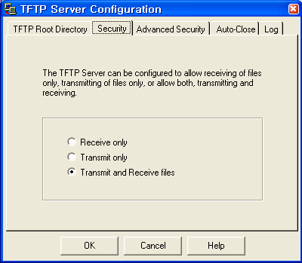

- Connect MGI64 with SIO cable
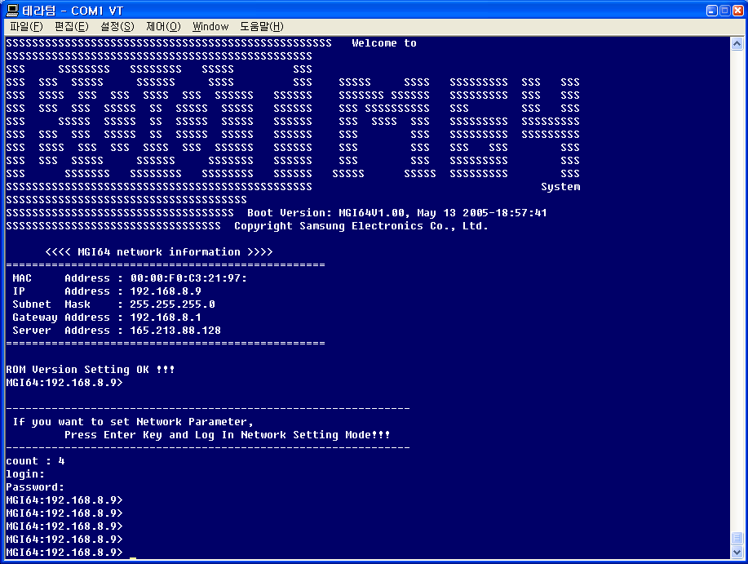
Before the digit 0, press ‘enter key’
Id: mgi
Pwd: mgi

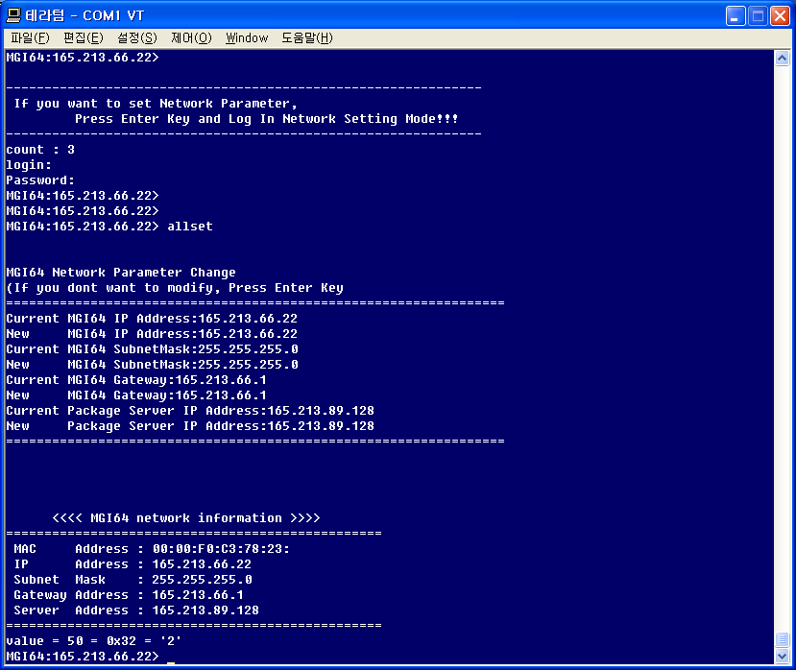
Input “allset” command
Tftp Server IP address

- After then, reboot, MGI64 Card reload the S/W imge. And save it.

