checking up and maintenance and repairing.
Until Now to operate offline administrator program we have used RS-232C as a interface between OfficeServ system and PC.
But there was some problem of network speed and preparing the cable and limitation of range between OfficeServ system
and PC. So we added the LAN feature which make it possible to access Offline administration mode by using telnet.

The followings describe the two type of method which are using SIO port and Telnet.
(In order to use telnet you have to know the IP address of MCP Board.)

Consol's SIO port Connection Setup and Lan Configuration
OfficeServ500 BOOT ROM via SIO&LAN upgrade
Connect SIO (DB-9) IOM 1 port to the RS-232C PC port.

Consol's SIO port Connection Setup and Lan Configuration

SIO(DB-9) PC (DB-9)
3 2
2 3
5 5

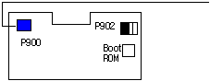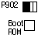BP900

oot3ROM
P902

<3pin spec>

①②③
Figure 1. MCP 3Pin SIO Configuration

1. The method of Offline mode Access (Refer to above figures)

1.1 Using SIO port
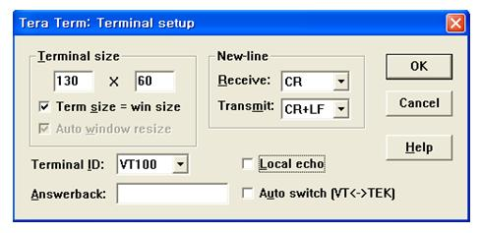
Figure 2. SIO PC Setup.
(Caution) when you setup NewLine, you have to choose CR+LF in Transmit item.

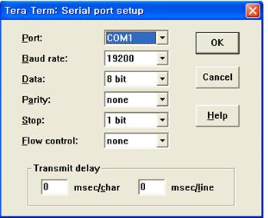
Figure 3. SIO PC Setup.

1. The method of Offline mode Access (Refer to above figures)
1.1 Using SIO port
1) After you connect PC to Consol SIO port 1 (DB-9) in IOM B’d of OS500 with 19200 BPS speed.
Power on or press reset button then you could see the follow blue colored message.
And press the Enter Key. (the red colored is the message which you have to input)

[Startup PGM] <<< Startup Program of OfficeServ 500/7200 System >>> V1.06:2006/02/09

[Startup PGM] Success to the getting mcp file(MPPSV263.ZPG), try to loading to DRAM
[Startup PGM] Because mcp file(MPPSV263.ZPG) is zip file, need to decompress after loading !
<= When This Time Press [ENTER] Key

2) After System accept the Enter Command it shows the following Message .
And System would wait for user's password input.
Please input your password : os500samsung
Be careful not to input anything or wrong password.
If you do not input anything or input the wrong password , after 30sec later
system would be restarted. If it is normal, you could see the following Menu list.

[Startup PGM] STOP the load to DRAM by Consol command
[Startup PGM] OffiecServ500/7200 System, Enter password !
os500samsung

1.2 Using Telnet.
Telnet method is only supported in OS500 System.
(Causion 1) To access to Boot Program with Offline Mode by using Telnet
you should try to connect within 5 seconds after Power On or Reset.
To access to Startup Program with Offline Mode by using Telnet
you should try to connect within 15~40 seconds after Power On or Reset.
(Causion 2) In General Telnet Port number uses 23, but in the case of connecting to Boot or Startup Program
You should use the port number 5082

1) By using PC's telnet program (IP : MCP IP, Port :5082) connect to the MCP
Red color string is input command and blue color is the string shown in your terminal.

2) After connected System will wait for password input.
At that time please input your password (os500samsung) and you can see the Menu list and
system would go into Offline mode.
If you do not input anything or input the wrong password then System would be restarted.
[Startup PGM] STOP the load to DRAM by Consol command
[Startup PGM] OffiecServ500/7200 System, Enter password !
os500samsung

2. How to change Boot ROM program
2.1 Using SIO port
It is the general method to chage BOOT ROM program by using ROM Writer ,
but you can also change BOOT program by entering "chgboot" command after loading "btos500.pgm" file to the SM or MMC card.

- you can find the current default IP of MCP B'd in previous picture Offline mode
in Startup.
- If you want to change its ipadress , please enter the command "writeip".
writeip assign generate gateway ip and subnet mask automatically.
To assign manually you can enter the command "writeip2" as following.
EX) WRITEIP2 160.217.070.009 160.217.070.003 255.255.255.000
(second is default gateway and 3rd is subnet mask)

- To update BTOS500.pgm you have to use the "chgboot" command, answer the following question to be 'y'
(If you input 'n' then command execution would be canceled.)

[Startup PGM] *******************************************************************************
[Startup PGM] * Warning : Are you sure?(y/n) *
[Startup PGM] *-----------------------------------------------------------------------------*
[Startup PG
[Startup PGM] * If you answer yes, All content will be clear in the BOOT FLASH MEMORY *
[Startup PGM] *******************************************************************************

y

[Startup PGM] Start change BOOT program (Wait a minute please ... )
[Startup PGM] Success to the getting BOOT file(BTOS500.PGM
), try to loading to DRAM
[Startup PGM] To be display '#' mark every 128K byte loading to DRAM
##
[Startup PGM] load file Check sum is O.K, Origin CheckSum:0696, loaded CheckSum:0696, file size:154320 byte
[O.K]
[Startup PGM] Success to the loading to DRAM
[Startup PGM] Now start change Boot program of OfficeServ500 System
[Startup PGM] BOOT FLASH MEMORY TYPE is AMD AM29LV040B, Sector_size is 0x10000
[Startup PGM] Erased Boot flash memory
[Startup PGM] Now start write Boot program on Boot flash memory.... Wait a minute please ...
|1%
######################################

[Startup PGM][O.K]

[Startup PGM] *******************************************************************************
[Startup PGM] * End of BOOT program change *
[Startup PGM] * System restarts... Wait a minute *
[Startup PGM] *******************************************************************************

8) After Boot program update is completed , the System would be restarted.
Please check the version and date on the initial screen .
[Boot PGM] <<< Boot Program of OfficeServ 500/7200 System >>> V1.06:2006/05/26
[Boot PGM] This board is for SmartMedia memory card.

2.2 Using Telnet
(Caution)
To access to System at the Offline mode in Startup Program,
Please connect to the MCP B'D(IP: IP, Port:5082) within 15~40 seconds using telnet program
after Power on or Reset.
Here the time of 15~40seconds mean the time between after boot Program started up and On running
Startup Program.

1) It is same to the SIO Port using Method in Offline mode of Startup Program.
(Caution)If Boot program update is completed , system would be restarted,
At that time, the following message would be shown just before restarting
This restart process is going by SIO , therefore if you are using telnet method
you need to connect again by telnet program.

