# SCM Operating System Migration Tool

## **Migration Tool**

The Version over SCM v5.4.2.6 should use “CentOS 6” or CentOS 7.

We suggest the migration with Migration Tool.

The purpose of this tool is to prevent loss of data due to operating system changes by backing up and restoring existing data before the re-installation of the operating system.

|  |  |
| --- | --- |
| Operating System Version | SCM Version |
| CentOS 5 | Below V5.4.2.6 |
| CentOS 6 | V6.0.0.5 or later |
| CentOS 7 | Above V7.0.1.1 |

## **Summary of the entire migration step**

This chapter displays flow of the entire migration sequence.

Migration Tool Feature is a rectangle with a blue background.

If other operation is required, it is a rectangle with a vertical line.

Rhombus is an indication of what should check.

Start

VSCM 버전 확인

V5.4.2.6으로

업그레이드

V5.4.2.6에서 백업 수행

업 수행

Check

SCM Version

Upgrade

to V5.4.2.6

Backup using migration tool

Download backup

Data from Server

Install SCM version

to upgrade(DVD)

Upload backup

data to Server

Migration using

Migration tool

Migration result

Install Previous

Version ISO DVD

Rollback to

Previous version

Migration Done

Under V5.4.2.6

V5.4.2.6 or Higher

Rollback Done

Fail

Success

## **Migration Tool Feature**

This chapter explains the Migration tool which be supported feature.

1. Backup from v5.4.2.6 or higher version

* This tool provides the ability to backup data from an existing operating systems.
* Backup Data is following lists.
  + - Database
    - Basic Configuration (IP, License, Encoding, TLS certificates, NTP, DNS, etc.)
    - UMS(Voicemail and UMS)
    - Announcement
    - CDR
    - Phone Data(Phone and Gateway’s package and profile)
    - Photo Data(User’s Phone data)
* Backup feature is only available v5.4.2.6 or higher.

1. Migration

* This tool provides the ability to migration from backup data by created using migration tool.
* Migration feature is available in V6.x or V7.x

|  |  |
| --- | --- |
| Data backup | Migration |
| V5.4.2.6 | V6.x |
| V7.x |
| V6.x | V7.x |

1. Rollback to previous version

* This tool provides the ability to roll back data from backup data by created using migration tool.

## **Migration Tool Usage**

This chapter explains how to use the Migration tool feature.

### Pre-requirement

* 1. **CentOS_MigrationTOOL.tar.gz**
* Migration Tool for CentOS 5/6/7
  1. **Version to upgrade ISO DVD(V6.x or V7.x)**
  2. **Data Backup Storage**
  3. **Current version ISO DVD( for rollback)**

### Precautions

1. Migration Tool should be executed by super user (root).
2. Database and Basic Configuration should be backed up.
3. The SCM server must have enough space for data backup.
4. (Strongly Recommend) Execute the migration tool for each server to backup data.
   * 1. If migrating only the DB and Basic Configuration, operates the tool on single server.
5. This Migration tool, backup is only support V5.4.2.6 or higher version.

* If Current SCM version is lower than v5.4.2.6, should upgrade to v5.4.2.6.

1. In the amount of time the migration tool will operate depends on the amount of data.

* If the data is 85 GB, it takes at least 4 hours for each step of the migration tool.

※ above time is not include file transfer time and ISO DVD installation time.

1. V6.0.0.5 can be installed only at S500-II and S700 models.

This version MUST NOT be installed in S500 (4G memory) because of the insufficient memory size.

1. V7.x can be installed only at R340 model.

### Backup

* Before start backup, Migration Tool check the SCM version.
* Backup feature is only available in v5.4.2.6 or higher version.

**Step 1**. Upload “CentOS_MigrationTOOL.tar.gz” on the server and unzip to back up

the data.

FTP and SSH ID is **scm**, execution ID is “**root**”.

Then make directory “**/home/scm/MIG**”.

In the table below, the **red text** is the execution command.

[root@SCM-vmc-12 scm]# **cd /home/scm**

[root@SCM-vmc-12 scm]# **mkdir /home/scm/MIG**

[root@SCM-vmc-12 scm]# **cd /home/scm/MIG**

[root@SCM-vmc-12 scm]# **tar xvzf /home/scm/CentOS_MigrationTOOL.tar.gz**

**Step 2**. Start data backup.

When backup is done, “**scm_backup**” sub-directory is automatically created.

At least Database and Basic Configuration should be backed up.

In the table below, the **red text** is the execution command.

[root@SCM-vmc-12 scm]# **cd /home/scm/MIG**

[root@scme-vmc-12 MIG]# **./start_migration.sh**

========================================================

MIGRATION TOOL CLI

========================================================

Centos xx

Consol Commands :

1. Backup - Backup SCM Data

2. Restore - Restore using backed up SCM Data

3. Migration - Migration to a new system using backed up SCM data

exit - exit.

CLI >> **1**

Backup Commands :

0. Total Backup - Total Data Backup.

1. DB Backup - Database Backup.

2. CONFIG Backup - Basic Configuration Backup .

3. UMS Backup - VoiceMail and UMS Data Backup.

4. Announce Backup - Announce Data Backup.

5. CDR Backup - CDR Data Backup.

6. Phone Data Backup - Phone/GW Data Backup.

7. Photo Data Backup - User Photo Data Backup.

exit - exit.

CLI >> **0**

**Step 3.** After Backup is done, make a one file using tar.

In the table below, the **red text** is the execution command.

Input is 0, Start Backup

This program will shutdown scm express software.

Will you execute ? (yes/no)

CLI >> **yes**

TOTAL DISK_SIZE: 32765 MB

[Disk Current/Max 18114/32765 MB, required 1708 MB]

SCM Stop >> START

SCM Stop >> END

DB Backup >> Start

…

CDR Backup >> Start

CDR Backup >> Success

Phone/GW Backup >> Start

Phone/GW Backup >> Success

Photo Backup >> Start

Photo Backup >> Success

Backup Completed.

[root@SCM-vmc-12 MIG]# **tar cvf scme-backup.tar scm_backup log**

**Step 4**. Download compressed backup file (**scme-backup.tar**) to your PC.

When uploading a file to a server or downloading a backup file, use the ftp program such as FileZilla.

### Migration

**Step 5**. Install version to upgrade ISO DVD to SCM Server.

* 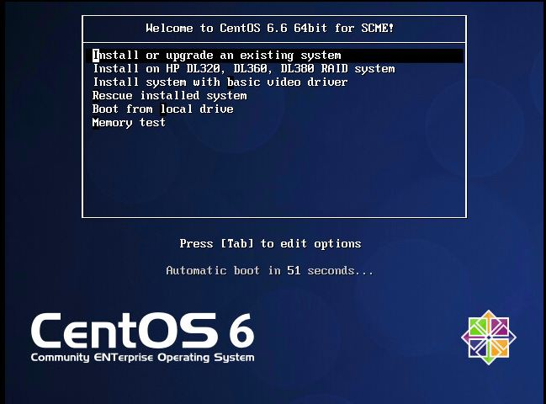If you boot up the server after DVD inserted DVD, you can see the installation screen automatically.
* The installation is started automatically if any input is not there after 60 seconds.

It takes 30 minutes to install CentOS.

* Server reboots automatically after finishing OS installation OS and ejecting DVD.
* In CentOS 6, “SCM Configuration Wizard” is not exist.
* “SCM Configuration Wizard” has been replaced by MINICLI.
* **Do not execute MINICLI before Migration step is done.**
  + If executes MINICLI, we recommend reinstalling it on DVD.

**Step 6**. Make network initial settings.

In the table below, the **red text** is the execution command and

“10.251.191.36” IP field is a example, please type customer IP.

* IP Configure ( Simple way to configure temporary IP )

[root@localhost ~]# **ifconfig eth0:1 10.251.191.36 up**

If you did't configure eth0, you can simply use the command as follow

[root@localhost ~]# **ifconfig eth0 10.251.191.36 up**

.

After configure the IP, run the FileZilla program and connect to the server. If the connection is not available, perform "IP Configure(2)".

* IP Configure(2) ( Be careful to spaceing and single quotation mark )

[root@localhost ~]# **sed –I ‘s/BOOTPROTO=dhcp/BOOTPROTO=static/g’ /etc/sysconfig/network-scripts/ifcfg-eth0**

[root@localhost ~]# **echo IPADDR=10.251.191.36 >> /etc/sysconfig/network-scripts/ifcfg-eth0**

[root@localhost ~]# **ifdown eth0**

[root@localhost ~]# **ifup eth0**

* **For your reference**

How to check Ethernet port up/down status.

ethtool eth0

ethtool eth1

ethtool eth2

**Step 7**. Upload the backup file and CentOS_MigrationTOOL file to the SCM server using

ftp program such as FileZilla.

* FTP and SSH ID is **scm**, execution ID is “**root**”.
* Then make directory “**/home/scm/MIG**”.
* Unzip “backup file” and “CentOS_MigrationTOOL” file.

In the table below, the **red text** is the execution command.

[root@localhost scm]# **cd /home/scm**

[root@localhost scm]# **mkdir /home/scm/MIG**

[root@localhost scm]# **cd /home/scm/MIG**

[root@localhost scm]# **tar xvzf /home/scm/CentOS_MigrationTOOL.tar.gz**

[root@localhost scm]# **tar xvf /home/scm/scme-backup.tar**

**Step 8**. Start Migration using Backup data.

* Before start Migration, Migration Tool check the SCM version.
* Migration feature is only support in v6.x or v7.x
* This feature should be executed after proceeding with the “Backup from previous version”.
* In the table below, the **red text** is the execution command.

[root@SCM-vmc-12 MIG]# **cd /home/scm/MIG**

[root@SCM-vmc-12 MIG]# **./start_migration.sh**

=======================================================

MIGRATION TOOL CLI

=======================================================

Consol Commands :

1. Backup - Backup SCM Data

2. Restore - Restore using backed up SCM Data

3. Migration - Migration to a new system using backed up SCM data

exit - exit.

CLI >> 3

Migration Commands :

0. Total Migration - Total Data Migration.

1. DB/CONFIG Migration - Database, Basic Configuration Migration.

2. CONFIG Migration - Basic Configuration Migration .

**Step 9.** During the execution of the program, an error message for the “/proc/…” path is displayed, but this is not a problem.

3. UMS Migration - VoiceMail and UMS Data Migration.

4. Announce Migration - Announce Data Migration.

5. CDR Migration - CDR Data Migration.

6. Phone Data Migration - Phone/GW Data Migration.

7. Photo Data Migration - User Photo Data Migration.

exit - exit.

CLI >> **0**

Input is 0, Start Restore

This program will shutdown scm express software.

Will you execute ? (yes/no)

CLI >> **yes**

Migration Started

TOTAL DISK_SIZE: 225973 MB

…

e is 65537 (0x10001)

Signature ok

subject=/CN=10.251.191.36

Getting Private key

restore Final Step >> Success

We need to reboot the system, Do you want it?(Y/N) : **y**

----------------------------------------------------------------

IP Configuration Complete

Reboot SCM System....

----------------------------------------------------------------

Broadcast message from root@localhost.localdomain

(/dev/pts/1) at 20:33 ...

The system is going down for reboot NOW!

Migration Completed

**(After the server reboot)**

* In the table below, the **red text** is the execution command.

### Rollback to V5.4.2.6 or V6.x

This feature should be executed after proceeding with the “Backup from v5.4.2.6 or v6.x”.

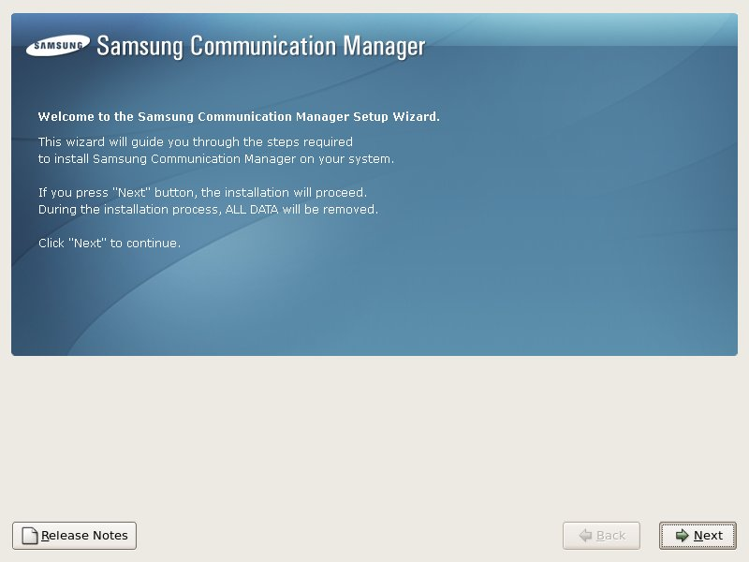**Step 1**. Install V5.4.2.6 or v6.x ISO DVD to SCM Server.

* If you boot up the server after DVD inserted DVD, you can see the installation screen automatically.
* Click “Next” to Install
* Click “Reboot” to reboot system.
* Do not execute “SCM Configuration Wizard” before Rollback step is done.
* If executes “SCM Configuration Wizard”, we recommend reinstalling it on DVD.

**Step 2**. Make network initial settings.

In the table below, the **red text** is the execution command.

[root@localhost **~]# echo IPADDR=10.251.191.36 >> /etc/sysconfig/network-scripts/ifcfg-eth0**

[root@localhost ~]# **echo BOOTPROTO=static >> /etc/sysconfig/network-scripts/ifcfg-eth0**

[root@localhost ~]# **echo TYPE=Ethernet >> /etc/sysconfig/network-scripts/ifcfg-eth0**

[root@localhost ~]# **echo DEVICE=eth0 >> /etc/sysconfig/network-scripts/ifcfg-eth0**

[root@localhost ~]# **ifdown eth0**

[root@localhost ~]# **ifup eth0**

**Step 3**. Upload the backup file and CentOS_MigrationTOOL file to the SCM server using ftp program such as FileZilla.

* FTP and SSH ID is **scm**, execution ID is “**root**”.
* Then make directory “**/home/scm/MIG**”.
* Unzip “backup file” and “CentOS_MigrationTOOL.tar.gz” file.

In the table below, the **red text** is the execution command.

[root@SCM-vmc-12 scm]# **cd /home/scm**

[root@SCM-vmc-12 scm]# **mkdir /home/scm/MIG**

[root@SCM-vmc-12 scm]# **cd /home/scm/MIG**

[root@SCM-vmc-12 scm]# **tar xvzf /home/scm/CentOS_MigrationTOOL.tar.gz**

[root@SCM-vmc-12 scm]# **tar xvf /home/scm/scme-backup.tar**

**Step 5**. Start Rollback to previous version

* Before start Rollback, Migration Tool check the SCM version.
* This feature should be executed after proceeding with the “Backup from V5.4.2.6 or v6.x”.

In the table below, the **red text** is the execution command.

[root@SCM-vmc-12 MIG]# **cd /home/scm/MIG**

[root@SCM-vmc-12 MIG]# **./start_migration.sh**

=======================================================

MIGRATION TOOL CLI

=======================================================

Consol Commands :

1. Backup - Backup SCM Data

2. Restore - Restore using backed up SCM Data

3. Migration - Migration to a new system using backed up SCM data

exit - exit.

CLI >> **2**

Backup Commands :

0. Total Restore - Total Data Restore

1. DB/CONFIG Restore - Database, Basic Configuration Restore.

2. CONFIG Restore - Basic Configuration Restore .

3. UMS Restore - VoiceMail and UMS Data Restore.

4. Announce Restore - Announce Data Restore.

5. CDR Restore - CDR Data Restore.

6. Phone Data Restore - Phone/GW Data Restore.

7. Photo Data Restore - User Photo Data Restore.

exit - exit.

CLI >> **0**

Input is 0, Start Restore

This program will shutdown scm express software.

Will you execute ? (yes/no)

CLI >> **yes**

TOTAL DISK_SIZE: 225973 MB

…

We need to reboot the system, Do you want it?(Y/N) : **y**

----------------------------------------------------------------

IP Configuration Complete

Reboot SCM System....

----------------------------------------------------------------

Broadcast message from root@localhost.localdomain

(/dev/pts/1) at 20:33 ...

The system is going down for reboot NOW!

Migration Completed

**(After the server reboot)**

## **A description of each error phrase and what to do.**

1. The migration tool has occurred a problem during a progress. Please save a screen display text and keep a log folder.

* Please ask for development analysis including the text displayed on the screen and all the contents of the log folder created in the path where the program was executed.

1. Current CentOS VERSION (~~~~) is not supported.

* The Operation System version of this system is not supported.

Please check Migration Tool and Operating System Version.

1. You are running this tool with SCM 5.1.0.5, Invalid SCM version (5.1.0.5). The running SCM version MUST be 5.4.2.6. If you are running other version, upgrade to 5.4.2.6 first and then execute this tool.

* The SCM version of this system is a version that can’t work.

Please check SCM version is v5.4.2.6.

,

1. ~~You are running this tool with SCM 6.1.X.X, Invalid SCM version (6.1.X.X). The running SCM version MUST be 6.0.0.5. If you are running other version. Install a version 6.0.0.5 first and then execute this tool.~~

* ~~The SCM version of this system is a version that can’t work.~~

~~Please check SCM version is v6.0.0.5.~~

1. SCM is not installed in this system.

* Please check SCM is installed.