To : | Doc. No. | SECYYMM-XX-X
C.C. : | Country | ALL
From: | Tel: 82-31-279- Fax:  E-mail: @samsung.com
Subject : ITP5112L S/W Release

Overview :
ITP51xx S/W release
ITP51xx S/W: V04.17(0906181200)

New Version Changes

’V04.17(0906181200) : 18 Jun, 2009
ITP5112L S/W changed items

Added Features & Modified items & Fixed Bug.
1. VLAN operation modified. (See below)
: In the V4.15, VLAN operation of “LAN to Phone” port is dependent on VLAN operation of “LAN to PC” port. In this new version, VLAN operation of “LAN to Phone” port and “LAN to PC” port is independent each other. And VLAN setting menu is modified.
2. “Follow Me” Forward display added.
: When the user sets “Follow me” Fwd at another ITP using feature code “60”, user’s ITP displays “Follow me” Fwd in the Call Forwarding menu.

Modified VLAN Setting Menu in the V4.17
- VLAN Setting menu is separated into “LAN to Phone” port and “LAN to PC” port.
- And each port is separated into VLAN Enable/Disable, id and priority.
(Tagging option is removed.)

- How to configure VLAN in the V4.17
  - LAN to Phone Port(for IP phone’s VLAN)
- 3. Network Setup → 4. VLAN Setup → 1. VLAN(LAN ←→ Phone)
- VLAN Enable/Disable
Enable(1)/Disable(0)
1
(1: Enable(Tagged Mode), 0: Disable(Untagged Mode))

- VLAN ID
ID(2 ~ 4094)
10
(ID range : 2 ~ 4094)

- VLAN Priority
Priority(0 ~ 7)
7
( 7 is highest priority)

  - LAN to PC Port(for PC’s VLAN)
- 3. Network Setup → 4. VLAN Setup → 2. VLAN(LAN ←→ PC)
- VLAN Enable /Disable
Enable(1)/Disable(0)
1
(1: Enable(Tagged Mode), 0: Disable(Untagged Mode))

- VLAN ID
ID(2 ~ 4094)
20
(ID range : 2 ~ 4094)

- VLAN Priority
Priority(0 ~ 7)
0
( 7 is highest priority)

S/W Compatibility Table :
MODEL | MCP2-L/M | ITP5112L
VERSION | OfficeServ 7100 : V4.30k  OfficeServ 7200 : V4.30k  OfficeServ 7400 : V4.30k  ( IDLE MODE from V4.30d) | V04.17
DATE |  | 18 Jun, 2009

Previous Version Change History:

’V04.15(0903291200) : 29 Mar, 2009
ITP5112L S/W changed items

Added Features & Modified items
- Forward setting’s error display modified
: Forward setting’s error display is not distinguished between when the forward setting is not allowed by the system DB and when user sets forward number to a wrong number. When the forward setting is not allowed, error display is “Forward Setting is not allowed”. And when forward number is not correct, error display is “Invalid FWD Number”.

Fixed Bugs
- VLAN bug fixed. (See below)
: When the PC is connected to PC port of the ITP and ITP enables its VLAN function, multicast packet for PC is not transferred to the PC. Bug fixed.

- Ping Ring generation is modified.
: ITP5112L generates a ping ring as a continuous tone.(different from 2line ITP’s ping ring). Bug fixed.

Modified VLAN Setting Menu
- VLAN Setting menu is separated into “LAN to Phone” port and “LAN to PC” port.
- And each port is separated into VLAN ID, priority and tagging option.

- Previous version : How to configure VLAN before V4.15
  - LAN Port(for IP phone’s VLAN)
- 1. Configuration menu → 3. Network Setup → 4. VLAN(LAN Port)
VLAN: EN(1)/DIS(0) ID Priority
1 10 1
(ID: 2 ~ 4094 , Priority: 0 ~ 7)
(* Enter the space key between parameters.)
→ VLAN enable, ID = 10, Priority = 1(higher priority than PC)

- PC Port(for PC’s VLAN)
- 1. Configuration menu → 3. Network Setup → 5. VLAN(PC Port)
VLAN: EN(1)/DIS(0) ID Priority
1 20 5
(ID: 2 ~ 4094 , Priority: 0 ~ 7)
→ VLAN enable, ID = 20, Priority = 5

- How to configure VLAN in the ITP after V4.15
  - LAN to Phone Port(for IP phone’s VLAN)
- 3. Network Setup → 4. VLAN Setup → 1. VLAN(LAN ←→ Phone)
- VLAN ID
ID(1:off, 2 ~ 4094:on)
10
VLAN Id ‘1’ means that LAN to Phone port does not use VLAN feature.
And VLAN Id ‘2 ~ 4094’ means that LAN to Phone port use VLAN feature.

- VLAN Priority
Priority(0 ~ 7)
1

- Tag/Untag Option
Tagged(1)/Untagged(0)
0
Tagged means that VLAN header is tagged to tx packet.
According to switch’s VLAN configuration, this tagging option is varied. But if both “LAN to
Phone” port and “LAN to PC” port VLAN are enabled, “LAN to Phone” port operates in the
untagged mode regardless of tag option value.

  - LAN to PC Port(for PC’s VLAN)
- 3. Network Setup → 4. VLAN Setup → 2. VLAN(LAN ←→ PC)
- VLAN ID
ID(1:off, 2 ~ 4094:on)
20
VLAN Id ‘1’ means that LAN to Phone port does not use VLAN feature.
And VLAN Id ‘2 ~ 4094’ means that LAN to PC port use VLAN feature.

- VLAN Priority
Priority(0 ~ 7)
5

- Tag/Untag Option
PC port only operates in the
Untagged mode. Press End key.
PC port only operates in the untagged mode.(Does not support tagged mode.)

’V04.14(0901191200) : 19 Jan, 2009
ITP5112L S/W changed items

Added Features & Modified items
1. 19 character support.
: User Name’s character length is extended to 19 character and it supports to display 24 characters per one line on LCD. But font size is smaller than before.
It is able to enter the STN Name(User Name) using MMC104 or Menu7(Myphone-My Name).
2. RFC2833 feature is added.
: This new version supports transferring DTMF digits according to RFC 2833 when DTMF option is set to enable through SCMv2 System.

3. SRTP feature is added
: This new version supports secure RTP for voice communication when SRTP option is set to enable through SCMv2 System.

4. ITP IDLE MODE(Hotdesking) feature is added . (See below)
: This feature has compatibility with OfficeServ System ver 4.30 over.

Fixed Bugs
- Long Key input value in enbloc mode is modified.
: Normal digit key value is different from long digit key input value. So long digit key should be ASCII value in enbloc mode.
This feature is not related to speed dialing using DS(STN) keys. But It is related to SPD(speed dial) block in OfficeServ System.
- Ping Ring generation is modified.
: ITP5112L generate a ping ring one time when other pickup group member station get a phone call.

ITP IDLE MODE (Hotdesking) Feature
ITP IDLE MODE feature allows a user to easily switch from an office phone to the remote phone with ability to have one telephone number by extension logging into the system. A user can log in via ‘Extension Login’ through the remote phone that ‘IDLE MODE’ is enabled.
Once the user has successfully logged in through the remote phone, the user’s own configuration data which is available is provided by the system. (Some kinds of data excluded. For example phonebook, call logs and messages)
- ITP Logout
If an IP phone logs out in the login state that it is registered on the system, it shall go to login standby state. In this state, no call service shall be performed.
- 'IDLE_MODE' option is added in MMC840.
- ITP Login
If an IP phone logs in to the system from the login standby state, it shall be registered on the system. In this state, the call service shall be performed. When logging in to the system, the user ID and password must be entered.
- ITP Logout function code
When an IP phone logs out of the system in the state that it is registered on the system, the logout function code registered in the system shall be used.
- 'LOGOUT' feature code is added in MMC724.
- ITP Restart
When an IP phone restarts, its last state shall be given to it. That is, if it was in the login state, it shall be logged in using the last user ID. If it was in the logout state, it shall restart in the login standby state.
- Compatibility
OfficeServ 7100, 7200, 7300 version V4.30

’08.02.29 V04.10(0802291200)
- ITP51xx S/W changed items

Added Features & Modified items
1. PnP(Plug and Play) feature added. (See below)
: Without manual configuration process, ITP can be automatically registered to OfficeServ using DHCP server.
2. Multiple server support scheme modified. (See below)
: When ITP currently runs at secondary server and primary server becomes alive, ITP automatically
goes back to primary server.

Plug and Play using DHCP server

Without any configuration process in the ITP, ITP can be automatically registered to the OfficeServ
system using DHCP server and specific DHCP option fields.
- To use PnP mode, ITP has to be factory-reset state.
- After doing factory-reset ITP, ITP runs at DHCP mode by default.
- ITP can’t use PnP mode at the static IP mode.
(Using static IP mode means that manual configuration process is required in the ITP.)

Network Environment and DHCP Server Configuration
1. DHCP server setup
- To use PnP mode, following two DHCP server’s option are used.
(Because various types of DHCP server are used, it’s not possible to explain option setup process
in this release note. Refer to your DHCP server’s configuration guide to setup this options.)
※ Two DHCP options to support ITP’s PnP
→ TFTP_Server_Name(66): "SEC_ITP" (66 is DHCP options’s number.)
(This option is used to distinguish our DHCP server from the other one under the circumstance
one more DHCP servers are running.)

→ TFTP_Server_IP(128): OfficeServ’s IP (128 is DHCP options’s number.)
(Using this OfficeServ’s IP address, ITP tries to register to OfficeServ)

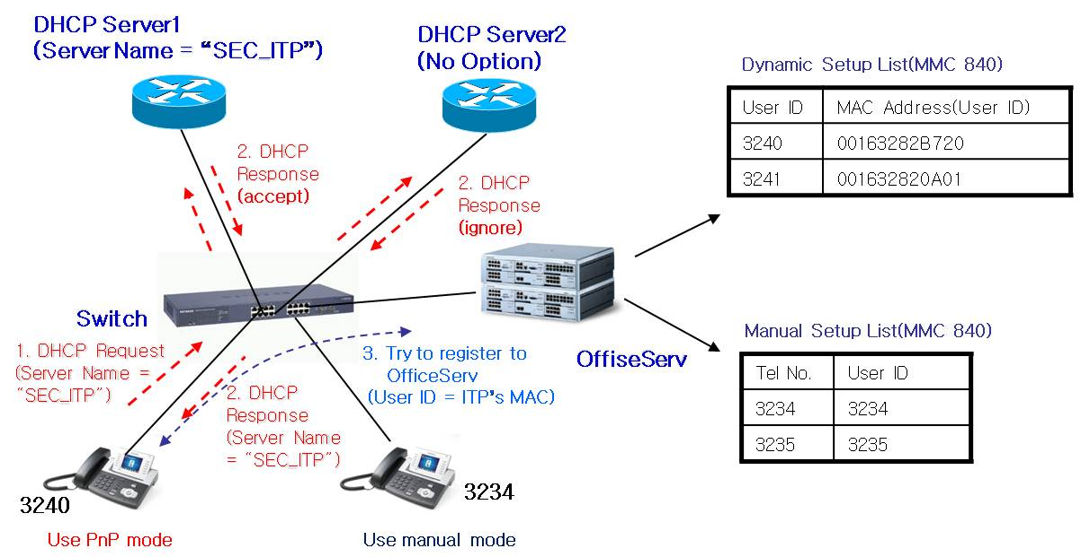
IPT PnP Running Environment

※ As above picture, Some ITPs can use PnP mode and some ITPs can use manual mode simultaneously.

System MMC setup
- In the MMC 840, input ITP’s MAC address to USER ID field.
(Alphabet character of MAC address has to be capital letter.)
[3240]USER ID  00163282B720 | [3241]USER ID  001632820A01

- After DHCP server’s option setup and MMC setup complete, power on ITP to register.
- In the beginning of booting process, ITP gets own IP and OfficeServ’s IP address from DHCP server.
- ITP sends register message including own MAC address instead of ITP’s USER ID.
- OfficeServ sends “Register OK” message including ITP’s USER ID and ITP’s setup process is completed.

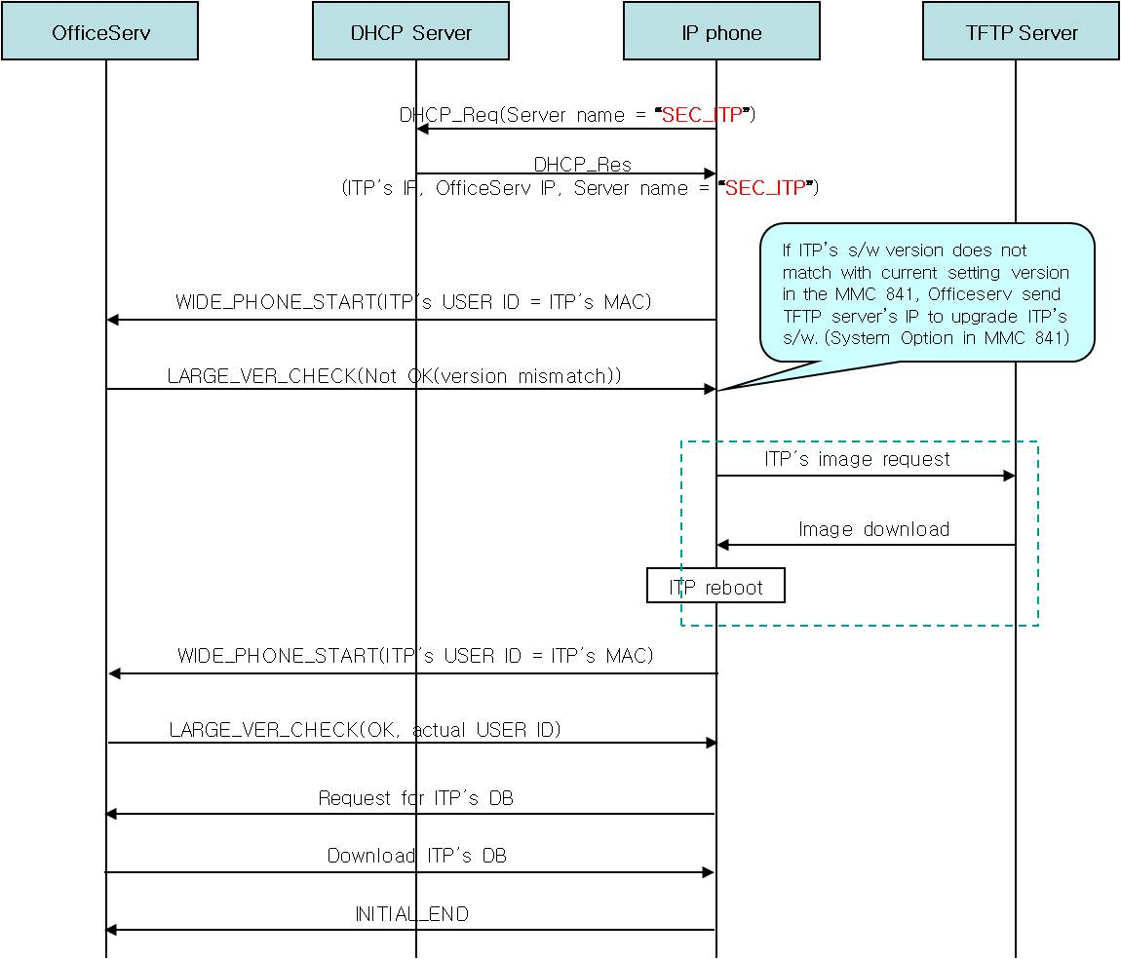
IPT’s PnP Flow

Enchanced Multiserver support scheme
When ITP currently runs at secondary server and primary server becomes alive, ITP automatically
goes back to primary server.
(In the prior scheme, ITP goes back to primary server after secondary server becomes down.)

- When the primary server is down or doesn’t respond to the ITP, ITP automatically registers to the
next secondary server.(Server is Officeserv system.)
- After primary server is dead and ITP moves to the secondary server(1~3), ITP continue to check
that primary server is alive.
- When ITP receives primary server’s answer, it automatically goes back to primary server.
(If ITP’s user is making a call at the secondary server, ITP goes back to primary server after ITP
user’s call ends.)
- If ITP is turned on or restarts, it always tries to register to the primary server.
- To use this feature, multiple server information is needed.(ITP supports 4 servers)

’07.03.09 V04.00(0703091200)
- ITP51xx S/W changed items

Added Features & Modified items
    - Russian Display Support
: When the ITP’s language is set to Russian, ITP can display Russian characters.
We modify that ITP’s LCD display module can process Russian fonts.

