To : | Doc. No. | SECYYMM-XX-X
C.C. : | Country | ALL
From: | Tel: Fax:  E-mail:
Subject : ITP5112L S/W Release

Overview :
ITP51xx S/W release
ITP51xx S/W: V04.10(0802291200)

New Version Changes
’08.02.29 V04.10(0802291200)
- ITP51xx S/W changed items

Added Features & Modified items
1. PnP(Plug and Play) feature added. (See below)
: Without manual configuration process, ITP can be automatically registered to OfficeServ using DHCP server.
2. Multiple server support scheme modified. (See below)
: When ITP currently runs at secondary server and primary server becomes alive, ITP automatically
goes back to primary server.

Plug and Play using DHCP server

Without any configuration process in the ITP, ITP can be automatically registered to the OfficeServ
system using DHCP server and specific DHCP option fields.
- To use PnP mode, ITP has to be factory-reset state.
- After doing factory-reset ITP, ITP runs at DHCP mode by default.
- ITP can’t use PnP mode at the static IP mode.
(Using static IP mode means that manual configuration process is required in the ITP.)

Network Environment and DHCP Server Configuration
1. DHCP server setup
- To use PnP mode, following two DHCP server’s option are used.
(Because various types of DHCP server are used, it’s not possible to explain option setup process
in this release note. Refer to your DHCP server’s configuration guide to setup this options.)
※ Two DHCP options to support ITP’s PnP
→ TFTP_Server_Name(66): "SEC_ITP" (66 is DHCP options’s number.)
(This option is used to distinguish our DHCP server from the other one under the circumstance
one more DHCP servers are running.)

→ TFTP_Server_IP(128): OfficeServ’s IP (128 is DHCP options’s number.)
(Using this OfficeServ’s IP address, ITP tries to register to OfficeServ)

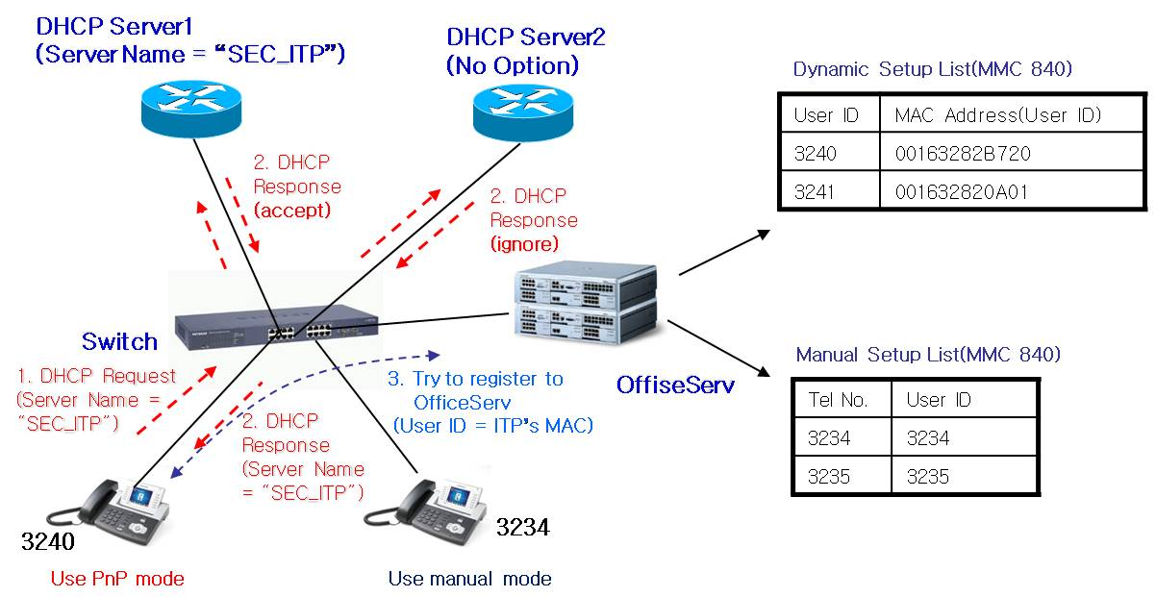
IPT PnP Running Environment

※ As above picture, Some ITPs can use PnP mode and some ITPs can use manual mode simultaneously.

System MMC setup
- In the MMC 840, input ITP’s MAC address to USER ID field.
(Alphabet character of MAC address has to be capital letter.)
[3240]USER ID  00163282B720 | [3241]USER ID  001632820A01

- After DHCP server’s option setup and MMC setup complete, power on ITP to register.
- In the beginning of booting process, ITP gets own IP and OfficeServ’s IP address from DHCP server.
- ITP sends register message including own MAC address instead of ITP’s USER ID.
- OfficeServ sends “Register OK” message including ITP’s USER ID and ITP’s setup process is completed.

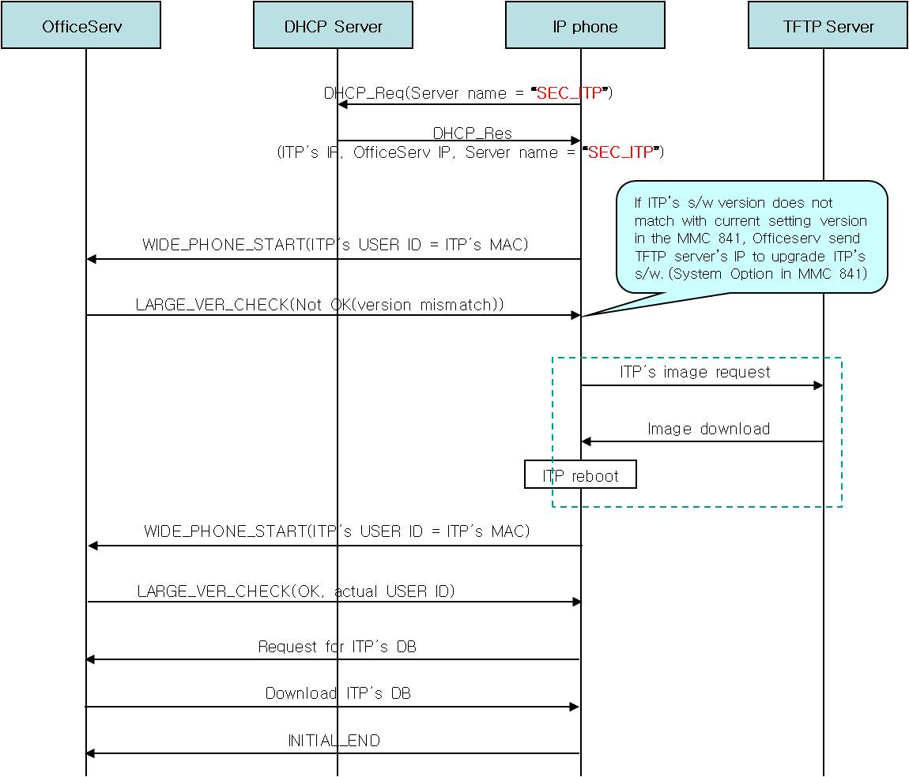
IPT’s PnP Flow

Enchanced Multiserver support scheme
When ITP currently runs at secondary server and primary server becomes alive, ITP automatically
goes back to primary server.
(In the prior scheme, ITP goes back to primary server after secondary server becomes down.)

- When the primary server is down or doesn’t respond to the ITP, ITP automatically registers to the
next secondary server.(Server is Officeserv system.)
- After primary server is dead and ITP moves to the secondary server(1~3), ITP continue to check
that primary server is alive.
- When ITP receives primary server’s answer, it automatically goes back to primary server.
(If ITP’s user is making a call at the secondary server, ITP goes back to primary server after ITP
user’s call ends.)
- If ITP is turned on or restarts, it always tries to register to the primary server.
- To use this feature, multiple server information is needed.(ITP supports 4 servers)

’07.03.09 V04.00(0703091200)
- ITP51xx S/W changed items

Added Features & Modified items
    - Russian Display Support
: When the ITP’s language is set to Russian, ITP can display Russian characters.
We modify that ITP’s LCD display module can process Russian fonts.

S/W Compatibility Table :
- For Russian Display Support
MODEL | MCP2-L/M | ITP5112L
VERSION | OfficeServ 12 : V2.69c  OfficeServ 100 : V2.69c  OfficeServ 500 : V2.69c  OfficeServ 7200 : V2.69c | V04.10
DATE | V2.69c (07.03.09) | 08.02.29

