To : | Doc. No. | SECYYMM-XX-X
C.C. : | Country | ALL
From: | Tel: 82-31-279- Fax:  E-mail: @samsung.com
Subject : ITP51xx S/W Release(5107/5114/5121)

Overview :
ITP51xx S/W release
ITP51xx S/W: V03.30(0802291200)

New Version Changes
’08.02.29 V03.30(0802291200)
- ITP51xx S/W changed items

Added Features & Modified items
1. PnP(Plug and Play) feature added. (See below)
: Without manual configuration process, ITP can be automatically registered to OfficeServ using DHCP server.
2. Multiple server support scheme modified. (See below)
: When ITP currently runs at secondary server and primary server becomes alive, ITP automatically
goes back to primary server.

Plug and Play using DHCP server

Without any configuration process in the ITP, ITP can be automatically registered to the OfficeServ
system using DHCP server and specific DHCP option fields.
- To use PnP mode, ITP has to be factory-reset state.
- After doing factory-reset ITP, ITP runs at DHCP mode by default.
- ITP can’t use PnP mode at the static IP mode.
(Using static IP mode means that manual configuration process is required in the ITP.)

Network Environment and DHCP Server Configuration
1. DHCP server setup
- To use PnP mode, following two DHCP server’s option are used.
(Because various types of DHCP server are used, it’s not possible to explain option setup process
in this release note. Refer to your DHCP server’s configuration guide to setup this options.)
※ Two DHCP options to support ITP’s PnP
→ TFTP_Server_Name(66): "SEC_ITP" (66 is DHCP options’s number.)
(This option is used to distinguish our DHCP server from the other one under the circumstance
one more DHCP servers are running.)

→ TFTP_Server_IP(128): OfficeServ’s IP (128 is DHCP options’s number.)
(Using this OfficeServ’s IP address, ITP tries to register to OfficeServ)

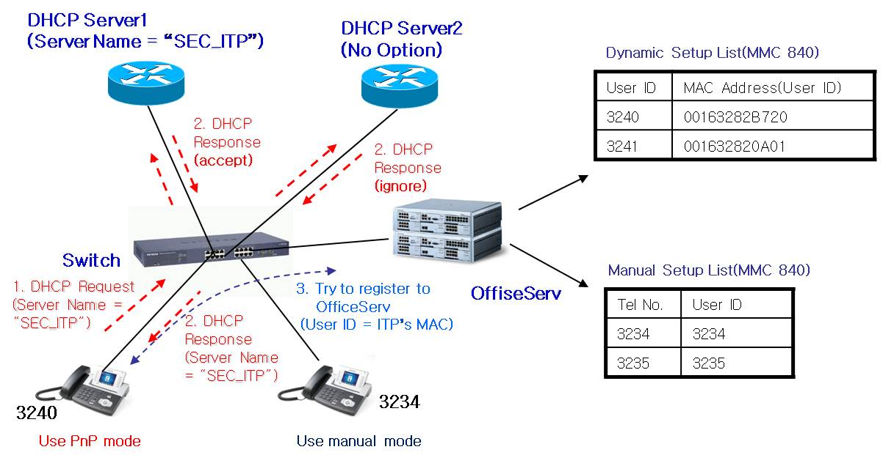
IPT PnP Running Environment

※ As above picture, Some ITPs can use PnP mode and some ITPs can use manual mode simultaneously.

System MMC setup
- In the MMC 840, input ITP’s MAC address to USER ID field.
(Alphabet character of MAC address has to be capital letter.)
[3240]USER ID  00163282B720 | [3241]USER ID  001632820A01

- After DHCP server’s option setup and MMC setup complete, power on ITP to register.
- In the beginning of booting process, ITP gets own IP and OfficeServ’s IP address from DHCP server.
- ITP sends register message including own MAC address instead of ITP’s USER ID.
- OfficeServ sends “Register OK” message including ITP’s USER ID and ITP’s setup process is completed.

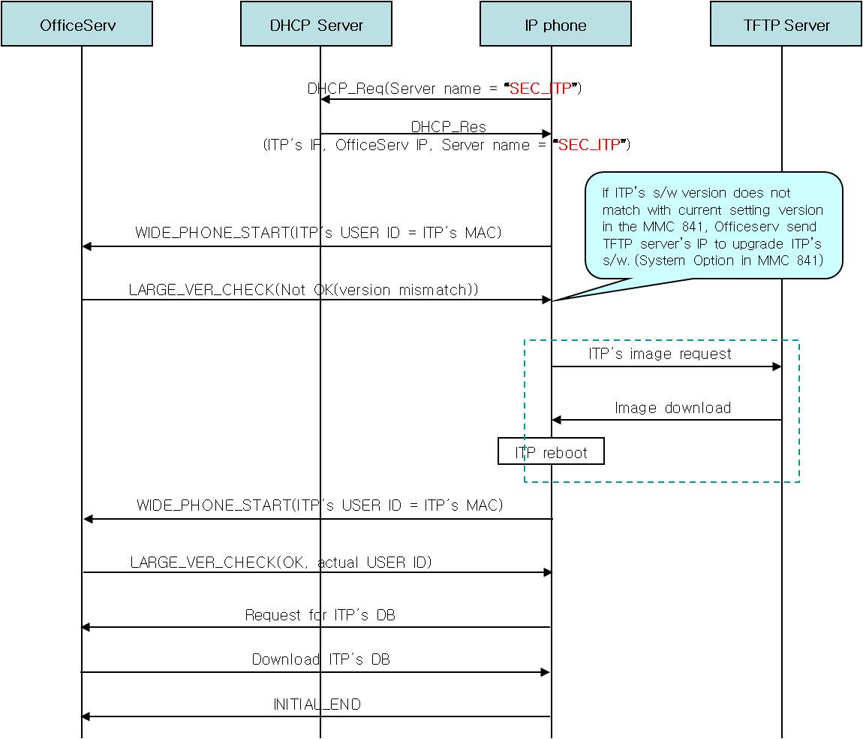
IPT’s PnP Flow

Enchanced Multiserver support scheme
When ITP currently runs at secondary server and primary server becomes alive, ITP automatically
goes back to primary server.
(In the prior scheme, ITP goes back to primary server after secondary server becomes down.)

- When the primary server is down or doesn’t respond to the ITP, ITP automatically registers to the
next secondary server.(Server is Officeserv system.)
- After primary server is dead and ITP moves to the secondary server(1~3), ITP continue to check
that primary server is alive.
- When ITP receives primary server’s answer, it automatically goes back to primary server.
(If ITP’s user is making a call at the secondary server, ITP goes back to primary server after ITP
user’s call ends.)
- If ITP is turned on or restarts, it always tries to register to the primary server.
- To use this feature, multiple server information is needed.(ITP supports 4 servers)

S/W Compatibility Table :
MODEL | MCP2-L/M | ITP5107S, 5114D, 51121D
VERSION | OfficeServ 7400 : V4.10  OfficeServ 7200 : V4.10 | V03.30
DATE |  | 08.02.29

Previous Version Change History:

’07.08.23 V03.21(0708231200)
- ITP51xx S/W changed items

Added Features & Modified items
    - Handset Rx gain adjusted.
: For voice quality enhancement, handset Rx gain adjusted.

’07.07.24 V03.20(0707241200)
- ITP51xx S/W changed items

Added Features & Modified items
    - PLC(Packet Loss Concealment) function added.
: When there is a little packet loss in the network, PLC prevents voice quality from going bad.
2) ITP’s ring volume level changed.
: In the MMC841, user can select 8 levels of 12 ring levels.
3) Barge-in bug fixed.
: When two ITPs have a conversation, another ITP barges in conversation.
And when ITP stops barging-in, original two ITP can’t hear their voice. Bug fixed.
4) New DSP image applied.
: In the beginning of a conversation, sometimes voice distortion occurs.
To improve voice quality, new DSP image applied.
5) DHCP mode bug fixed.
: When the ITP is running on DHCP mode and ITP’s IP is changed by DHCP server,
ITP can’t run using changed IP. Bug Fixed.

’07.03.09 V03.19(0703091200)
- ITP51xx S/W changed items

Added Features & Modified items
    - Russian Display Support
: When the ITP’s language is set to Russian, ITP can display Russian characters.
We modify that ITP’s LCD display module can process Russian fonts.

’06.11.27 V03.18(0611271200)
- ITP51xx S/W changed items

Added Features & Modified items
    - Multiple Server support(See below)
: When the current server is down or doesn’t respond to the phone, ITP automatically registers to the next server.
: ITP supports 4 servers.
    - VLAN(802.1p/q) support(See below)
: To distinguish between voice packet and data packet from the PC, ITP supports VLAN(802.1p/q) function.

Fixed Bugs
- If ITP operates in the DHCP or PPPoE mode and the DHCP server or PPPoE server does not respond for a long time, ITP does not display any error message.
: ITP display error message if the DHCP/PPPoE server has no answer for one minute.

- If any other device uses same ip address with ITP, ip conflict occurs.
Although this device is turned off, ITP can’t clear ip conflict status.
: ITP clears ip conflict status when the other device is turned off.

- When “STN NO RING” option is enabled in the MMC 110, ITP restart when the call is incoming.
: Bug fixed.

4) In the beginning of conversation, voice is sometimes broken during a few seconds. (Clicking noise)
: ITP’s Echo Cancel function is modified to remove clicking noise.

5) Sidetone volume Bug fixed.
: Although ITP’s sidetone volume is changed in the MMC 807, it has no change.

Multiple server support for ITP51xx

* Multiple server support
- When the current server is down or doesn’t respond to the phone, ITP automatically registers to the
next server.(Server is Officeserv system.)
- After current server(server 1) is dead and ITP moves to the next server(server 2), ITP doesn’t
automatically come back to the previous server(server 1) although previous server becomes alive again.
- If ITP is turned on or restarts, it always tries to register to the first server.
- To use this feature, multiple server information is needed.(ITP supports 4 servers)

- How to set server information
- 1. Configuration menu → 5. System Server Setup → 1. Server 1(2~4) Setup
1. Server 1(2~4) IP
2. System 1(2~4) ID
3. System 1(2~4) Password

→ If only one server information is set, ITP’s operation is same to the previous
s/w version.

VLAN feature in the ITP51xx

* VLAN(802.1p/q) feature
- When the ITP and PC are used in the same LAN environment, voice quality can be affected by PC’s
data traffic.(PC is connected to ITP.)
- To distinguish between voice packet and data packet from the PC, ITP can use VLAN(802.1p/q)
function.

* VLAN(802.1p/q) Test Environment

- How to configure VLAN in the ITP
  - LAN Port(for IP phone’s VLAN)
- 1. Configuration menu → 3. Network Setup → 4. VLAN(LAN Port)
VLAN: EN(1)/DIS(0) ID Priority
1 10 1
(ID: 2 ~ 4094 , Priority: 0 ~ 7)
(* Enter the space key between parameters.)
→ VLAN enable, ID = 10, Priority = 1(higher priority than PC)

- PC Port(for PC’s VLAN)
- 1. Configuration menu → 3. Network Setup → 5. VLAN(PC Port)
VLAN: EN(1)/DIS(0) ID Priority
1 20 5
(ID: 2 ~ 4094 , Priority: 0 ~ 7)
→ VLAN enable, ID = 20, Priority = 5

- How to confirm VLAN setting
- If we don’t use VLAN, ping packet is normally exchanged between ITP and PC.
- If we use VLAN and VLAN’s ID is different, ping packet cannot be exchanged between ITP and PC.
- Ping packet is only exchanged between ITPs and MCP(MGI) or between PCs.
- Register ITP to MCP and make a call.
→ If ITP cannot register to MCP, check a VLAN connection between ITP and MCP.

S/W Compatibility Table :
MODEL | MCP2-L/M | ITP5107S, 5114D, 51121D
VERSION | OfficeServ 12 : V2.60 (or above)  OfficeServ 100 : V2.60 (or above)  OfficeServ 500 : V2.60 (or above)  OfficeServ 7200 : V2.61(or above) | V03.18
DATE | V2.60 (05.10.17)  V2.61 (05.11.08) | 06.11.27

Previous Version Change History:

’06.08.16 V03.16(0608161200)
- ITP51xx S/W changed items

Added Features & Modified items
    - Line Test Retry Count : 2 -> 4
: IP phone retry registration after it doesn’t receive ACK msg for 4 times Link Test MSG consecutively.
    - Adjust some parameters about voice quality.
: To enhance ITP’s voice quality, some parameters(HLC, CLT) are adjusted.

Fixed Bugs
- G.711 packetization (Frame size) modification
: DSP can’t support G.711 packetization size over 40ms.
- Exception handling for DSP error
So G.711 packetization would be set to 20ms if it is over 40ms.

- Speaker volume bug fixed.
: When group call is received, ITP’s speaker volume becomes maximum.

- ITP’s Connection retry bug fixed.
: Because of heavy network traffic, link is disconnected between ITP and OfficeServ.
After network traffic becomes normal, some ITPs do not retry connection to
OfficeServ.
- Spot news display bug fixed.
: ITP can’t display spot news messages.

’06.04.14 V03.11(0604141700)
- ITP51xx S/W changed items

Added Features & Modified items
    - DSP Clock 125MHz -> 100MHz
: TNETV 1055 & 1056 Specification recommends to use DSP clock speed 100MHz.

Fixed Bugs
- Echo cancellation problem
: If someone camp on while you are talking over the IP phone using speaker mode, it will be occurred echo cancellation error by beep tone in your phone(speaker).
So bug fixed.

’05.12.09 V03.10(0512091200)
- ITP51xx S/W changed items

Added Features & Modified items
    - When the call is incoming, ring led is blinking separately from ring tone’s cadence. Modified that ring led’s blink synchronizes with the ring cadence.
    - [D051123002] In the ITP setup mode, the password entry shows the ITP’s password instead of “****”. Modified this requirement.
    - If a ITP’s LAN cable is disconnected and re-connected, ITP starts to register on system again to display correctly.

Fixed Bugs
- There is a delay for a few seconds at the receiver when you sends the external calls.(This problem appears only when ITP operates with OfficeServ 7400). Bug fixed.
- If the system restarts and the ITP re-registers on system, ITP’s led must be initialized. Bug fixed.
- [D051116003] The ITP 5114D and 5107S phones lost ALL AUDIO when it was assigned as a remote (PUBLIC w/ Firewall) phone. It will initially function normally, no problems. But after 20 minutes the remote ITP phones will lose both way audio. No speech path at all. The phone must physically be powered off and on again. Bug Fixed.
- If a system DB is cracked and the wrong ring frequency value(MMC 111) is sent to the ITP, ITP restart when the call is incoming. Bug Fixed.

’05.10.27 V03.01(0510271200)
- ITP51xx S/W changed items
- There is no difference of the Ring led’s color between external call and internal call.
Bug fixed.
- Ring led does not blink when the call is incoming. Bug fixed.
- In the common listen mode, speaker volume is not be controlled. Bug fixed.

